This part of the Jenkins User Documentation contains a series of tutorials to help you begin building your applications in an automated fashion with Jenkins.

Introductory tutorials

The following tutorials show how to use Jenkins to cover the basics of CI/CD concepts based on specific technology stacks.

Choose the tutorial that’s relvant to your technology stack or one that you’re most familiar with:

* Build a Java app with Maven
* Build a Node.js and React app with npm
* Build a Python app with PyInstaller

The following tutorials show how to use key features of Jenkins (such as Blue Ocean) to facilitate implementing CI/CD processes to build your applications:

* Create a Pipeline in Blue Ocean

Advanced tutorials

The following tutorials demonstrate more advanced features of Jenkins and how to manage your Pipeline projects with greater sophistication and flexibility.

* Build a multibranch Pipeline project

# Build a Java app with Maven

If you are a Java developer who uses Maven and who is new to CI/CD concepts, or you might be familiar with these concepts but don’t know how to implement building your application using Jenkins, then this tutorial is for you.

The simple Java application (which you’ll obtain from a sample repository on GitHub) outputs the string "Hello world!" and is accompanied by a couple of unit tests to check that the main application works as expected. The results of these tests are saved to a JUnit XML report.

**Duration:** This tutorial takes 20-40 minutes to complete (assuming you’ve already met the prerequisites below). The exact duration will depend on the speed of your machine and whether or not you’ve already run Jenkins in Docker from another tutorial.

You can stop this tutorial at any point in time and continue from where you left off.

If you’ve already run though another tutorial, you can skip the Prerequisites and Run Jenkins in Docker sections below and proceed on to forking the sample repository. (Just ensure you have Git installed locally.) If you need to restart Jenkins, simply follow the restart instructions in Stopping and restarting Jenkins and then proceed on.

### Prerequisites

For this tutorial, you will require:

* A macOS, Linux or Windows machine with:
  + 256 MB of RAM, although more than 512MB is recommended.
  + 10 GB of drive space for Jenkins and your Docker images and containers.
* The following software installed:
  + Docker - Read more about installing Docker in the Installing Docker section of the Installing Jenkins page.  
    **Note:** If you use Linux, this tutorial assumes that you are not running Docker commands as the root user, but instead with a single user account that also has access to the other tools used throughout this tutorial.
  + Git and optionally GitHub Desktop.

### Run Jenkins in Docker

In this tutorial, you’ll be running Jenkins as a Docker container from the jenkinsci/blueocean Docker image.

To run Jenkins in Docker, follow the relevant instructions below for either macOS and Linux or Windows.

You can read more about Docker container and image concepts in the Docker and Downloading and running Jenkins in Dockersections of the Installing Jenkins page.

#### On macOS and Linux

1. Open up a terminal window.
2. Run the jenkinsci/blueocean image as a container in Docker using the following docker run command (bearing in mind that this command automatically downloads the image if this hasn’t been done):
3. docker run \
4. --rm \
5. -u root \
6. -p 8080:8080 \
7. -v jenkins-data:/var/jenkins_home \
8. -v /var/run/docker.sock:/var/run/docker.sock \
9. -v "$HOME":/home \

jenkinsci/blueocean

|  |  |
| --- | --- |
|  | Maps the /var/jenkins_home directory in the container to the Docker volume with the name jenkins-data. If this volume does not exist, then this docker run command will automatically create the volume for you. |
|  | Maps the $HOME directory on the host (i.e. your local) machine (usually the /Users/<your-username> directory) to the /home directory in the container. |

**Note:** If copying and pasting the command snippet above doesn’t work, try copying and pasting this annotation-free version here:

docker run \

--rm \

-u root \

-p 8080:8080 \

-v jenkins-data:/var/jenkins_home \

-v /var/run/docker.sock:/var/run/docker.sock \

-v "$HOME":/home \

jenkinsci/blueocean

1. Proceed to the Setup wizard.

#### On Windows

1. Open up a command prompt window.
2. Run the jenkinsci/blueocean image as a container in Docker using the following docker run command (bearing in mind that this command automatically downloads the image if this hasn’t been done):
3. docker run ^
4. --rm ^
5. -u root ^
6. -p 8080:8080 ^
7. -v jenkins-data:/var/jenkins_home ^
8. -v /var/run/docker.sock:/var/run/docker.sock ^
9. -v "%HOMEPATH%":/home ^

jenkinsci/blueocean

For an explanation of these options, refer to the macOS and Linux instructions above.

1. Proceed to the Setup wizard.

#### Accessing the Jenkins/Blue Ocean Docker container

If you have some experience with Docker and you wish or need to access the Jenkins/Blue Ocean Docker container through a terminal/command prompt using the docker exec command, you can add an option like --name jenkins-tutorials (with the docker run above), which would give the Jenkins/Blue Ocean Docker container the name "jenkins-tutorials".

This means you could access the Jenkins/Blue Ocean container (through a separate terminal/command prompt window) with a docker exec command like:

docker exec -it jenkins-tutorials bash

#### Setup wizard

Before you can access Jenkins, there are a few quick "one-off" steps you’ll need to perform.

##### **Unlocking Jenkins**

When you first access a new Jenkins instance, you are asked to unlock it using an automatically-generated password.

1. After the 2 sets of asterisks appear in the terminal/command prompt window, browse to http://localhost:8080 and wait until the **Unlock Jenkins** page appears.

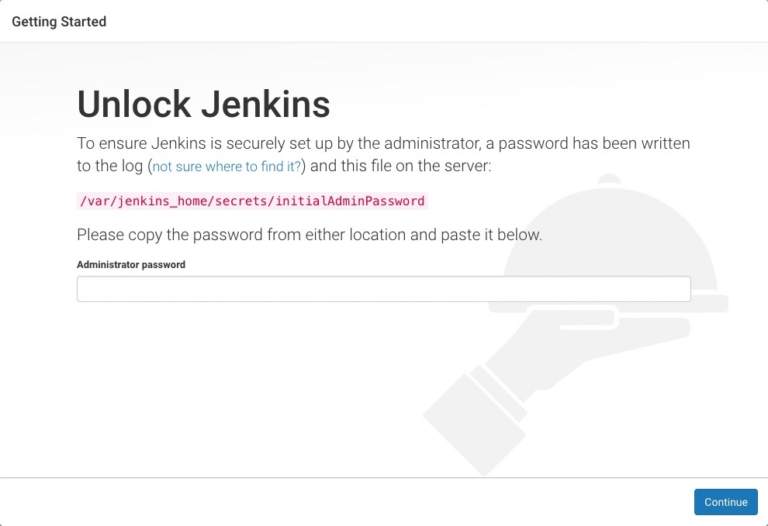

1. From your terminal/command prompt window again, copy the automatically-generated alphanumeric password (between the 2 sets of asterisks).

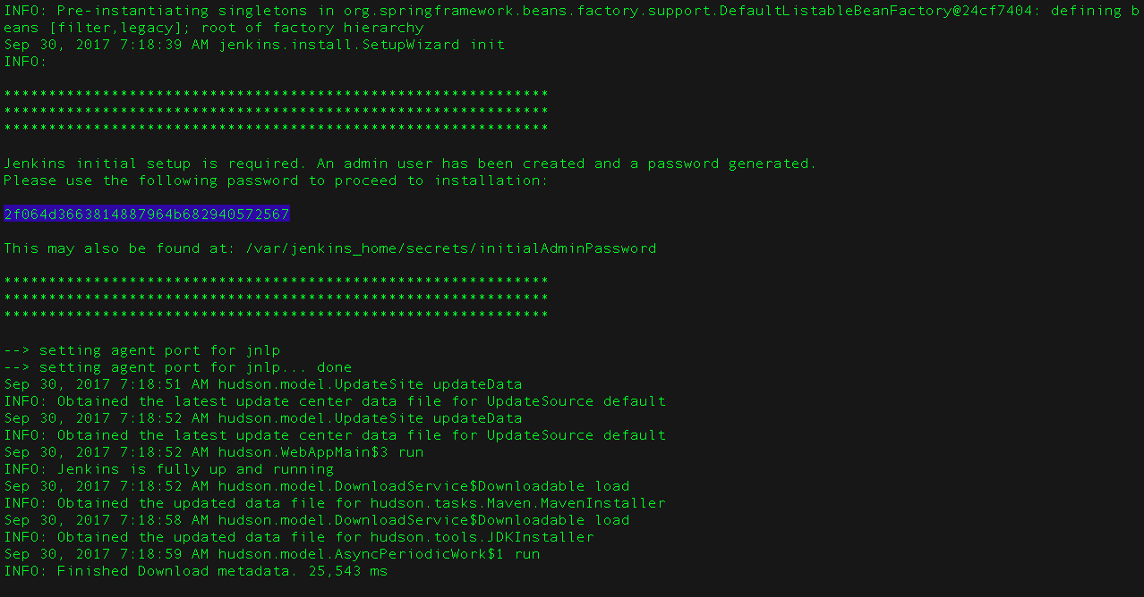

1. On the **Unlock Jenkins** page, paste this password into the **Administrator password** field and click **Continue**.

##### **Customizing Jenkins with plugins**

After unlocking Jenkins, the **Customize Jenkins** page appears.

On this page, click **Install suggested plugins**.

The setup wizard shows the progression of Jenkins being configured and the suggested plugins being installed. This process may take a few minutes.

##### **Creating the first administrator user**

Finally, Jenkins asks you to create your first administrator user.

1. When the **Create First Admin User** page appears, specify your details in the respective fields and click **Save and Finish**.
2. When the **Jenkins is ready** page appears, click **Start using Jenkins**.  
   **Notes:**
   * This page may indicate **Jenkins is almost ready!** instead and if so, click **Restart**.
   * If the page doesn’t automatically refresh after a minute, use your web browser to refresh the page manually.
3. If required, log in to Jenkins with the credentials of the user you just created and you’re ready to start using Jenkins!

#### Stopping and restarting Jenkins

Throughout the remainder of this tutorial, you can stop the Jenkins/Blue Ocean Docker container by typing Ctrl-C in the terminal/command prompt window from which you ran the docker run ... command above.

To restart the Jenkins/Blue Ocean Docker container:

1. Run the same docker run ... command you ran for macOS, Linux or Windows above.  
   **Note:** This process also updates the jenkinsci/blueocean Docker image, if an updated one is available.
2. Browse to http://localhost:8080.
3. Wait until the log in page appears and log in.

### Fork and clone the sample repository on GitHub

Obtain the simple "Hello world!" Java application from GitHub, by forking the sample repository of the application’s source code into your own GitHub account and then cloning this fork locally.

1. Ensure you are signed in to your GitHub account. If you don’t yet have a GitHub account, sign up for a free one on the GitHub website.
2. Fork the simple-java-maven-app on GitHub into your local GitHub account. If you need help with this process, refer to the Fork A Repo documentation on the GitHub website for more information.
3. Clone your forked simple-java-maven-app repository (on GitHub) locally to your machine. To begin this process, do either of the following (where <your-username> is the name of your user account on your operating system):
   * If you have the GitHub Desktop app installed on your machine:
     1. In GitHub, click the green **Clone or download** button on your forked repository, then **Open in Desktop**.
     2. In GitHub Desktop, before clicking **Clone** on the **Clone a Repository** dialog box, ensure **Local Path** for:
        + macOS is /Users/<your-username>/Documents/GitHub/simple-java-maven-app
        + Linux is /home/<your-username>/GitHub/simple-java-maven-app
        + Windows is C:\Users\<your-username>\Documents\GitHub\simple-java-maven-app
   * Otherwise:
     1. Open up a terminal/command line prompt and cd to the appropriate directory on:
        + macOS - /Users/<your-username>/Documents/GitHub/
        + Linux - /home/<your-username>/GitHub/
        + Windows - C:\Users\<your-username>\Documents\GitHub\ (although use a Git bash command line window as opposed to the usual Microsoft command prompt)
     2. Run the following command to continue/complete cloning your forked repo:  
        git clone https://github.com/YOUR-GITHUB-ACCOUNT-NAME/simple-java-maven-app  
        where YOUR-GITHUB-ACCOUNT-NAME is the name of your GitHub account.

### Create your Pipeline project in Jenkins

1. Go back to Jenkins, log in again if necessary and click **create new jobs** under **Welcome to Jenkins!**  
   **Note:** If you don’t see this, click **New Item** at the top left.
2. In the **Enter an item name** field, specify the name for your new Pipeline project (e.g. simple-java-maven-app).
3. Scroll down and click **Pipeline**, then click **OK** at the end of the page.
4. ( Optional ) On the next page, specify a brief description for your Pipeline in the **Description** field (e.g. An entry-level Pipeline demonstrating how to use Jenkins to build a simple Java application with Maven.)
5. Click the **Pipeline** tab at the top of the page to scroll down to the **Pipeline** section.
6. From the **Definition** field, choose the **Pipeline script from SCM** option. This option instructs Jenkins to obtain your Pipeline from Source Control Management (SCM), which will be your locally cloned Git repository.
7. From the **SCM** field, choose **Git**.
8. In the **Repository URL** field, specify the directory path of your locally cloned repository above, which is from your user account/home directory on your host machine, mapped to the /home directory of the Jenkins container - i.e.
   * For macOS - /home/Documents/GitHub/simple-java-maven-app
   * For Linux - /home/GitHub/simple-java-maven-app
   * For Windows - /home/Documents/GitHub/simple-java-maven-app
9. Click **Save** to save your new Pipeline project. You’re now ready to begin creating your Jenkinsfile, which you’ll be checking into your locally cloned Git repository.

### Create your initial Pipeline as a Jenkinsfile

You’re now ready to create your Pipeline that will automate building your Java application with Maven in Jenkins. Your Pipeline will be created as a Jenkinsfile, which will be committed to your locally cloned Git repository (simple-java-maven-app).

This is the foundation of "Pipeline-as-Code", which treats the continuous delivery pipeline as a part of the application to be versioned and reviewed like any other code. Read more about Pipeline and what a Jenkinsfile is in the Pipeline and Using a Jenkinsfile sections of the User Handbook.

First, create an initial Pipeline to download a Maven Docker image and run it as a Docker container (which will build your simple Java application). Also add a "Build" stage to the Pipeline that begins orchestrating this whole process.

1. Using your favorite text editor or IDE, create and save new text file with the name Jenkinsfile at the root of your local simple-java-maven-app Git repository.
2. Copy the following Declarative Pipeline code and paste it into your empty Jenkinsfile:
3. pipeline {
4. agent {
5. docker {
6. image 'maven:3-alpine'
7. args '-v /root/.m2:/root/.m2'
8. }
9. }
10. stages {
11. stage('Build') {
12. steps {
13. sh 'mvn -B -DskipTests clean package'
14. }
15. }
16. }

}

|  |  |
| --- | --- |
|  | This image parameter (of the agent section’s docker parameter) downloads the maven:3-apline Docker image (if it’s not already available on your machine) and runs this image as a separate container. This means that:   * + You’ll have separate Jenkins and Maven containers running locally in Docker.   + The Maven container becomes the agent that Jenkins uses to run your Pipeline project. However, this container is short-lived - its lifespan is only that of the duration of your Pipeline’s execution. |
|  | This args parameter creates a reciprocal mapping between the /root/.m2 (i.e. Maven repository) directories in the short-lived Maven Docker container and that of your Docker host’s filesystem. Explaining the details behind this is beyond the scope of this tutorial. However, the main reason for doing this is to ensure that the artifacts necessary to build your Java application (which Maven downloads while your Pipeline is being executed) are retained in the Maven repository beyond the lifespan of the Maven container. This prevents Maven from having to download the same artifacts during successive runs of your Jenkins Pipeline, which you’ll be conducting later on. Be aware that unlike the Docker data volume you created for jenkins-data above, the Docker host’s filesystem is effectively cleared out each time Docker is restarted. This means you’ll lose the downloaded Maven repository artifacts each time Docker restarts. |
|  | Defines a stage (directive) called Build that appears on the Jenkins UI. |
|  | This sh step (of the steps section) runs the Maven command to cleanly build your Java application (without running any tests). |

1. Save your edited Jenkinsfile and commit it to your local simple-java-maven-app Git repository. E.g. Within the simple-java-maven-app directory, run the commands:  
   git add .  
   then  
   git commit -m "Add initial Jenkinsfile"
2. Go back to Jenkins again, log in again if necessary and click **Open Blue Ocean** on the left to access Jenkins’s Blue Ocean interface.
3. In the **This job has not been run** message box, click **Run**, then quickly click the **OPEN** link which appears briefly at the lower-right to see Jenkins running your Pipeline project. If you weren’t able to click the **OPEN** link, click the row on the main Blue Ocean interface to access this feature.  
   **Note:** You may need to wait several minutes for this first run to complete. After making a clone of your local simple-java-maven-app Git repository itself, Jenkins:
   * Initially queues the project to be run on the agent.
   * Downloads the Maven Docker image and runs it in a container on Docker.

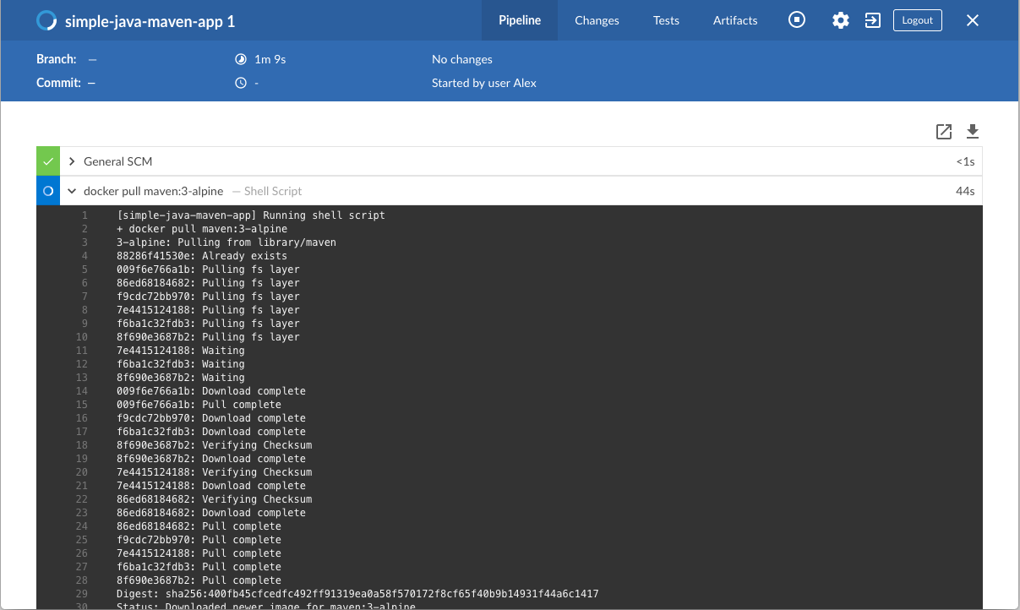

* + Runs the Build stage (defined in the Jenkinsfile) on the Maven container. During this time, Maven downloads many artifacts necessary to build your Java application, which will ultimately be stored in Jenkins’s local Maven repository (in the Docker host’s filesystem).

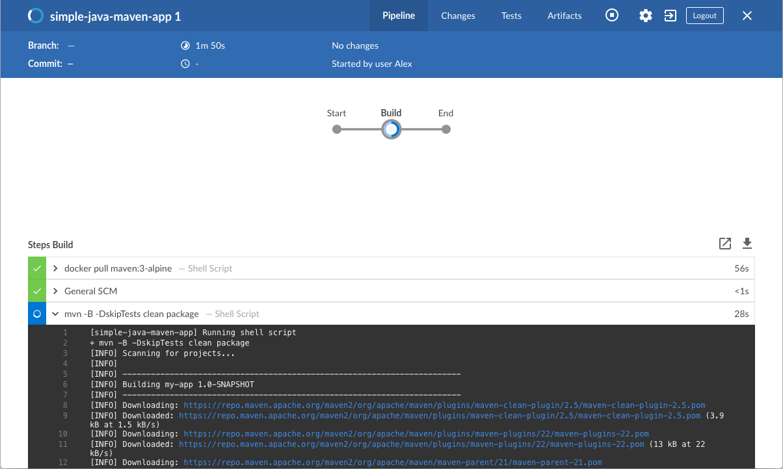

1. The Blue Ocean interface turns green if Jenkins built your Java application successfully.
2. 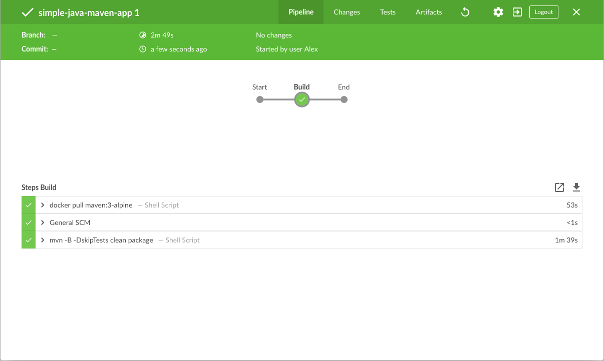
3. Click the **X** at the top-right to return to the main Blue Ocean interface.

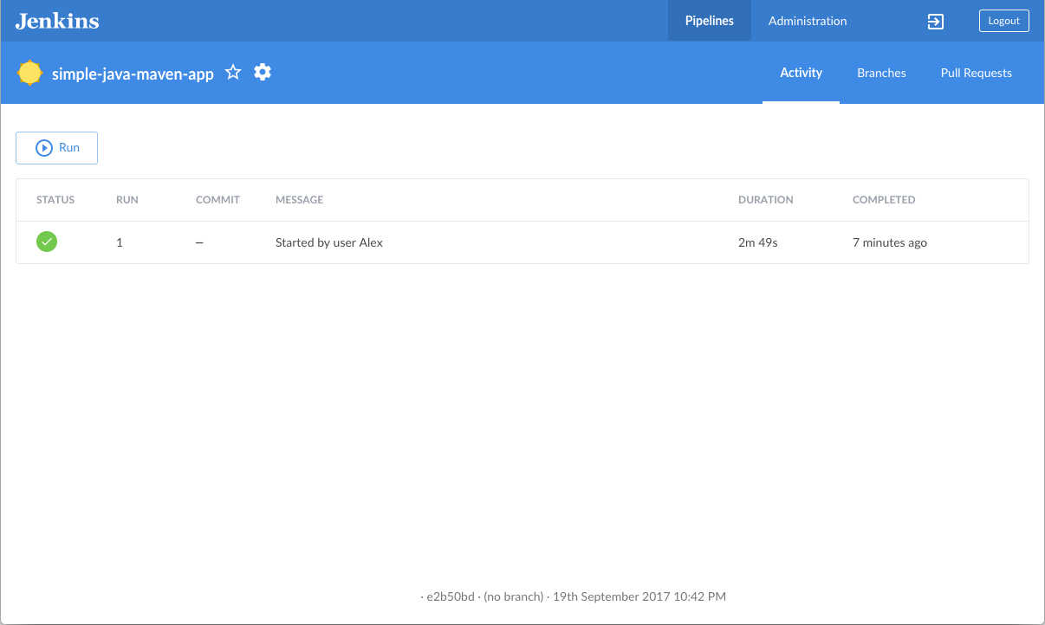

### Add a test stage to your Pipeline

1. Go back to your text editor/IDE and ensure your Jenkinsfile is open.
2. Copy and paste the following Declarative Pipeline syntax immediately under the Build stage of your Jenkinsfile:
3. stage('Test') {
4. steps {
5. sh 'mvn test'
6. }
7. post {
8. always {
9. junit 'target/surefire-reports/*.xml'
10. }
11. }

}

so that you end up with:

pipeline {

agent {

docker {

image 'maven:3-alpine'

args '-v /root/.m2:/root/.m2'

}

}

stages {

stage('Build') {

steps {

sh 'mvn -B -DskipTests clean package'

}

}

stage('Test') {

steps {

sh 'mvn test'

}

post {

always {

junit 'target/surefire-reports/*.xml'

}

}

}

}

}

|  |  |
| --- | --- |
|  | Defines a stage (directive) called Test that appears on the Jenkins UI. |
|  | This sh step (of the steps section) executes the Maven command to run the unit test on your simple Java application. This command also generates a JUnit XML report, which is saved to the target/surefire-reports directory (within the /var/jenkins_home/workspace/simple-java-maven-app directory in the Jenkins container). |
|  | This junit step (provided by the JUnit Plugin) archives the JUnit XML report (generated by the mvn test command above) and exposes the results through the Jenkins interface. In Blue Ocean, the results are accessible through the **Tests** page of a Pipeline run. The post section’s always condition that contains this junit step ensures that the step is always executed at the completion of the Test stage, regardless of the stage’s outcome. |

1. Save your edited Jenkinsfile and commit it to your local simple-java-maven-app Git repository. E.g. Within the simple-java-maven-app directory, run the commands:  
   git stage .  
   then  
   git commit -m "Add 'Test' stage"
2. Go back to Jenkins again, log in again if necessary and ensure you’ve accessed Jenkins’s Blue Ocean interface.
3. Click **Run** at the top left, then quickly click the **OPEN** link which appears briefly at the lower-right to see Jenkins running your amended Pipeline project. If you weren’t able to click the **OPEN** link, click the top row on the Blue Ocean interface to access this feature.  
   **Note:** You’ll notice from this run that Jenkins no longer needs to download the Maven Docker image. Instead, Jenkins only needs to run a new container from the Maven image downloaded previously. Also, if Docker had not restarted since you last ran the Pipeline above, then no Maven artifacts need to be downloaded during the "Build" stage. Therefore, running your Pipeline this subsequent time should be much faster.  
   If your amended Pipeline ran successfully, here’s what the Blue Ocean interface should look like. Notice the additional "Test" stage. You can click on the previous "Build" stage circle to access the output from that stage.

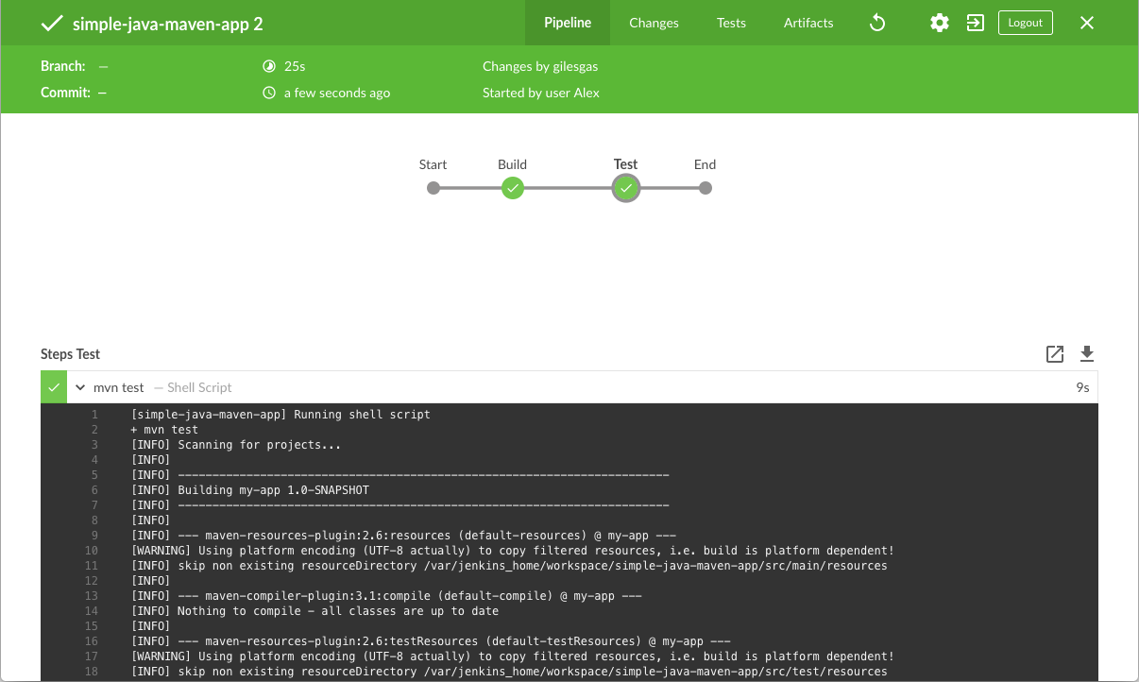

1. Click the **X** at the top-right to return to the main Blue Ocean interface.

### Add a final deliver stage to your Pipeline

1. Go back to your text editor/IDE and ensure your Jenkinsfile is open.
2. Copy and paste the following Declarative Pipeline syntax immediately under the Test stage of your Jenkinsfile:
3. stage('Deliver') {
4. steps {
5. sh './jenkins/scripts/deliver.sh'
6. }

}

so that you end up with:

pipeline {

agent {

docker {

image 'maven:3-alpine'

args '-v /root/.m2:/root/.m2'

}

}

stages {

stage('Build') {

steps {

sh 'mvn -B -DskipTests clean package'

}

}

stage('Test') {

steps {

sh 'mvn test'

}

post {

always {

junit 'target/surefire-reports/*.xml'

}

}

}

stage('Deliver') {

steps {

sh './jenkins/scripts/deliver.sh'

}

}

}

}

|  |  |
| --- | --- |
|  | Defines a new stage called Deliver that appears on the Jenkins UI. |
|  | This sh step (of the steps section) runs the shell script deliver.sh located in the jenkins/scripts directory from the root of the simple-java-maven-app repository. Explanations about what this script does are covered in the deliver.sh file itself. As a general principle, it’s a good idea to keep your Pipeline code (i.e. the Jenkinsfile) as tidy as possible and place more complex build steps (particularly for stages consisting of 2 or more steps) into separate shell script files like the deliver.sh file. This ultimately makes maintaining your Pipeline code easier, especially if your Pipeline gains more complexity. |

1. Save your edited Jenkinsfile and commit it to your local simple-java-maven-app Git repository. E.g. Within the simple-java-maven-app directory, run the commands:  
   git stage .  
   then  
   git commit -m "Add 'Deliver' stage"
2. Go back to Jenkins again, log in again if necessary and ensure you’ve accessed Jenkins’s Blue Ocean interface.
3. Click **Run** at the top left, then quickly click the **OPEN** link which appears briefly at the lower-right to see Jenkins running your amended Pipeline project. If you weren’t able to click the **OPEN** link, click the top row on the Blue Ocean interface to access this feature.  
   If your amended Pipeline ran successfully, here’s what the Blue Ocean interface should look like. Notice the additional "Deliver" stage. Click on the previous "Test" and "Build" stage circles to access the outputs from those stages.

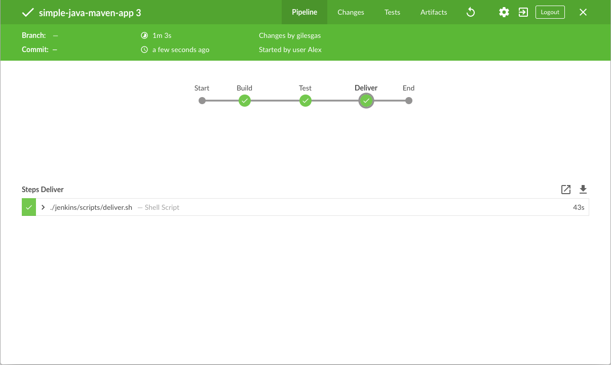

Here’s what the output of the "Deliver" stage should look like, showing you the execution results of your Java application at the end.

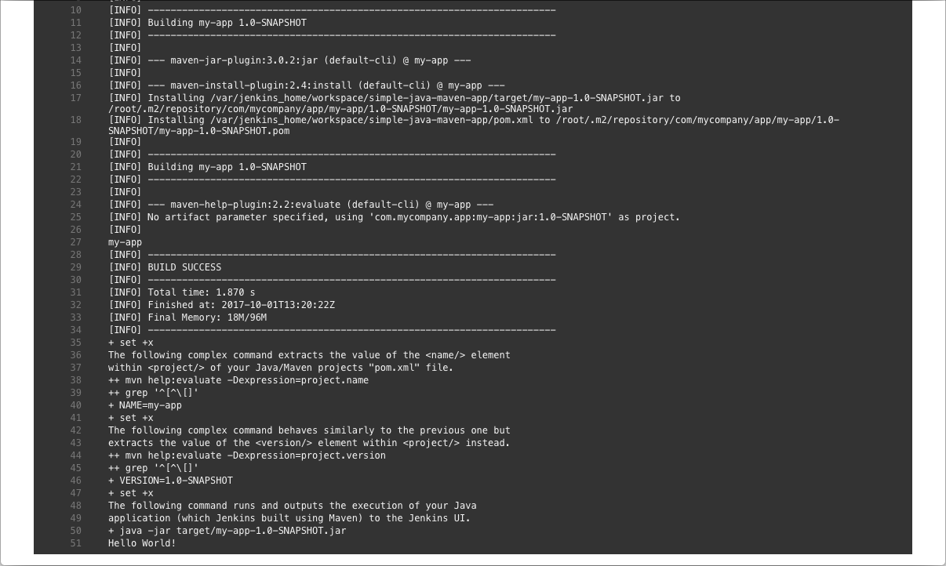

1. Click the **X** at the top-right to return to the main Blue Ocean interface, which lists your previous Pipeline runs in reverse chronological order.

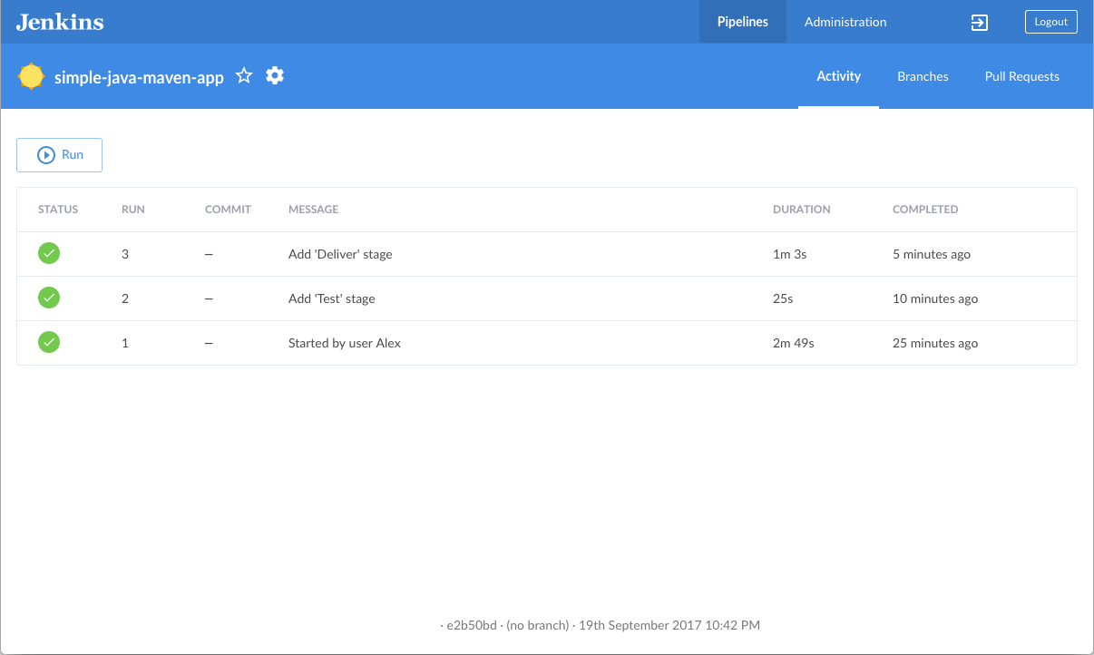

# Build a Node.js and React app with npm

This tutorial shows you how to use Jenkins to orchestrate building a simpleNode.js and React application with the Node Package Manager (npm).

If you are a Node.js and React developer who is new to CI/CD concepts, or you might be familiar with these concepts but don’t know how to implement building your application using Jenkins, then this tutorial is for you.

The simple Node.js and React application (which you’ll obtain from a sample repository on GitHub) generates a web page with the content "Welcome to React" and is accompanied by a test to check that the application renders satisfactorily.

**Duration:** This tutorial takes 20-40 minutes to complete (assuming you’ve already met the prerequisites below). The exact duration will depend on the speed of your machine and whether or not you’ve already run Jenkins in Docker from another tutorial.

You can stop this tutorial at any point in time and continue from where you left off.

If you’ve already run though another tutorial, you can skip the Prerequisites and Run Jenkins in Docker sections below and proceed on to forking the sample repository. (Just ensure you have Git installed locally.) If you need to restart Jenkins, simply follow the restart instructions in Stopping and restarting Jenkins and then proceed on.

### Prerequisites

For this tutorial, you will require:

* A macOS, Linux or Windows machine with:
  + 256 MB of RAM, although more than 512MB is recommended.
  + 10 GB of drive space for Jenkins and your Docker images and containers.
* The following software installed:
  + Docker - Read more about installing Docker in the Installing Docker section of the Installing Jenkins page.  
    **Note:** If you use Linux, this tutorial assumes that you are not running Docker commands as the root user, but instead with a single user account that also has access to the other tools used throughout this tutorial.
  + Git and optionally GitHub Desktop.

### Run Jenkins in Docker

In this tutorial, you’ll be running Jenkins as a Docker container from the jenkinsci/blueocean Docker image.

To run Jenkins in Docker, follow the relevant instructions below for either macOS and Linux or Windows.

You can read more about Docker container and image concepts in the Docker and Downloading and running Jenkins in Dockersections of the Installing Jenkins page.

#### On macOS and Linux

1. Open up a terminal window.
2. Run the jenkinsci/blueocean image as a container in Docker using the following docker run command (bearing in mind that this command automatically downloads the image if this hasn’t been done):
3. docker run \
4. --rm \
5. -u root \
6. -p 8080:8080 \
7. -v jenkins-data:/var/jenkins_home \
8. -v /var/run/docker.sock:/var/run/docker.sock \
9. -v "$HOME":/home \

jenkinsci/blueocean

|  |  |
| --- | --- |
|  | Maps the /var/jenkins_home directory in the container to the Docker volume with the name jenkins-data. If this volume does not exist, then this docker run command will automatically create the volume for you. |
|  | Maps the $HOME directory on the host (i.e. your local) machine (usually the /Users/<your-username> directory) to the /home directory in the container. |

**Note:** If copying and pasting the command snippet above doesn’t work, try copying and pasting this annotation-free version here:

docker run \

--rm \

-u root \

-p 8080:8080 \

-v jenkins-data:/var/jenkins_home \

-v /var/run/docker.sock:/var/run/docker.sock \

-v "$HOME":/home \

jenkinsci/blueocean

1. Proceed to the Setup wizard.

#### On Windows

1. Open up a command prompt window.
2. Run the jenkinsci/blueocean image as a container in Docker using the following docker run command (bearing in mind that this command automatically downloads the image if this hasn’t been done):
3. docker run ^
4. --rm ^
5. -u root ^
6. -p 8080:8080 ^
7. -v jenkins-data:/var/jenkins_home ^
8. -v /var/run/docker.sock:/var/run/docker.sock ^
9. -v "%HOMEPATH%":/home ^

jenkinsci/blueocean

For an explanation of these options, refer to the macOS and Linux instructions above.

1. Proceed to the Setup wizard.

#### Accessing the Jenkins/Blue Ocean Docker container

If you have some experience with Docker and you wish or need to access the Jenkins/Blue Ocean Docker container through a terminal/command prompt using the docker exec command, you can add an option like --name jenkins-tutorials (with the docker run above), which would give the Jenkins/Blue Ocean Docker container the name "jenkins-tutorials".

This means you could access the Jenkins/Blue Ocean container (through a separate terminal/command prompt window) with a docker exec command like:

docker exec -it jenkins-tutorials bash

#### Setup wizard

Before you can access Jenkins, there are a few quick "one-off" steps you’ll need to perform.

##### **Unlocking Jenkins**

When you first access a new Jenkins instance, you are asked to unlock it using an automatically-generated password.

1. After the 2 sets of asterisks appear in the terminal/command prompt window, browse to http://localhost:8080 and wait until the **Unlock Jenkins** page appears.



1. From your terminal/command prompt window again, copy the automatically-generated alphanumeric password (between the 2 sets of asterisks).



1. On the **Unlock Jenkins** page, paste this password into the **Administrator password** field and click **Continue**.

##### **Customizing Jenkins with plugins**

After unlocking Jenkins, the **Customize Jenkins** page appears.

On this page, click **Install suggested plugins**.

The setup wizard shows the progression of Jenkins being configured and the suggested plugins being installed. This process may take a few minutes.

##### **Creating the first administrator user**

Finally, Jenkins asks you to create your first administrator user.

1. When the **Create First Admin User** page appears, specify your details in the respective fields and click **Save and Finish**.
2. When the **Jenkins is ready** page appears, click **Start using Jenkins**.  
   **Notes:**
   * This page may indicate **Jenkins is almost ready!** instead and if so, click **Restart**.
   * If the page doesn’t automatically refresh after a minute, use your web browser to refresh the page manually.
3. If required, log in to Jenkins with the credentials of the user you just created and you’re ready to start using Jenkins!

#### Stopping and restarting Jenkins

Throughout the remainder of this tutorial, you can stop the Jenkins/Blue Ocean Docker container by typing Ctrl-C in the terminal/command prompt window from which you ran the docker run ... command above.

To restart the Jenkins/Blue Ocean Docker container:

1. Run the same docker run ... command you ran for macOS, Linux or Windows above.  
   **Note:** This process also updates the jenkinsci/blueocean Docker image, if an updated one is available.
2. Browse to http://localhost:8080.
3. Wait until the log in page appears and log in.

### Fork and clone the sample repository on GitHub

Obtain the simple "Welcome to React" Node.js and React application from GitHub, by forking the sample repository of the application’s source code into your own GitHub account and then cloning this fork locally.

1. Ensure you are signed in to your GitHub account. If you don’t yet have a GitHub account, sign up for a free one on the GitHub website.
2. Fork the simple-node-js-react-npm-app on GitHub into your local GitHub account. If you need help with this process, refer to the Fork A Repo documentation on the GitHub website for more information.
3. Clone your forked simple-node-js-react-npm-app repository (on GitHub) locally to your machine. To begin this process, do either of the following (where <your-username> is the name of your user account on your operating system):
   * If you have the GitHub Desktop app installed on your machine:
     1. In GitHub, click the green **Clone or download** button on your forked repository, then **Open in Desktop**.
     2. In GitHub Desktop, before clicking **Clone** on the **Clone a Repository** dialog box, ensure **Local Path** for:
        + macOS is /Users/<your-username>/Documents/GitHub/simple-node-js-react-npm-app
        + Linux is /home/<your-username>/GitHub/simple-node-js-react-npm-app
        + Windows is C:\Users\<your-username>\Documents\GitHub\simple-node-js-react-npm-app
   * Otherwise:
     1. Open up a terminal/command line prompt and cd to the appropriate directory on:
        + macOS - /Users/<your-username>/Documents/GitHub/
        + Linux - /home/<your-username>/GitHub/
        + Windows - C:\Users\<your-username>\Documents\GitHub\ (although use a Git bash command line window as opposed to the usual Microsoft command prompt)
     2. Run the following command to continue/complete cloning your forked repo:  
        git clone https://github.com/YOUR-GITHUB-ACCOUNT-NAME/simple-node-js-react-npm-app  
        where YOUR-GITHUB-ACCOUNT-NAME is the name of your GitHub account.

### Create your Pipeline project in Jenkins

1. Go back to Jenkins, log in again if necessary and click **create new jobs** under **Welcome to Jenkins!**  
   **Note:** If you don’t see this, click **New Item** at the top left.
2. In the **Enter an item name** field, specify the name for your new Pipeline project (e.g. simple-node-js-react-npm-app).
3. Scroll down and click **Pipeline**, then click **OK** at the end of the page.
4. ( Optional ) On the next page, specify a brief description for your Pipeline in the **Description** field (e.g. An entry-level Pipeline demonstrating how to use Jenkins to build a simple Node.js and React application with npm.)
5. Click the **Pipeline** tab at the top of the page to scroll down to the **Pipeline** section.
6. From the **Definition** field, choose the **Pipeline script from SCM** option. This option instructs Jenkins to obtain your Pipeline from Source Control Management (SCM), which will be your locally cloned Git repository.
7. From the **SCM** field, choose **Git**.
8. In the **Repository URL** field, specify the directory path of your locally cloned repository above, which is from your user account/home directory on your host machine, mapped to the /home directory of the Jenkins container - i.e.
   * For macOS - /home/Documents/GitHub/simple-node-js-react-npm-app
   * For Linux - /home/GitHub/simple-node-js-react-npm-app
   * For Windows - /home/Documents/GitHub/simple-node-js-react-npm-app
9. Click **Save** to save your new Pipeline project. You’re now ready to begin creating your Jenkinsfile, which you’ll be checking into your locally cloned Git repository.

### Create your initial Pipeline as a Jenkinsfile

You’re now ready to create your Pipeline that will automate building your Node.js and React application in Jenkins. Your Pipeline will be created as a Jenkinsfile, which will be committed to your locally cloned Git repository (simple-node-js-react-npm-app).

This is the foundation of "Pipeline-as-Code", which treats the continuous delivery pipeline as a part of the application to be versioned and reviewed like any other code. Read more about Pipeline and what a Jenkinsfile is in the Pipeline and Using a Jenkinsfile sections of the User Handbook.

First, create an initial Pipeline to download a Node Docker image and run it as a Docker container (which will build your simple Node.js and React application). Also add a "Build" stage to the Pipeline that begins orchestrating this whole process.

1. Using your favorite text editor or IDE, create and save new text file with the name Jenkinsfile at the root of your local simple-node-js-react-npm-app Git repository.
2. Copy the following Declarative Pipeline code and paste it into your empty Jenkinsfile:
3. pipeline {
4. agent {
5. docker {
6. image 'node:6-alpine'
7. args '-p 3000:3000'
8. }
9. }
10. stages {
11. stage('Build') {
12. steps {
13. sh 'npm install'
14. }
15. }
16. }

}

|  |  |
| --- | --- |
|  | This image parameter (of the agent section’s docker parameter) downloads the node:6-alpine Docker image (if it’s not already available on your machine) and runs this image as a separate container. This means that:   * + You’ll have separate Jenkins and Node containers running locally in Docker.   + The Node container becomes the agent that Jenkins uses to run your Pipeline project. However, this container is short-lived - its lifespan is only that of the duration of your Pipeline’s execution. |
|  | This args parameter makes the Node container (temporarily) accessible through port 3000. The significance of this is explained in the jenkins/scripts/deliver.sh file of your cloned repository, and is covered in a subsequent section of this tutorial. |
|  | Defines a stage (directive) called Build that appears on the Jenkins UI. |
|  | This sh step (of the steps section) executes the npm command to ensure that all dependencies required to run your application have been downloaded to the node_modules workspace directory (within the /var/jenkins_home/workspace/simple-node-js-react-npm-app directory in the Jenkins container). |

1. Save your edited Jenkinsfile and commit it to your local simple-node-js-react-npm-app Git repository. E.g. Within thesimple-node-js-react-npm-app directory, run the commands:  
   git add .  
   then  
   git commit -m "Add initial Jenkinsfile"
2. Go back to Jenkins again, log in again if necessary and click **Open Blue Ocean** on the left to access Jenkins’s Blue Ocean interface.
3. In the **This job has not been run** message box, click **Run**, then quickly click the **OPEN** link which appears briefly at the lower-right to see Jenkins building your Pipeline project. If you weren’t able to click the **OPEN** link, click the row on the main Blue Ocean interface to access this feature.  
   **Note:** You may need to wait several minutes for this first run to complete. After making a clone of your local simple-node-js-react-npm-app Git repository itself, Jenkins:
   * Initially queues the project to be run on the agent.
   * Downloads the Node Docker image and runs it in a container on Docker.

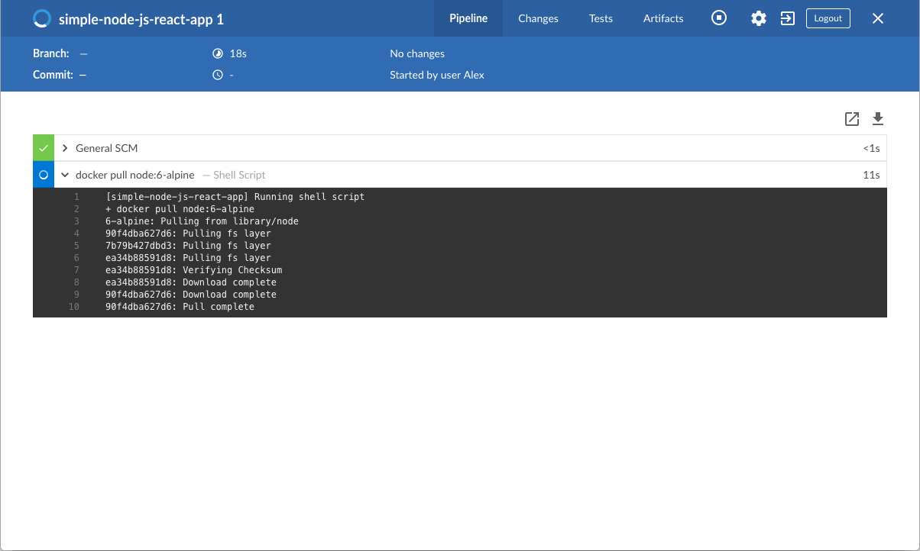

* + Runs the Build stage (defined in the Jenkinsfile) on the Node container. During this time, npm downloads many dependencies necessary to run your Node.js and React application, which will ultimately be stored in thenode_modules workspace directory (within the Jenkins home directory).

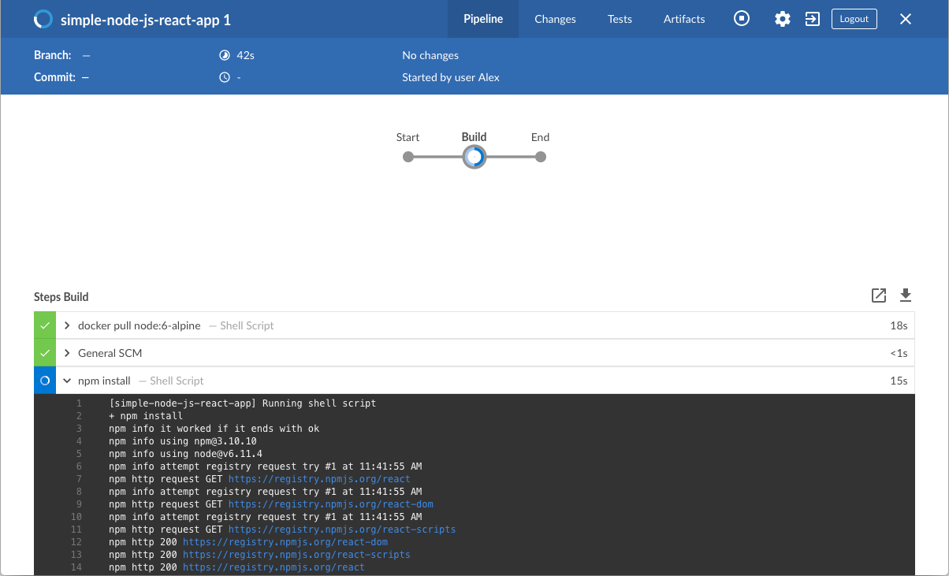

1. The Blue Ocean interface turns green if Jenkins built your Node.js and React application successfully.
2. 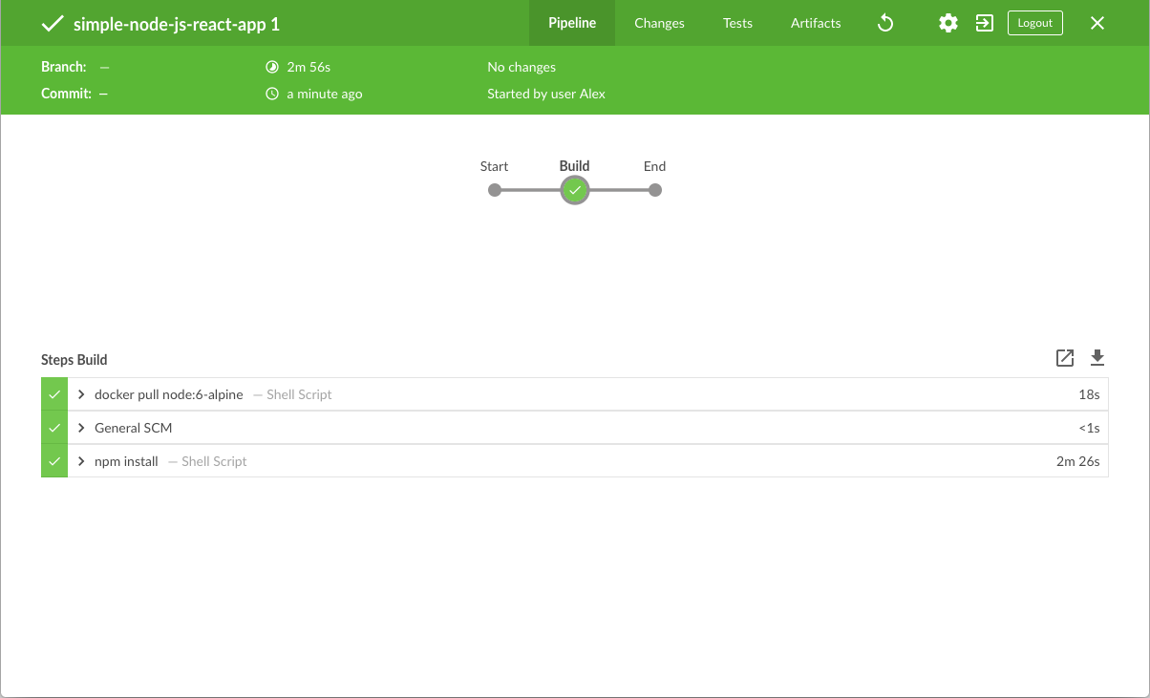
3. Click the **X** at the top-right to return to the main Blue Ocean interface.

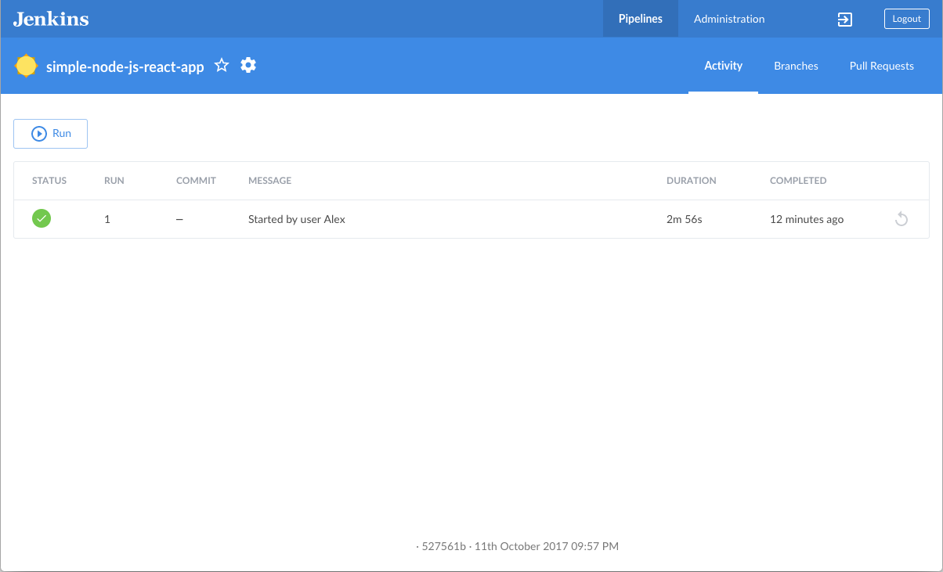

### Add a test stage to your Pipeline

1. Go back to your text editor/IDE and ensure your Jenkinsfile is open.
2. Copy and paste the following Declarative Pipeline syntax immediately under the agent section of your Jenkinsfile:
3. environment {
4. CI = 'true'

}

as well as the following immediately under the Build stage:

stage('Test') {

steps {

sh './jenkins/scripts/test.sh'

}

}

so that you end up with:

pipeline {

agent {

docker {

image 'node:6-alpine'

args '-p 3000:3000'

}

}

environment {

CI = 'true'

}

stages {

stage('Build') {

steps {

sh 'npm install'

}

}

stage('Test') {

steps {

sh './jenkins/scripts/test.sh'

}

}

}

}

|  |  |
| --- | --- |
|  | The environment directive sets the environment variable CI with a boolean value of true, which is available to all steps in this Pipeline. When the npm test command in test.sh (which is run during the Test stage defined further down the Pipeline) detects the environment variable CI with a value of true, then this command is run in "non-watch" (i.e. non-interactive) mode. In "watch" mode, npm test expects user input, which can pause running builds of CI/CD applications indefinitely. As an alternative to specifying the environment directive in a Jenkins Pipeline, you could also specify this environment variable in the package.json file (to pass on to the npm test command) by:   * 1. Uncommenting the npm install --save-dev cross-env command in jenkins/scripts/test.sh (to install the cross-env dependency during the Test stage). Read more about this in the test.sh file itself.   2. Updating the following line in the package.json file (at the root of the simple-node-js-react-npm-apprepository) from:      + "test": "react-scripts test --env=jsdom", to      + "test": "cross-env CI=true react-scripts test --env=jsdom", |
|  | Defines a stage (directive) called Test that appears on the Jenkins UI. |
|  | This sh step (of the steps section) runs the shell script test.sh located in the jenkins/scripts directory from the root of the simple-node-js-react-npm-app repository. Explanations about what this script does are covered in the test.sh file itself. As a general principle, it’s a good idea to keep your Pipeline code (i.e. the Jenkinsfile) as tidy as possible and place more complex build scripting steps into separate shell script files like the test.sh file. This ultimately facilitates the maintenance of your Pipeline, especially if it gains more complexity. |

1. Save your edited Jenkinsfile and commit it to your local simple-node-js-react-npm-app Git repository. E.g. Within thesimple-node-js-react-npm-app directory, run the commands:  
   git stage .  
   then  
   git commit -m "Add 'Test' stage"
2. Go back to Jenkins again, log in again if necessary and ensure you’ve accessed Jenkins’s Blue Ocean interface.
3. Click **Run** at the top left, then quickly click the **OPEN** link which appears briefly at the lower-right to see Jenkins running your amended Pipeline project. If you weren’t able to click the **OPEN** link, click the top row on the Blue Ocean interface to access this feature.  
   **Note:** You’ll notice from this run that Jenkins no longer needs to download the Node Docker image. Instead, Jenkins only needs to run a new container from the Node image downloaded previously. Also, from now on, no (new) npm dependencies should need to be downloaded during the "Build" stage. Therefore, running your Pipeline this subsequent time should be much faster.  
   If your amended Pipeline ran successfully, here’s what the Blue Ocean interface should look like. Notice the additional "Test" stage. You can click on the previous "Build" stage circle to access the output from that stage.

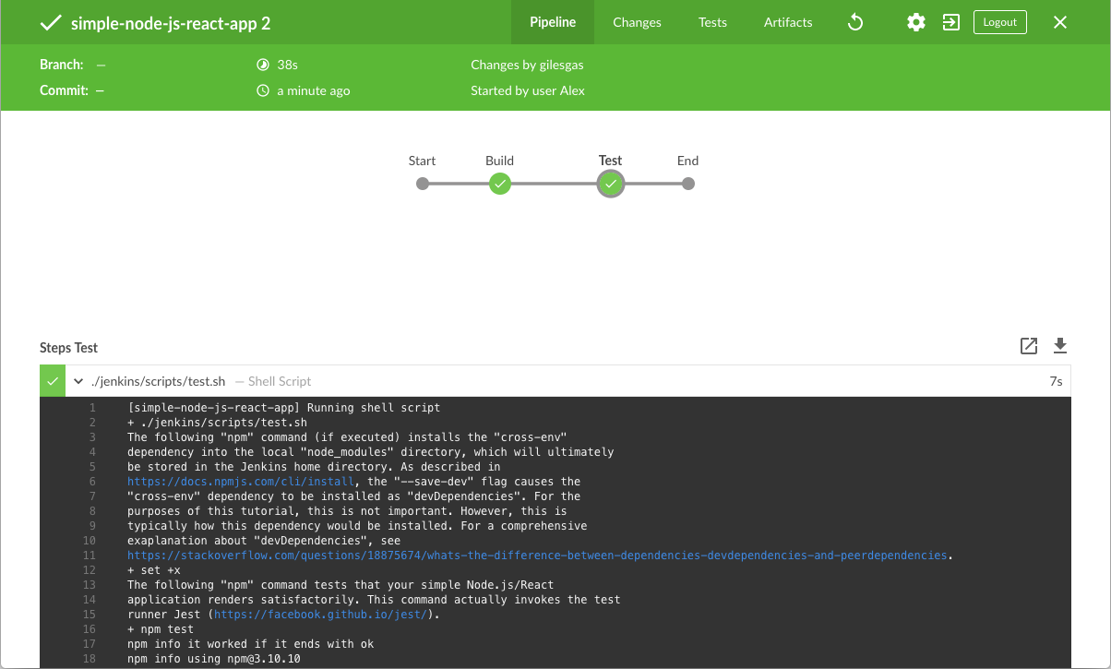

1. Click the **X** at the top-right to return to the main Blue Ocean interface.

### Add a final deliver stage to your Pipeline

1. Go back to your text editor/IDE and ensure your Jenkinsfile is open.
2. Copy and paste the following Declarative Pipeline syntax immediately under the Test stage of your Jenkinsfile:
3. stage('Deliver') {
4. steps {
5. sh './jenkins/scripts/deliver.sh'
6. input message: 'Finished using the web site? (Click "Proceed" to continue)'
7. sh './jenkins/scripts/kill.sh'
8. }

}

so that you end up with:

pipeline {

agent {

docker {

image 'node:6-alpine'

args '-p 3000:3000'

}

}

environment {

CI = 'true'

}

stages {

stage('Build') {

steps {

sh 'npm install'

}

}

stage('Test') {

steps {

sh './jenkins/scripts/test.sh'

}

}

stage('Deliver') {

steps {

sh './jenkins/scripts/deliver.sh'

input message: 'Finished using the web site? (Click "Proceed" to continue)'

sh './jenkins/scripts/kill.sh'

}

}

}

}

|  |  |
| --- | --- |
|  | This environment directive might not be present in your Pipeline if you chose to specify the CI environment variable in the package.json file above. |
|  | Defines a new stage called Deliver that appears on the Jenkins UI. |
|  | This sh step (of the steps section) runs the shell script deliver.sh located in the jenkins/scripts directory from the root of the simple-node-js-react-npm-app repository. Explanations about what this script does are covered in the deliver.sh file itself. |
|  | This input step (provided by the Pipeline: Input Step plugin) pauses the running build and prompts the user (with a custom message) to proceed or abort. |
|  | This sh step runs the shell script kill.sh, also located in the jenkins/scripts directory. Explanations about what this script does are covered in the kill.sh file itself. |

1. Save your edited Jenkinsfile and commit it to your local simple-node-js-react-npm-app Git repository. E.g. Within thesimple-node-js-react-npm-app directory, run the commands:  
   git stage .  
   then  
   git commit -m "Add 'Deliver' stage"
2. Go back to Jenkins again, log in again if necessary and ensure you’ve accessed Jenkins’s Blue Ocean interface.
3. Click **Run** at the top left, then quickly click the **OPEN** link which appears briefly at the lower-right to see Jenkins running your amended Pipeline project. If you weren’t able to click the **OPEN** link, click the top row on the Blue Ocean interface to access this feature.  
   If your amended Pipeline ran successfully, here’s what the Blue Ocean interface should look like. Notice the additional "Deliver" stage. Click on the previous "Test" and "Build" stage circles to access the outputs from those stages.

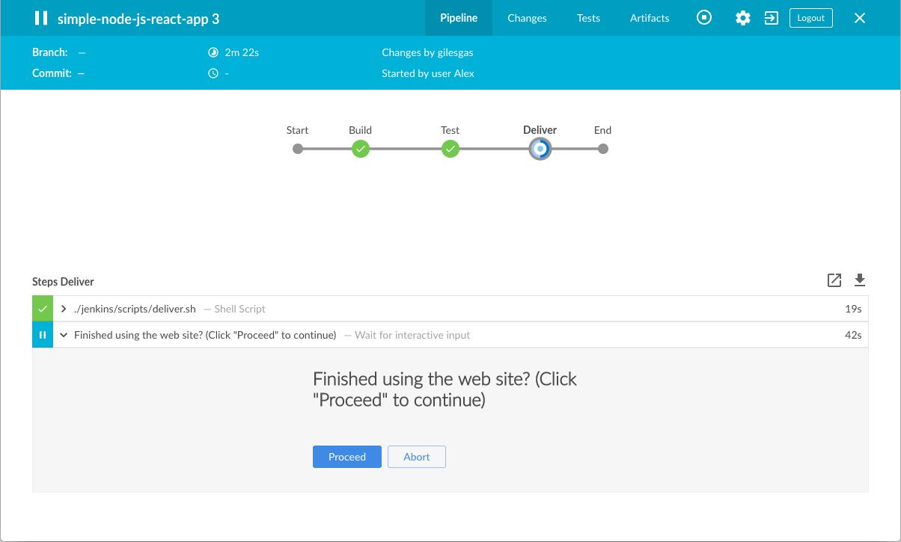

1. Ensure you are viewing the "Deliver" stage (click it if necessary), then click the green **./jenkins/scripts/deliver.sh** step to expand its content and scroll down until you see the http://localhost:3000 link.

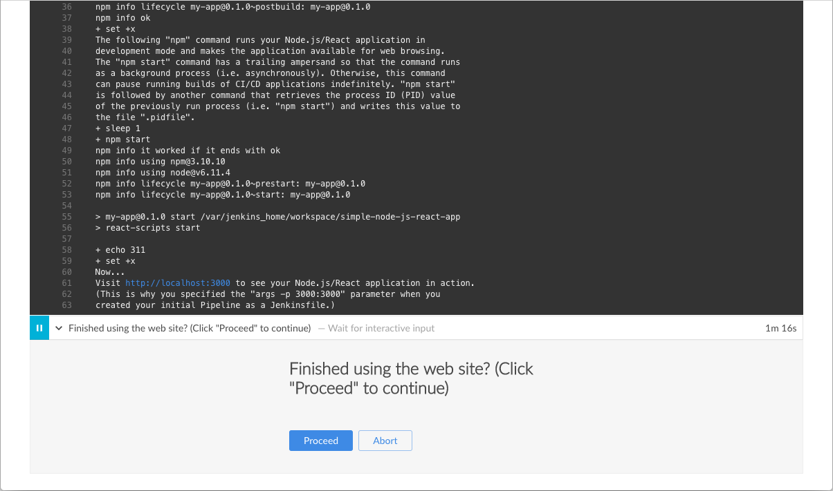

1. Click the http://localhost:3000 link to view your Node.js and React application running (in development mode) in a new web browser tab. You should see a page/site with the title **Welcome to React** on it.  
   **Tip:** If you’re feeling a little adventurous, you can try accessing the terminal/command prompt of your Jenkins Docker container, then using vi editor, tweak and save the App.js source file and see the results appear on the **Welcome to React**page. To do this, run the following commands:
2. docker exec -it <docker-container-name> bash
3. cd /var/jenkins_home/workspace/simple-node-js-react-npm-app/src

vi App.js

|  |  |
| --- | --- |
|  | This command provides access to the terminal/command prompt of your Jenkins Docker container. The <docker-container-name> can be obtained using the command docker ps. Otherwise, it would be jenkins-tutorials (if you specified this in the command you used to run this container above - i.e. --name jenkins-tutorials). |
|  | Once in the container, change directory to the Node.js and React source directory (in the Jenkins workspace directory within Jenkins home). |
|  | Access, edit and save changes to your application’s App.js file using vi editor. |

1. When you are finished viewing the page/site, click the **Proceed** button to complete the Pipeline’s execution.

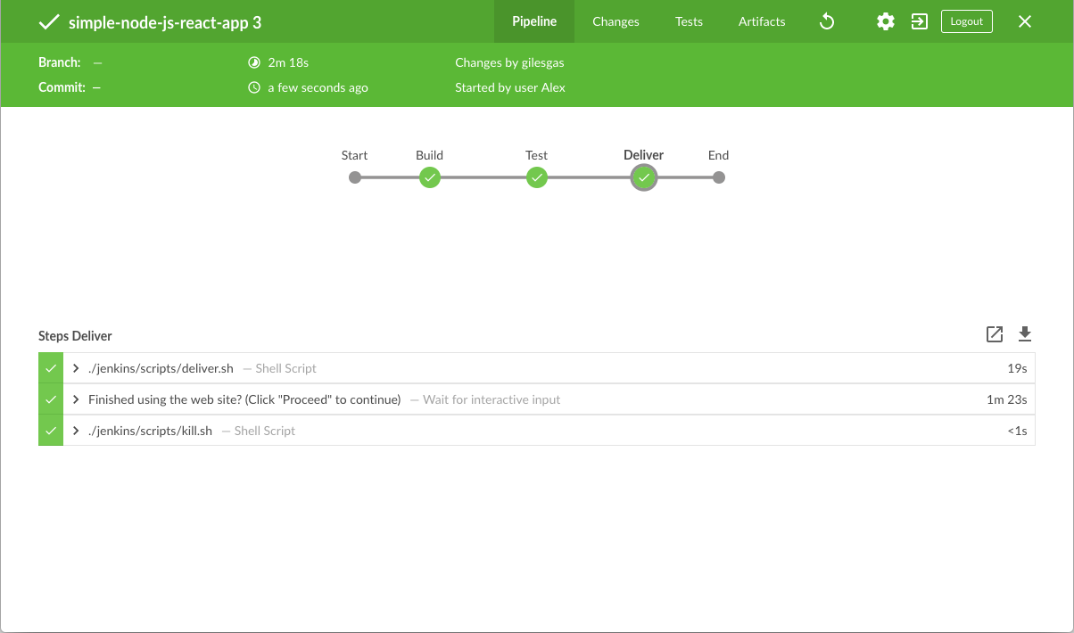

1. Click the **X** at the top-right to return to the main Blue Ocean interface, which lists your previous Pipeline runs in reverse chronological order.

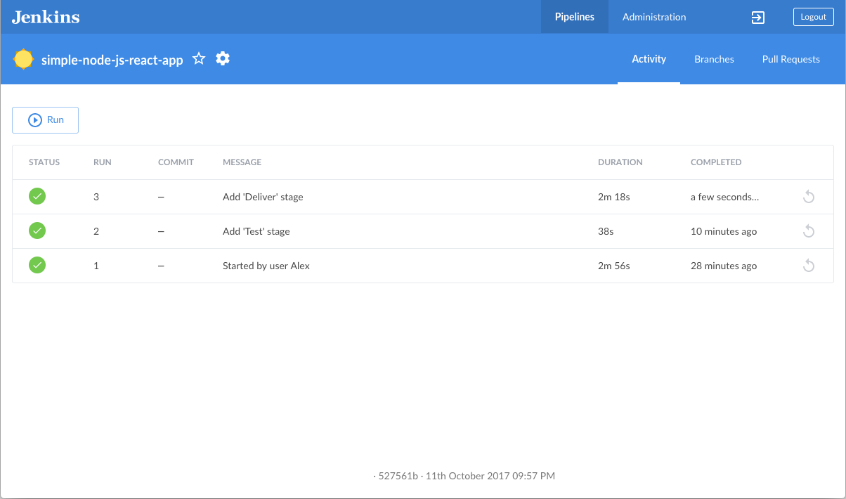

# Build a Python app with PyInstaller

If you are a Python developer who is new to CI/CD concepts, or you might be familiar with these concepts but don’t know how to implement building your application using Jenkins, then this tutorial is for you.

The simple Python application (which you’ll obtain from a sample repository on GitHub) is a command line tool "add2vals" that outputs the addition of two values. If at least one of the values is a string, "add2vals" treats both values as a string and instead concatenates the values. The "add2" function in the "calc" library (which "add2vals" imports) is accompanied by a set of unit tests. These are tested with pytest to check that this function works as expected and the results are saved to a JUnit XML report.

The delivery of the "add2vals" tool through PyInstaller converts this tool into a standalone executable file for Linux, which you can download through Jenkins and execute at the command line on Linux machines without Python.

**Note:** Unlike the other tutorials in this documentation, this tutorial requires approximately 500 MB more Docker image data to be downloaded.

**Duration:** This tutorial takes 20-40 minutes to complete (assuming you’ve already met the prerequisites below). The exact duration will depend on the speed of your machine and whether or not you’ve already run Jenkins in Docker from another tutorial.

You can stop this tutorial at any point in time and continue from where you left off.

If you’ve already run though another tutorial, you can skip the Prerequisites and Run Jenkins in Docker sections below and proceed on to forking the sample repository. (Just ensure you have Git installed locally.) If you need to restart Jenkins, simply follow the restart instructions in Stopping and restarting Jenkins and then proceed on.

### Prerequisites

For this tutorial, you will require:

* A macOS, Linux or Windows machine with:
  + 256 MB of RAM, although more than 512MB is recommended.
  + 10 GB of drive space for Jenkins and your Docker images and containers.
* The following software installed:
  + Docker - Read more about installing Docker in the Installing Docker section of the Installing Jenkins page.  
    **Note:** If you use Linux, this tutorial assumes that you are not running Docker commands as the root user, but instead with a single user account that also has access to the other tools used throughout this tutorial.
  + Git and optionally GitHub Desktop

### Run Jenkins in Docker

In this tutorial, you’ll be running Jenkins as a Docker container from the jenkinsci/blueocean Docker image.

To run Jenkins in Docker, follow the relevant instructions below for either macOS and Linux or Windows.

You can read more about Docker container and image concepts in the Docker and Downloading and running Jenkins in Dockersections of the Installing Jenkins page.

#### On macOS and Linux

1. Open up a terminal window.
2. Run the jenkinsci/blueocean image as a container in Docker using the following docker run command (bearing in mind that this command automatically downloads the image if this hasn’t been done):
3. docker run \
4. --rm \
5. -u root \
6. -p 8080:8080 \
7. -v jenkins-data:/var/jenkins_home \
8. -v /var/run/docker.sock:/var/run/docker.sock \
9. -v "$HOME":/home \

jenkinsci/blueocean

|  |  |
| --- | --- |
|  | Maps the /var/jenkins_home directory in the container to the Docker volume with the name jenkins-data. If this volume does not exist, then this docker run command will automatically create the volume for you. |
|  | Maps the $HOME directory on the host (i.e. your local) machine (usually the /Users/<your-username> directory) to the /home directory in the container. |

**Note:** If copying and pasting the command snippet above doesn’t work, try copying and pasting this annotation-free version here:

docker run \

--rm \

-u root \

-p 8080:8080 \

-v jenkins-data:/var/jenkins_home \

-v /var/run/docker.sock:/var/run/docker.sock \

-v "$HOME":/home \

jenkinsci/blueocean

1. Proceed to the Setup wizard.

#### On Windows

1. Open up a command prompt window.
2. Run the jenkinsci/blueocean image as a container in Docker using the following docker run command (bearing in mind that this command automatically downloads the image if this hasn’t been done):
3. docker run ^
4. --rm ^
5. -u root ^
6. -p 8080:8080 ^
7. -v jenkins-data:/var/jenkins_home ^
8. -v /var/run/docker.sock:/var/run/docker.sock ^
9. -v "%HOMEPATH%":/home ^

jenkinsci/blueocean

For an explanation of these options, refer to the macOS and Linux instructions above.

1. Proceed to the Setup wizard.

#### Accessing the Jenkins/Blue Ocean Docker container

If you have some experience with Docker and you wish or need to access the Jenkins/Blue Ocean Docker container through a terminal/command prompt using the docker exec command, you can add an option like --name jenkins-tutorials (with the docker run above), which would give the Jenkins/Blue Ocean Docker container the name "jenkins-tutorials".

This means you could access the Jenkins/Blue Ocean container (through a separate terminal/command prompt window) with a docker exec command like:

docker exec -it jenkins-tutorials bash

#### Setup wizard

Before you can access Jenkins, there are a few quick "one-off" steps you’ll need to perform.

##### **Unlocking Jenkins**

When you first access a new Jenkins instance, you are asked to unlock it using an automatically-generated password.

1. After the 2 sets of asterisks appear in the terminal/command prompt window, browse to http://localhost:8080 and wait until the **Unlock Jenkins** page appears.



1. From your terminal/command prompt window again, copy the automatically-generated alphanumeric password (between the 2 sets of asterisks).



1. On the **Unlock Jenkins** page, paste this password into the **Administrator password** field and click **Continue**.

##### **Customizing Jenkins with plugins**

After unlocking Jenkins, the **Customize Jenkins** page appears.

On this page, click **Install suggested plugins**.

The setup wizard shows the progression of Jenkins being configured and the suggested plugins being installed. This process may take a few minutes.

##### **Creating the first administrator user**

Finally, Jenkins asks you to create your first administrator user.

1. When the **Create First Admin User** page appears, specify your details in the respective fields and click **Save and Finish**.
2. When the **Jenkins is ready** page appears, click **Start using Jenkins**.  
   **Notes:**
   * This page may indicate **Jenkins is almost ready!** instead and if so, click **Restart**.
   * If the page doesn’t automatically refresh after a minute, use your web browser to refresh the page manually.
3. If required, log in to Jenkins with the credentials of the user you just created and you’re ready to start using Jenkins!

#### Stopping and restarting Jenkins

Throughout the remainder of this tutorial, you can stop the Jenkins/Blue Ocean Docker container by typing Ctrl-C in the terminal/command prompt window from which you ran the docker run ... command above.

To restart the Jenkins/Blue Ocean Docker container:

1. Run the same docker run ... command you ran for macOS, Linux or Windows above.  
   **Note:** This process also updates the jenkinsci/blueocean Docker image, if an updated one is available.
2. Browse to http://localhost:8080.
3. Wait until the log in page appears and log in.

### Fork and clone the sample repository on GitHub

Obtain the simple "add" Python application from GitHub, by forking the sample repository of the application’s source code into your own GitHub account and then cloning this fork locally.

1. Ensure you are signed in to your GitHub account. If you don’t yet have a GitHub account, sign up for a free one on the GitHub website.
2. Fork the simple-python-pyinstaller-app on GitHub into your local GitHub account. If you need help with this process, refer to the Fork A Repo documentation on the GitHub website for more information.
3. Clone your forked simple-python-pyinstaller-app repository (on GitHub) locally to your machine. To begin this process, do either of the following (where <your-username> is the name of your user account on your operating system):
   * If you have the GitHub Desktop app installed on your machine:
     1. In GitHub, click the green **Clone or download** button on your forked repository, then **Open in Desktop**.
     2. In GitHub Desktop, before clicking **Clone** on the **Clone a Repository** dialog box, ensure **Local Path** for:
        + macOS is /Users/<your-username>/Documents/GitHub/simple-python-pyinstaller-app
        + Linux is /home/<your-username>/GitHub/simple-python-pyinstaller-app
        + Windows is C:\Users\<your-username>\Documents\GitHub\simple-python-pyinstaller-app
   * Otherwise:
     1. Open up a terminal/command line prompt and cd to the appropriate directory on:
        + macOS - /Users/<your-username>/Documents/GitHub/
        + Linux - /home/<your-username>/GitHub/
        + Windows - C:\Users\<your-username>\Documents\GitHub\ (although use a Git bash command line window as opposed to the usual Microsoft command prompt)
     2. Run the following command to continue/complete cloning your forked repo:  
        git clone https://github.com/YOUR-GITHUB-ACCOUNT-NAME/simple-python-pyinstaller-app  
        where YOUR-GITHUB-ACCOUNT-NAME is the name of your GitHub account.

### Create your Pipeline project in Jenkins

1. Go back to Jenkins, log in again if necessary and click **create new jobs** under **Welcome to Jenkins!**  
   **Note:** If you don’t see this, click **New Item** at the top left.
2. In the **Enter an item name** field, specify the name for your new Pipeline project (e.g. simple-python-pyinstaller-app).
3. Scroll down and click **Pipeline**, then click **OK** at the end of the page.
4. ( Optional ) On the next page, specify a brief description for your Pipeline in the **Description** field (e.g. An entry-level Pipeline demonstrating how to use Jenkins to build a simple Python application with PyInstaller.)
5. Click the **Pipeline** tab at the top of the page to scroll down to the **Pipeline** section.
6. From the **Definition** field, choose the **Pipeline script from SCM** option. This option instructs Jenkins to obtain your Pipeline from Source Control Management (SCM), which will be your locally cloned Git repository.
7. From the **SCM** field, choose **Git**.
8. In the **Repository URL** field, specify the directory path of your locally cloned repository above, which is from your user account/home directory on your host machine, mapped to the /home directory of the Jenkins container - i.e.
   * For macOS - /home/Documents/GitHub/simple-python-pyinstaller-app
   * For Linux - /home/GitHub/simple-python-pyinstaller-app
   * For Windows - /home/Documents/GitHub/simple-python-pyinstaller-app
9. Click **Save** to save your new Pipeline project. You’re now ready to begin creating your Jenkinsfile, which you’ll be checking into your locally cloned Git repository.

### Create your initial Pipeline as a Jenkinsfile

You’re now ready to create your Pipeline that will automate building your Python application with PyInstaller in Jenkins. Your Pipeline will be created as a Jenkinsfile, which will be committed to your locally cloned Git repository (simple-python-pyinstaller-app).

This is the foundation of "Pipeline-as-Code", which treats the continuous delivery pipeline a part of the application to be versioned and reviewed like any other code. Read more about Pipeline and what a Jenkinsfile is in the Pipeline and Using a Jenkinsfile sections of the User Handbook.

First, create an initial Pipeline with a "Build" stage that executes the first part of the entire production process for your application. This "Build" stage downloads a Python Docker image and runs it as a Docker container, which in turn compiles your simple Python application into byte code.

1. Using your favorite text editor or IDE, create and save new text file with the name Jenkinsfile at the root of your local simple-python-pyinstaller-app Git repository.
2. Copy the following Declarative Pipeline code and paste it into your empty Jenkinsfile:
3. pipeline {
4. agent none
5. stages {
6. stage('Build') {
7. agent {
8. docker {
9. image 'python:2-alpine'
10. }
11. }
12. steps {
13. sh 'python -m py_compile sources/add2vals.py sources/calc.py'
14. }
15. }
16. }

}

|  |  |
| --- | --- |
|  | The agent section with the none parameter specified at the top of this Pipeline code block means that no global agent will be allocated for the entire Pipeline’s execution and that each stage directive must specify its own agent section. |
|  | Defines a stage (directive) called Build that appears on the Jenkins UI. |
|  | This image parameter (of the agent section’s docker parameter) downloads the python:2-alpine Docker image (if it’s not already available on your machine) and runs this image as a separate container. This means that:   * + You’ll have separate Jenkins and Python containers running locally in Docker.   + The Python container becomes the agent that Jenkins uses to run the Build stage of your Pipeline project. However, this container is short-lived - its lifespan is only that of the duration of your Build stage’s execution. |
|  | This sh step (of the steps section) runs the Python command to compile your application and its calc library into byte code files (each with .pyc extension), which are placed into the sources workspace directory (within the/var/jenkins_home/workspace/simple-python-pyinstaller-app directory in the Jenkins container). |

1. Save your edited Jenkinsfile and commit it to your local simple-python-pyinstaller-app Git repository. E.g. Within thesimple-python-pyinstaller-app directory, run the commands:  
   git add .  
   then  
   git commit -m "Add initial Jenkinsfile"
2. Go back to Jenkins again, log in again if necessary and click **Open Blue Ocean** on the left to access Jenkins’s Blue Ocean interface.
3. In the **This job has not been run** message box, click **Run**, then quickly click the **OPEN** link which appears briefly at the lower-right to see Jenkins running your Pipeline project. If you weren’t able to click the **OPEN** link, click the row on the main Blue Ocean interface to access this feature.  
   **Note:** You may need to wait a few minutes for this first run to complete. After making a clone of your local simple-python-pyinstaller-app Git repository itself, Jenkins:
   * Initially queues the project to be run on the agent.
   * Downloads the Python Docker image and runs it in a container on Docker.

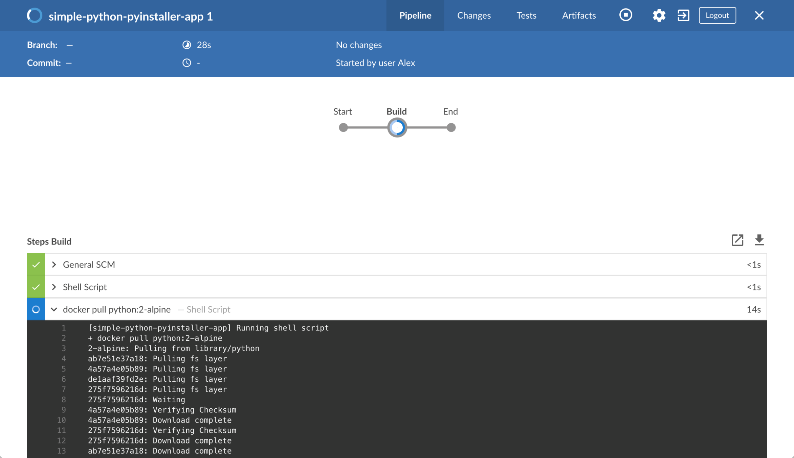

* + Runs the Build stage (defined in the Jenkinsfile) on the Python container. During this time, Python uses the py_compile module to compile the code of your Python application and its calc library into byte code, which are stored in the sources workspace directory (within the Jenkins home directory).

The Blue Ocean interface turns green if Jenkins compiled your Python application successfully.

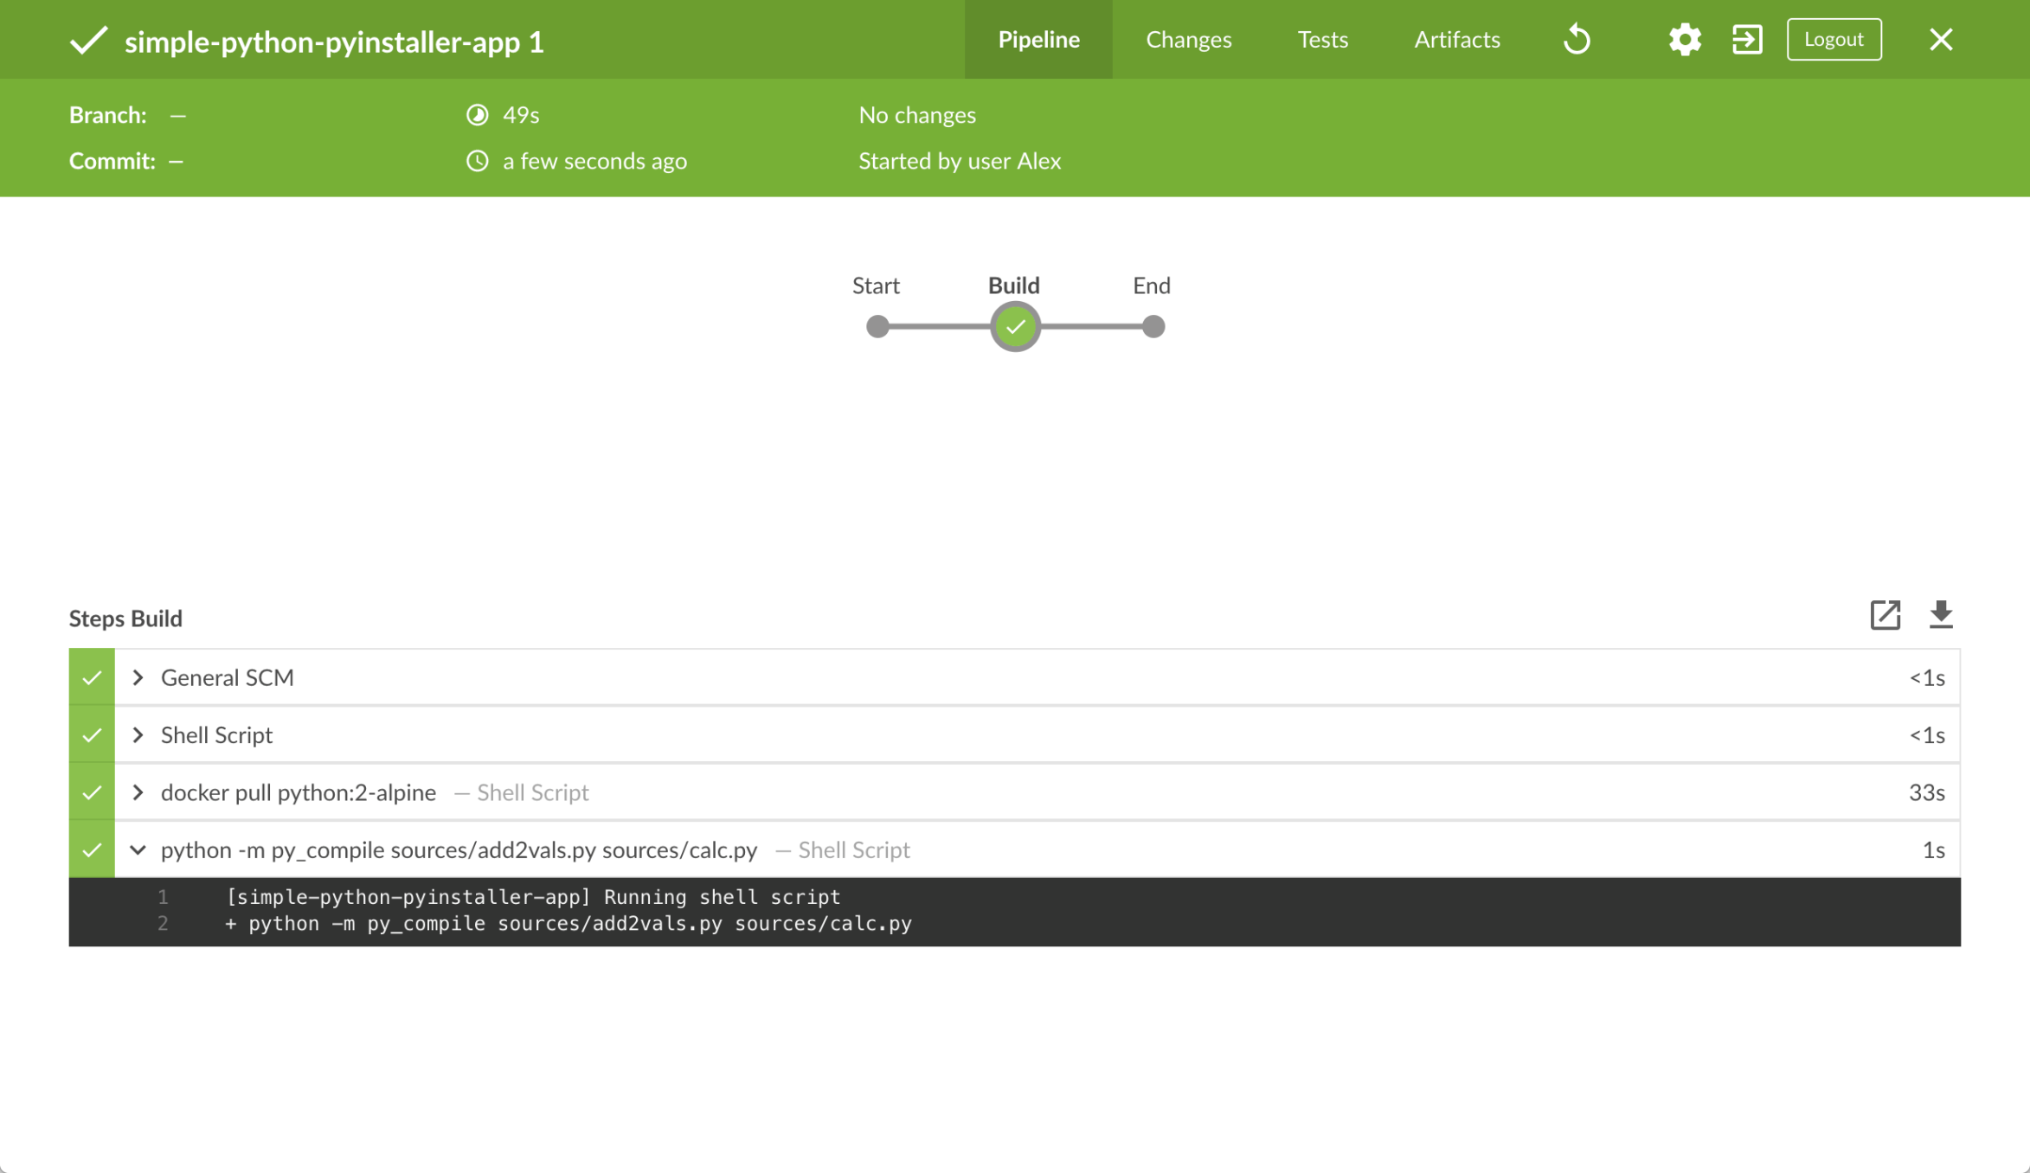

1. Click the **X** at the top-right to return to the main Blue Ocean interface.

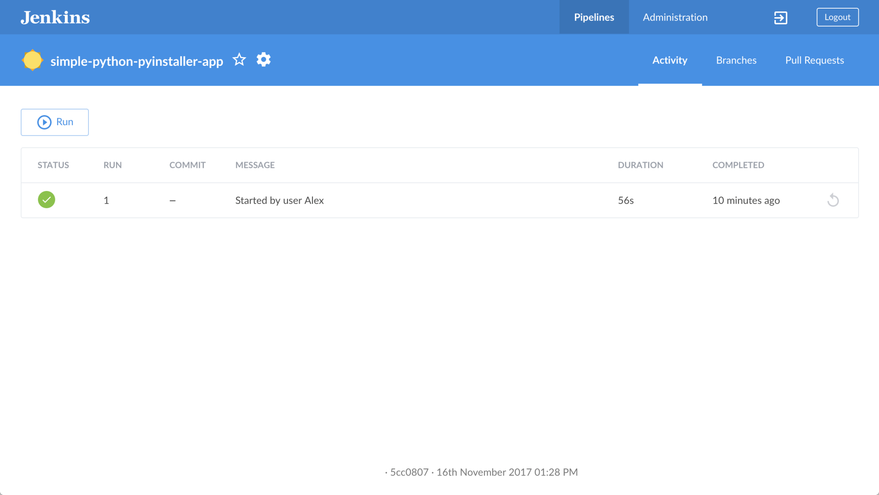

### Add a test stage to your Pipeline

1. Go back to your text editor/IDE and ensure your Jenkinsfile is open.
2. Copy and paste the following Declarative Pipeline syntax immediately under the Build stage of your Jenkinsfile:
3. stage('Test') {
4. agent {
5. docker {
6. image 'qnib/pytest'
7. }
8. }
9. steps {
10. sh 'py.test --verbose --junit-xml test-reports/results.xml sources/test_calc.py'
11. }
12. post {
13. always {
14. junit 'test-reports/results.xml'
15. }
16. }

}

so that you end up with:

pipeline {

agent none

stages {

stage('Build') {

agent {

docker {

image 'python:2-alpine'

}

}

steps {

sh 'python -m py_compile sources/add2vals.py sources/calc.py'

}

}

stage('Test') {

agent {

docker {

image 'qnib/pytest'

}

}

steps {

sh 'py.test --verbose --junit-xml test-reports/results.xml sources/test_calc.py'

}

post {

always {

junit 'test-reports/results.xml'

}

}

}

}

}

|  |  |
| --- | --- |
|  | Defines a stage (directive) called Test that appears on the Jenkins UI. |
|  | This image parameter (of the agent section’s docker parameter) downloads the qnib:pytest Docker image (if it’s not already available on your machine) and runs this image as a separate container. This means that:   * + You’ll have separate Jenkins and pytest containers running locally in Docker.   + The pytest container becomes the agent that Jenkins uses to run the Test stage of your Pipeline project. This container’s lifespan lasts the duration of your Test stage’s execution. |
|  | This sh step (of the steps section) executes pytest’s py.test command on sources/test_calc.py, which runs a set of unit tests (defined in test_calc.py) on the "calc" library’s add2 function (used by your simple Python application add2vals). The:   * + --verbose option makes py.test generate verbose output in the Jenkins/Blue Ocean interface.   + --junit-xml test-reports/results.xml option makes py.test generate a JUnit XML report, which is saved to test-reports/results.xml (within the /var/jenkins_home/workspace/simple-python-pyinstaller-appdirectory in the Jenkins container). |
|  | This junit step (provided by the JUnit Plugin) archives the JUnit XML report (generated by the py.test command above) and exposes the results through the Jenkins interface. In Blue Ocean, the results are accessible through the **Tests** page of a Pipeline run. The post section’s always condition that contains this junit step ensures that the step is always executed at the completion of the Test stage, regardless of the stage’s outcome. |

1. Save your edited Jenkinsfile and commit it to your local simple-python-pyinstaller-app Git repository. E.g. Within thesimple-python-pyinstaller-app directory, run the commands:  
   git stage .  
   then  
   git commit -m "Add 'Test' stage"
2. Go back to Jenkins again, log in again if necessary and ensure you’ve accessed Jenkins’s Blue Ocean interface.
3. Click **Run** at the top left, then quickly click the **OPEN** link which appears briefly at the lower-right to see Jenkins running your amended Pipeline project. If you weren’t able to click the **OPEN** link, click the top row on the Blue Ocean interface to access this feature.  
   **Note:** It may take a few minutes for the qnib:pytest Docker image to download (if this hasn’t already been done).  
   If your amended Pipeline ran successfully, here’s what the Blue Ocean interface should look like. Notice the additional "Test" stage. You can click on the previous "Build" stage circle to access the output from that stage.

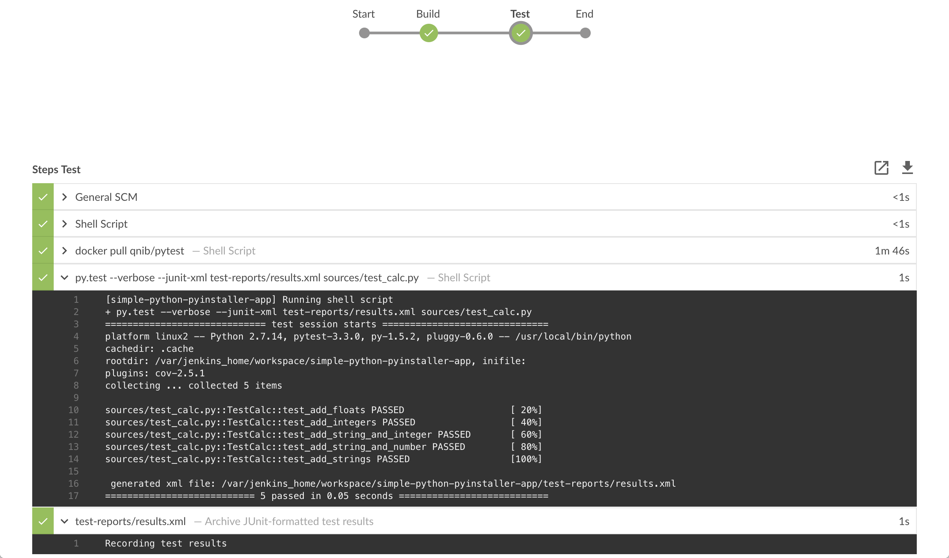

1. Click the **X** at the top-right to return to the main Blue Ocean interface.

### Add a final deliver stage to your Pipeline

1. Go back to your text editor/IDE and ensure your Jenkinsfile is open.
2. Copy and paste the following Declarative Pipeline syntax immediately under the Test stage of your Jenkinsfile:
3. stage('Deliver') {
4. agent {
5. docker {
6. image 'cdrx/pyinstaller-linux:python2'
7. }
8. }
9. steps {
10. sh 'pyinstaller --onefile sources/add2vals.py'
11. }
12. post {
13. success {
14. archiveArtifacts 'dist/add2vals'
15. }
16. }

}

so that you end up with:

pipeline {

agent none

stages {

stage('Build') {

agent {

docker {

image 'python:2-alpine'

}

}

steps {

sh 'python -m py_compile sources/add2vals.py sources/calc.py'

}

}

stage('Test') {

agent {

docker {

image 'qnib/pytest'

}

}

steps {

sh 'py.test --verbose --junit-xml test-reports/results.xml sources/test_calc.py'

}

post {

always {

junit 'test-reports/results.xml'

}

}

}

stage('Deliver') {

agent {

docker {

image 'cdrx/pyinstaller-linux:python2'

}

}

steps {

sh 'pyinstaller --onefile sources/add2vals.py'

}

post {

success {

archiveArtifacts 'dist/add2vals'

}

}

}

}

}

|  |  |
| --- | --- |
|  | Defines a stage (directive) called Deliver that appears on the Jenkins UI. |
|  | This image parameter (of the agent section’s docker parameter) downloads the cdrx/pyinstaller-linux Docker image (if it’s not already available on your machine) and runs this image as a separate container. This means that:   * + You’ll have separate Jenkins and PyInstaller (for Linux) containers running locally in Docker.   + The PyInstaller container becomes the agent that Jenkins uses to run the Deliver stage of your Pipeline project. This container’s lifespan lasts the duration of your Deliver stage’s execution. |
|  | This sh step (of the steps section) executes the pyinstaller command (in the PyInstaller container) on your simple Python application. This bundles your add2vals.py Python application into a single standalone executable file (via the --onefile option) and outputs the this file to the dist workspace directory (within the Jenkins home directory). Although this step consists of a single command, as a general principle, it’s a good idea to keep your Pipeline code (i.e. the Jenkinsfile) as tidy as possible and place more complex build steps (particularly for stages consisting of 2 or more steps) into separate shell script files like the deliver.sh file. This ultimately makes maintaining your Pipeline code easier, especially if your Pipeline gains more complexity. |
|  | This archiveArtifacts step (provided as part of Jenkins core) archives the standalone executable file (generated by the pyinstaller command above at dist/add2vals within the Jenkins home’s workspace directory) and exposes this file through the Jenkins interface. In Blue Ocean, archived artifacts like these are accessible through the **Artifacts** page of a Pipeline run. The post section’s success condition that contains this archiveArtifacts step ensures that the step is executed at the completion of the Deliver stage only if this stage completed successfully. |

1. Save your edited Jenkinsfile and commit it to your local simple-python-pyinstaller-app Git repository. E.g. Within thesimple-python-pyinstaller-app directory, run the commands:  
   git stage .  
   then  
   git commit -m "Add 'Deliver' stage"
2. Go back to Jenkins again, log in again if necessary and ensure you’ve accessed Jenkins’s Blue Ocean interface.
3. Click **Run** at the top left, then quickly click the **OPEN** link which appears briefly at the lower-right to see Jenkins running your amended Pipeline project. If you weren’t able to click the **OPEN** link, click the top row on the Blue Ocean interface to access this feature.  
   **Note:** It may take a few minutes for the cdrx/pyinstaller-linux Docker image to download (if this hasn’t already been done).  
   If your amended Pipeline ran successfully, here’s what the Blue Ocean interface should look like. Notice the additional "Deliver" stage. Click on the previous "Test" and "Build" stage circles to access the outputs from those stages.

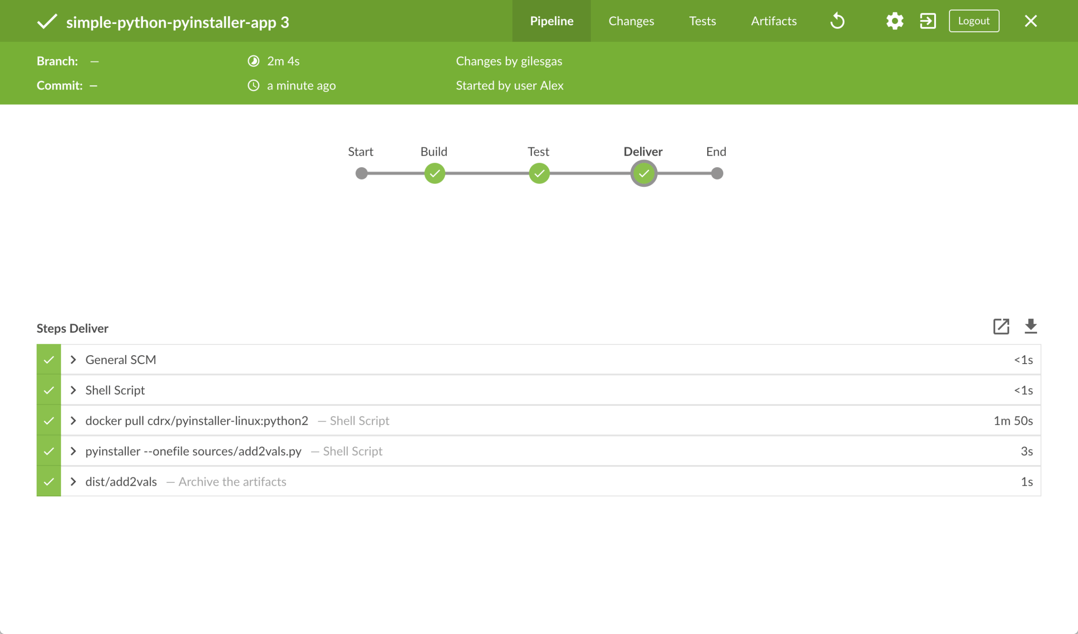

Here’s what the output of the "Deliver" stage should look like, showing you the results of PyInstaller bundling your Python application into a single standalone executable file.

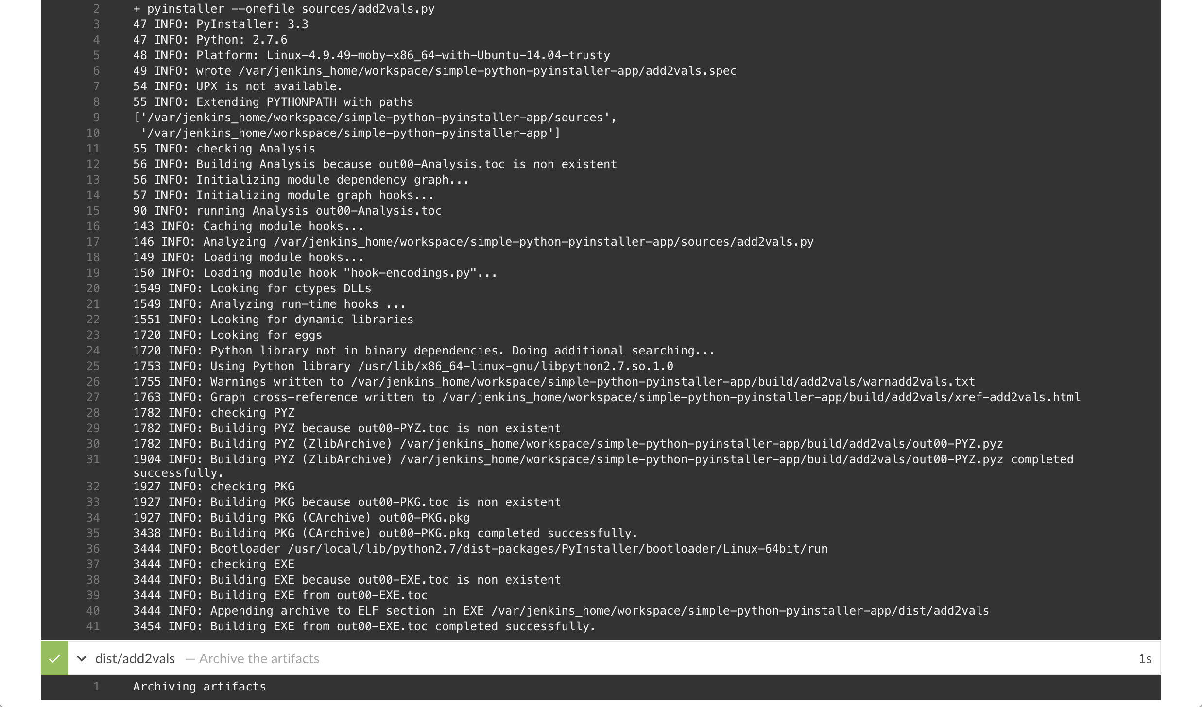

1. Click the **X** at the top-right to return to the main Blue Ocean interface, which lists your previous Pipeline runs in reverse chronological order.

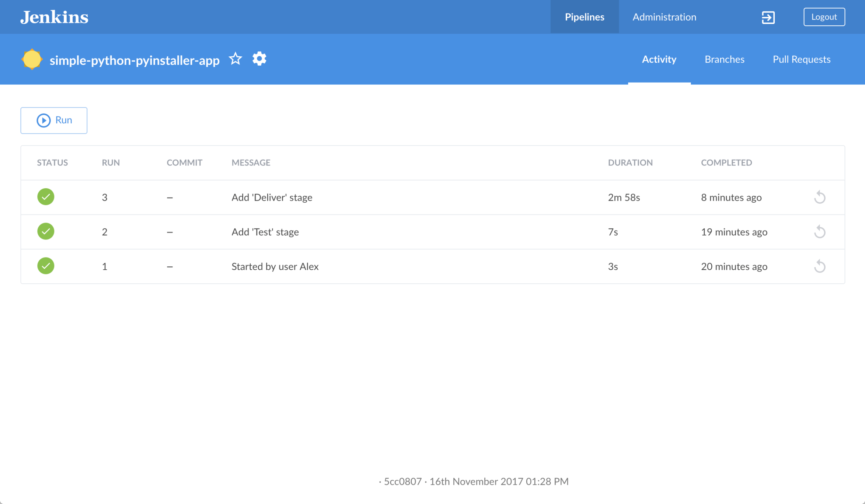

### Follow up (optional)

If you use Linux, you can try running the standalone add2vals application you generated with PyInstaller locally on your machine. To do this:

1. From the main Blue Ocean interface, access your last Pipeline run you performed above. To do this, click the top row (representing the most recent Pipeline run) on the main Blue Ocean’s **Activity** page.



1. On the results page of the Pipeline run, click **Artifacts** at the top right to access the **Artifacts** page.



1. In the list of artifacts, click the down-arrow icon at the far right of the **dist/add2vals** artifact item to download the standalone executable file to your browser’s "Downloads" directory.

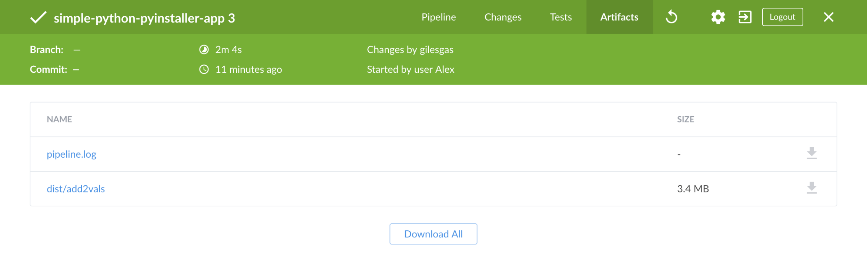

1. Back in your operating system’s terminal prompt, cd to your browser’s "Downloads" directory.
2. Make the add2vals file executable - i.e. chmod a+x add2vals
3. Run the command ./add2vals and follow the instructions provided by your app

# Create a Pipeline in Blue Ocean

Before starting this tutorial, it is recommended that you run through at least one of the initial set of tutorials from the Tutorials overview page first to familiarize yourself with CI/CD concepts (relevant to a technology stack you’re most familiar with) and how these concepts are implemented in Jenkins.

This tutorial uses the same application that the Build a Node.js and React app with npm tutorial is based on. Therefore, you’ll be building the same application although this time, completely through Blue Ocean. Since Blue Ocean provides a simplified Git-handling experience, you’ll be interacting directly with the repository on GitHub (as opposed to a local clone of this repository).

**Duration:** This tutorial takes 20-40 minutes to complete (assuming you’ve already met the prerequisites below). The exact duration will depend on the speed of your machine and whether or not you’ve already run Jenkins in Docker from another tutorial.

You can stop this tutorial at any point in time and continue from where you left off.

If you’ve already run though another tutorial, you can skip the Prerequisites and Run Jenkins in Docker sections below and proceed on to forking the sample repository. If you need to restart Jenkins, simply follow the restart instructions in Stopping and restarting Jenkins and then proceed on.

### Prerequisites

For this tutorial, you will require:

* A macOS, Linux or Windows machine with:
  + 256 MB of RAM, although more than 512MB is recommended.
  + 10 GB of drive space for Jenkins and your Docker images and containers.
* The following software installed:
  + Docker - Read more about installing Docker in the Installing Docker section of the Installing Jenkins page.  
    **Note:** If you use Linux, this tutorial assumes that you are not running Docker commands as the root user, but instead with a single user account that also has access to the other tools used throughout this tutorial.

### Run Jenkins in Docker

In this tutorial, you’ll be running Jenkins as a Docker container from the jenkinsci/blueocean Docker image.

To run Jenkins in Docker, follow the relevant instructions below for either macOS and Linux or Windows.

You can read more about Docker container and image concepts in the Docker and Downloading and running Jenkins in Dockersections of the Installing Jenkins page.

#### On macOS and Linux

1. Open up a terminal window.
2. Run the jenkinsci/blueocean image as a container in Docker using the following docker run command (bearing in mind that this command automatically downloads the image if this hasn’t been done):
3. docker run \
4. --rm \
5. -u root \
6. -p 8080:8080 \
7. -v jenkins-data:/var/jenkins_home \
8. -v /var/run/docker.sock:/var/run/docker.sock \
9. -v "$HOME":/home \

jenkinsci/blueocean

|  |  |
| --- | --- |
|  | Maps the /var/jenkins_home directory in the container to the Docker volume with the name jenkins-data. If this volume does not exist, then this docker run command will automatically create the volume for you. |
|  | Maps the $HOME directory on the host (i.e. your local) machine (usually the /Users/<your-username> directory) to the /home directory in the container. |

**Note:** If copying and pasting the command snippet above doesn’t work, try copying and pasting this annotation-free version here:

docker run \

--rm \

-u root \

-p 8080:8080 \

-v jenkins-data:/var/jenkins_home \

-v /var/run/docker.sock:/var/run/docker.sock \

-v "$HOME":/home \

jenkinsci/blueocean

1. Proceed to the Setup wizard.

#### On Windows

1. Open up a command prompt window.
2. Run the jenkinsci/blueocean image as a container in Docker using the following docker run command (bearing in mind that this command automatically downloads the image if this hasn’t been done):
3. docker run ^
4. --rm ^
5. -u root ^
6. -p 8080:8080 ^
7. -v jenkins-data:/var/jenkins_home ^
8. -v /var/run/docker.sock:/var/run/docker.sock ^
9. -v "%HOMEPATH%":/home ^

jenkinsci/blueocean

For an explanation of these options, refer to the macOS and Linux instructions above.

1. Proceed to the Setup wizard.

#### Accessing the Jenkins/Blue Ocean Docker container

If you have some experience with Docker and you wish or need to access the Jenkins/Blue Ocean Docker container through a terminal/command prompt using the docker exec command, you can add an option like --name jenkins-tutorials (with the docker run above), which would give the Jenkins/Blue Ocean Docker container the name "jenkins-tutorials".

This means you could access the Jenkins/Blue Ocean container (through a separate terminal/command prompt window) with a docker exec command like:

docker exec -it jenkins-tutorials bash

#### Setup wizard

Before you can access Jenkins, there are a few quick "one-off" steps you’ll need to perform.

##### **Unlocking Jenkins**

When you first access a new Jenkins instance, you are asked to unlock it using an automatically-generated password.

1. After the 2 sets of asterisks appear in the terminal/command prompt window, browse to http://localhost:8080 and wait until the **Unlock Jenkins** page appears.



1. From your terminal/command prompt window again, copy the automatically-generated alphanumeric password (between the 2 sets of asterisks).



1. On the **Unlock Jenkins** page, paste this password into the **Administrator password** field and click **Continue**.

##### **Customizing Jenkins with plugins**

After unlocking Jenkins, the **Customize Jenkins** page appears.

On this page, click **Install suggested plugins**.

The setup wizard shows the progression of Jenkins being configured and the suggested plugins being installed. This process may take a few minutes.

##### **Creating the first administrator user**

Finally, Jenkins asks you to create your first administrator user.

1. When the **Create First Admin User** page appears, specify your details in the respective fields and click **Save and Finish**.
2. When the **Jenkins is ready** page appears, click **Start using Jenkins**.  
   **Notes:**
   * This page may indicate **Jenkins is almost ready!** instead and if so, click **Restart**.
   * If the page doesn’t automatically refresh after a minute, use your web browser to refresh the page manually.
3. If required, log in to Jenkins with the credentials of the user you just created and you’re ready to start using Jenkins!

#### Stopping and restarting Jenkins

Throughout the remainder of this tutorial, you can stop the Jenkins/Blue Ocean Docker container by typing Ctrl-C in the terminal/command prompt window from which you ran the docker run ... command above.

To restart the Jenkins/Blue Ocean Docker container:

1. Run the same docker run ... command you ran for macOS, Linux or Windows above.  
   **Note:** This process also updates the jenkinsci/blueocean Docker image, if an updated one is available.
2. Browse to http://localhost:8080.
3. Wait until the log in page appears and log in.

### Fork the sample repository on GitHub

Fork the simple "Welcome to React" Node.js and React application on GitHub into your own GitHub account.

1. Ensure you are signed in to your GitHub account. If you don’t yet have a GitHub account, sign up for a free one on the GitHub website.
2. Fork the creating-a-pipeline-in-blue-ocean on GitHub into your local GitHub account. If you need help with this process, refer to the Fork A Repo documentation on the GitHub website for more information.  
   **Note:** This is a different repository to the one used in the Build a Node.js and React app with npm tutorial. Although these repositories contain the same application code, ensure you fork and use the correct one before continuing on.

### Create your Pipeline project in Blue Ocean

1. Go back to Jenkins and ensure you have accessed the Blue Ocean interface. To do this, make sure you:
   * have browsed to http://localhost:8080/blue and are logged in  
     or
   * have browsed to http://localhost:8080/, are logged in and have clicked **Open Blue Ocean** on the left.
2. In the **Welcome to Jenkins** box at the center of the Blue Ocean interface, click **Create a new Pipeline** to begin the Pipeline creation wizard.  
   **Note:** If you don’t see this box, click **New Pipeline** at the top right.
3. In **Where do you store your code?**, click **GitHub**.
4. In **Connect to GitHub**, click **Create an access key here**. This opens GitHub in a new browser tab.  
   **Note:** If you previously configured Blue Ocean to connect to GitHub using a personal access token, then Blue Ocean takes you directly to step 9 below.
5. In the new tab, sign in to your GitHub account (if necessary) and on the GitHub **New Personal Access Token** page, specify a brief **Token description** for your GitHub access token (e.g. Blue Ocean).  
   **Note:** An access token is usually an alphanumeric string that respresents your GitHub account along with permissions to access various GitHub features and areas through your GitHub account. This access token will have the appropriate permissions pre-selected, which Blue Ocean requires to access and interact with your GitHub account.
6. Scroll down to the end of the page (leaving all other **Select scopes** options with their default settings) and click **Generate token**.
7. On the resulting **Personal access tokens** page, copy your newly generated access token.
8. Back in Blue Ocean, paste the access token into the **Your GitHub access token** field and click **Connect**.

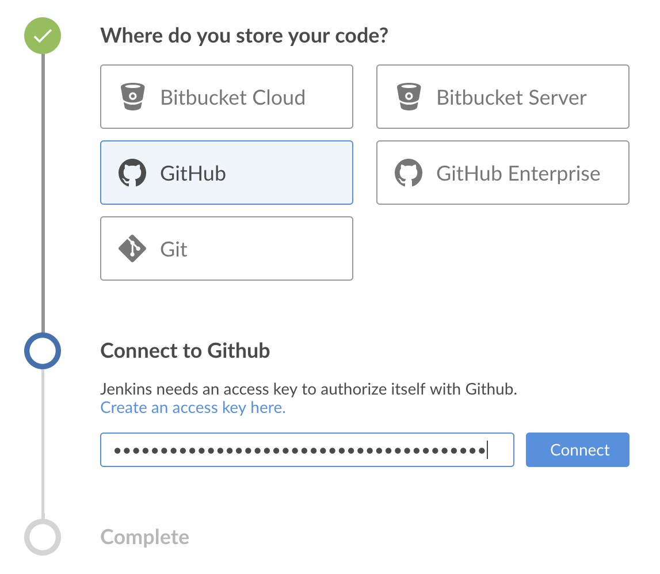  
Jenkins now has access to your GitHub account (provided by your access token).

1. In **Which organization does the repository belong to?**, click your GitHub account (where you forked the repository above).
2. In **Choose a repository**, click your forked repository **creating-a-pipeline-in-blue-ocean**.
3. Click **Create Pipeline**.  
   Blue Ocean detects that there is no Jenkinsfile at the root level of the repository’s master branch and proceed to help you create one. (Therefore, you’ll need to click another **Create Pipeline** at the end of the page to proceed.)  
   **Note:** Under the hood, a Pipeline project created through Blue Ocean is actually "multibranch Pipeline". Therefore, Jenkins looks for the presence of at least one Jenkinsfile in any branch of your repository.

### Create your initial Pipeline

1. Following on from creating your Pipeline project (above), in the Pipeline editor, select **docker** from the **Agent** dropdown in the **Pipeline Settings** panel on the right.

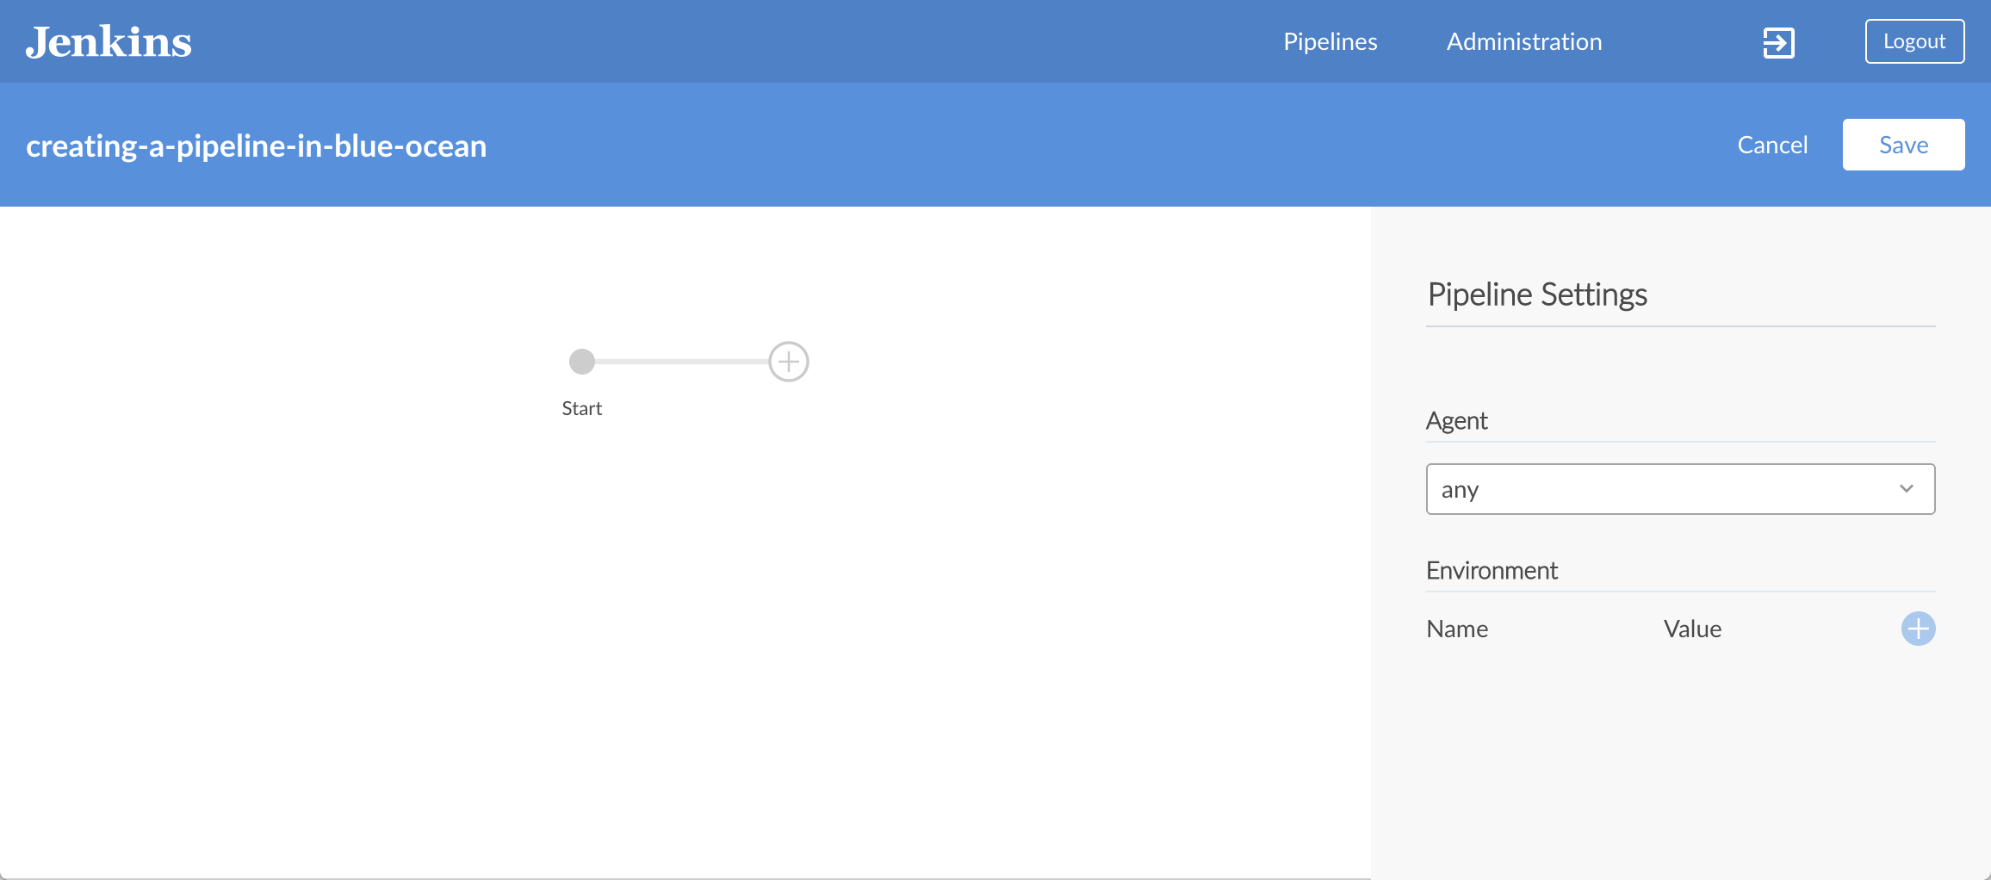

1. In the **Image** and **Args** fields that appear, specify node:6-alpine and -p 3000:3000 respectively.

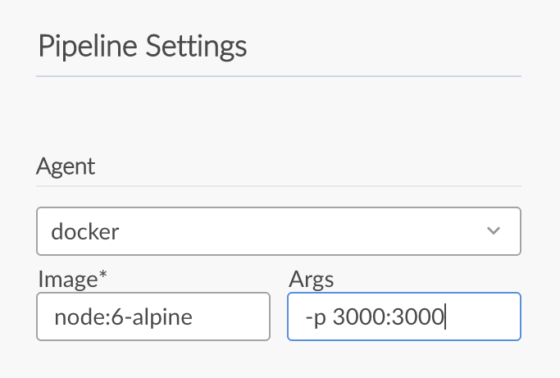  
**Note:** For an explanation of these values, refer to annotations **1** and **2** of the Declarative Pipeline in the “Create your initial Pipeline…​” section of the Build a Node.js and React app tutorial.

1. Back in the main Pipeline editor, click the **+** icon, which opens the new stage panel on the right.

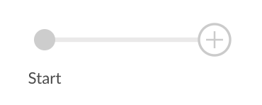

1. In this panel, type Build in the **Name your stage** field and then click the **Add Step** button below, which opens the **Choose step type** panel.

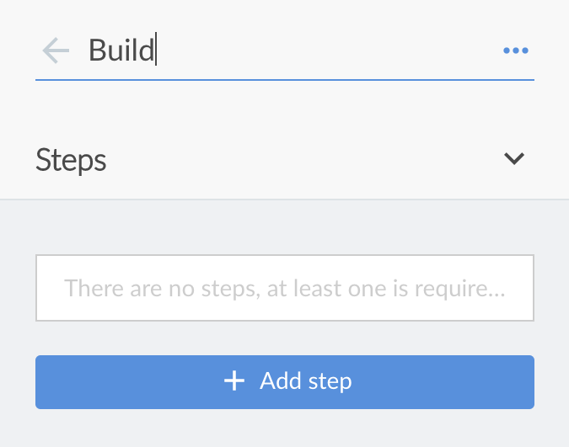

1. In this panel, click **Shell Script** near the top of the list (to choose that step type), which opens the **Build / Shell Script** panel, where you can enter this step’s values.

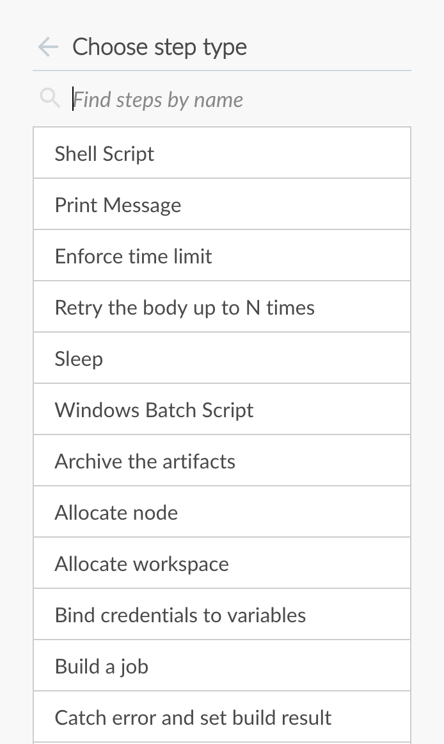  
**Tip:** The most commonly used step types appear closest to the top of this list. To find other steps further down this list, you can filter this list using the **Find steps by name** option.

1. In the **Build / Shell Script** panel, specify npm install.

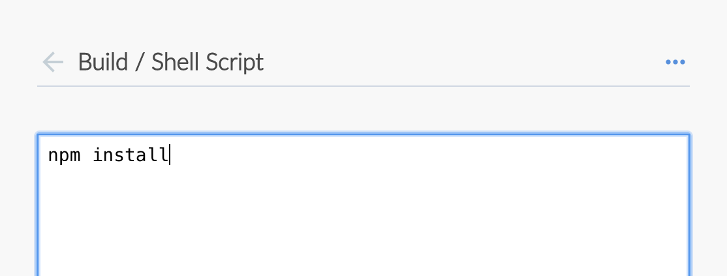  
**Note:** For an explanation of this step, refer to annotation **4** of the Declarative Pipeline in the “Create your initial Pipeline…​” section of the Build a Node.js and React app tutorial.

1. ( Optional ) Click the top-left back arrow icon  to return to the main Pipeline editor.
2. Click the **Save** button at the top right to begin saving your new Pipeline with its "Build" stage.
3. In the **Save Pipeline** dialog box, specify the commit message in the **Description** field (e.g. Add initial Pipeline (Jenkinsfile)).

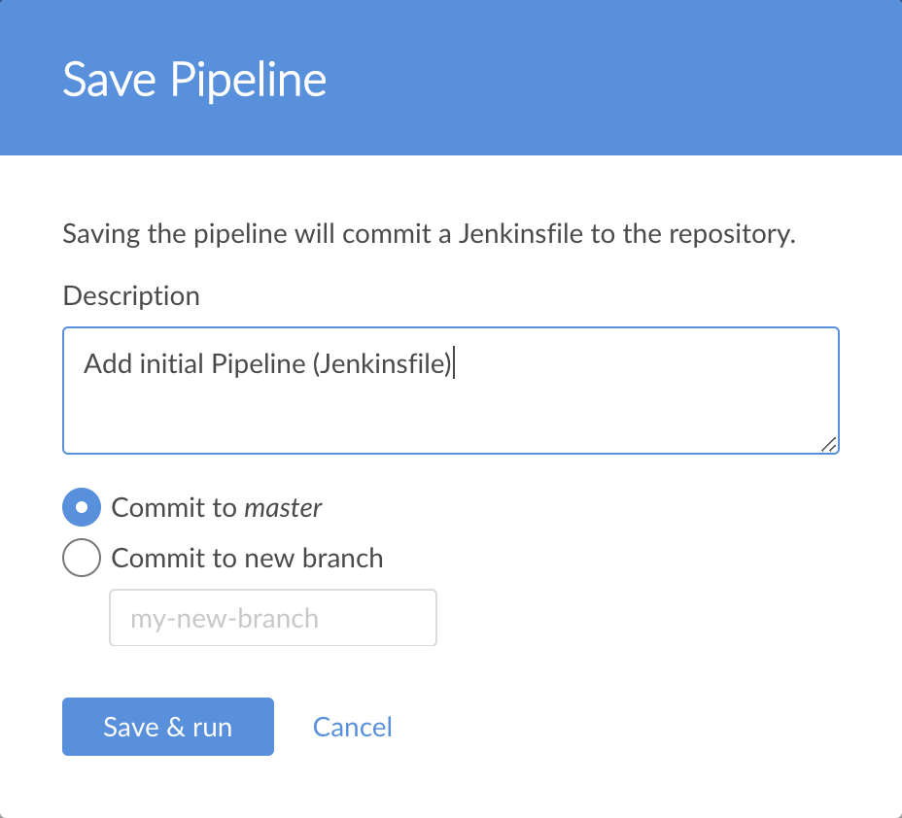

1. Leaving all other options as is, click **Save & run** and Jenkins proceeds to build your Pipeline.
2. When the main Blue Ocean interface appears, click the row to see Jenkins build your Pipeline project.  
   **Note:** You may need to wait several minutes for this first run to complete. During this time, Jenkins does the following:
   1. Commits your Pipeline as a Jenkinsfile to the only branch (i.e. master) of your repository.
   2. Initially queues the project to be built on the agent.
   3. Downloads the Node Docker image and runs it in a container on Docker.
   4. Executes the Build stage (defined in the Jenkinsfile) on the Node container. (During this time, npm downloads many dependencies necessary to run your Node.js and React application, which will ultimately be stored in the local node_modules directory within the Jenkins home directory).

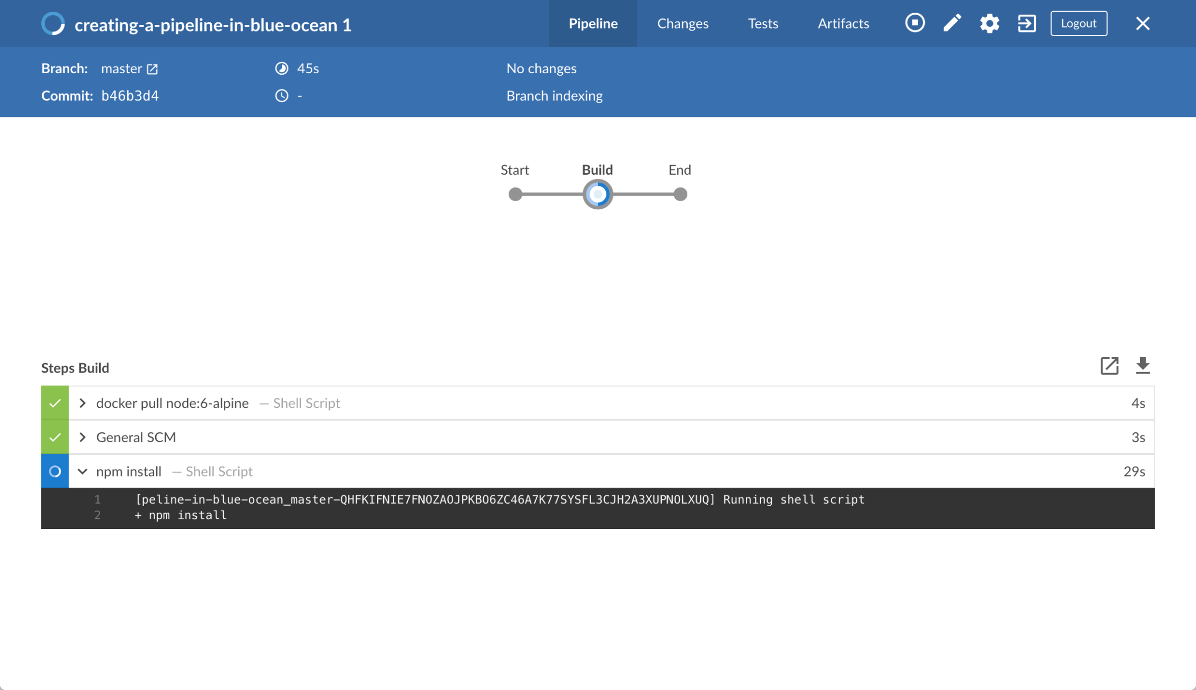

1. The Blue Ocean interface turns green if Jenkins built your application successfully.
2. 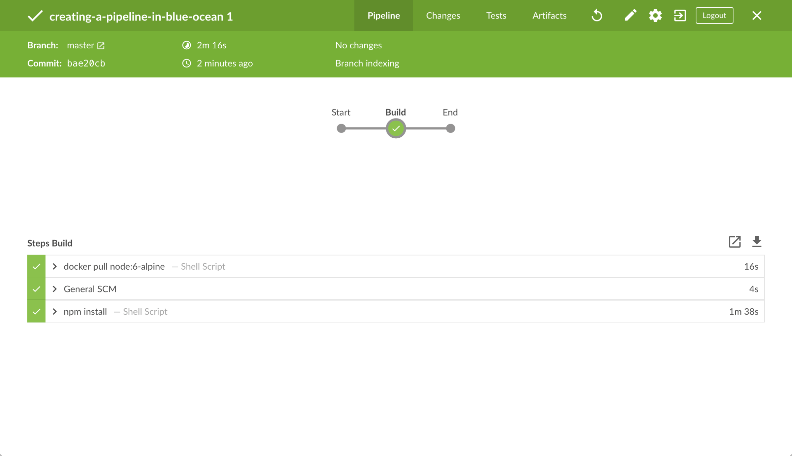
3. Click the **X** at the top-right to return to the main Blue Ocean interface.

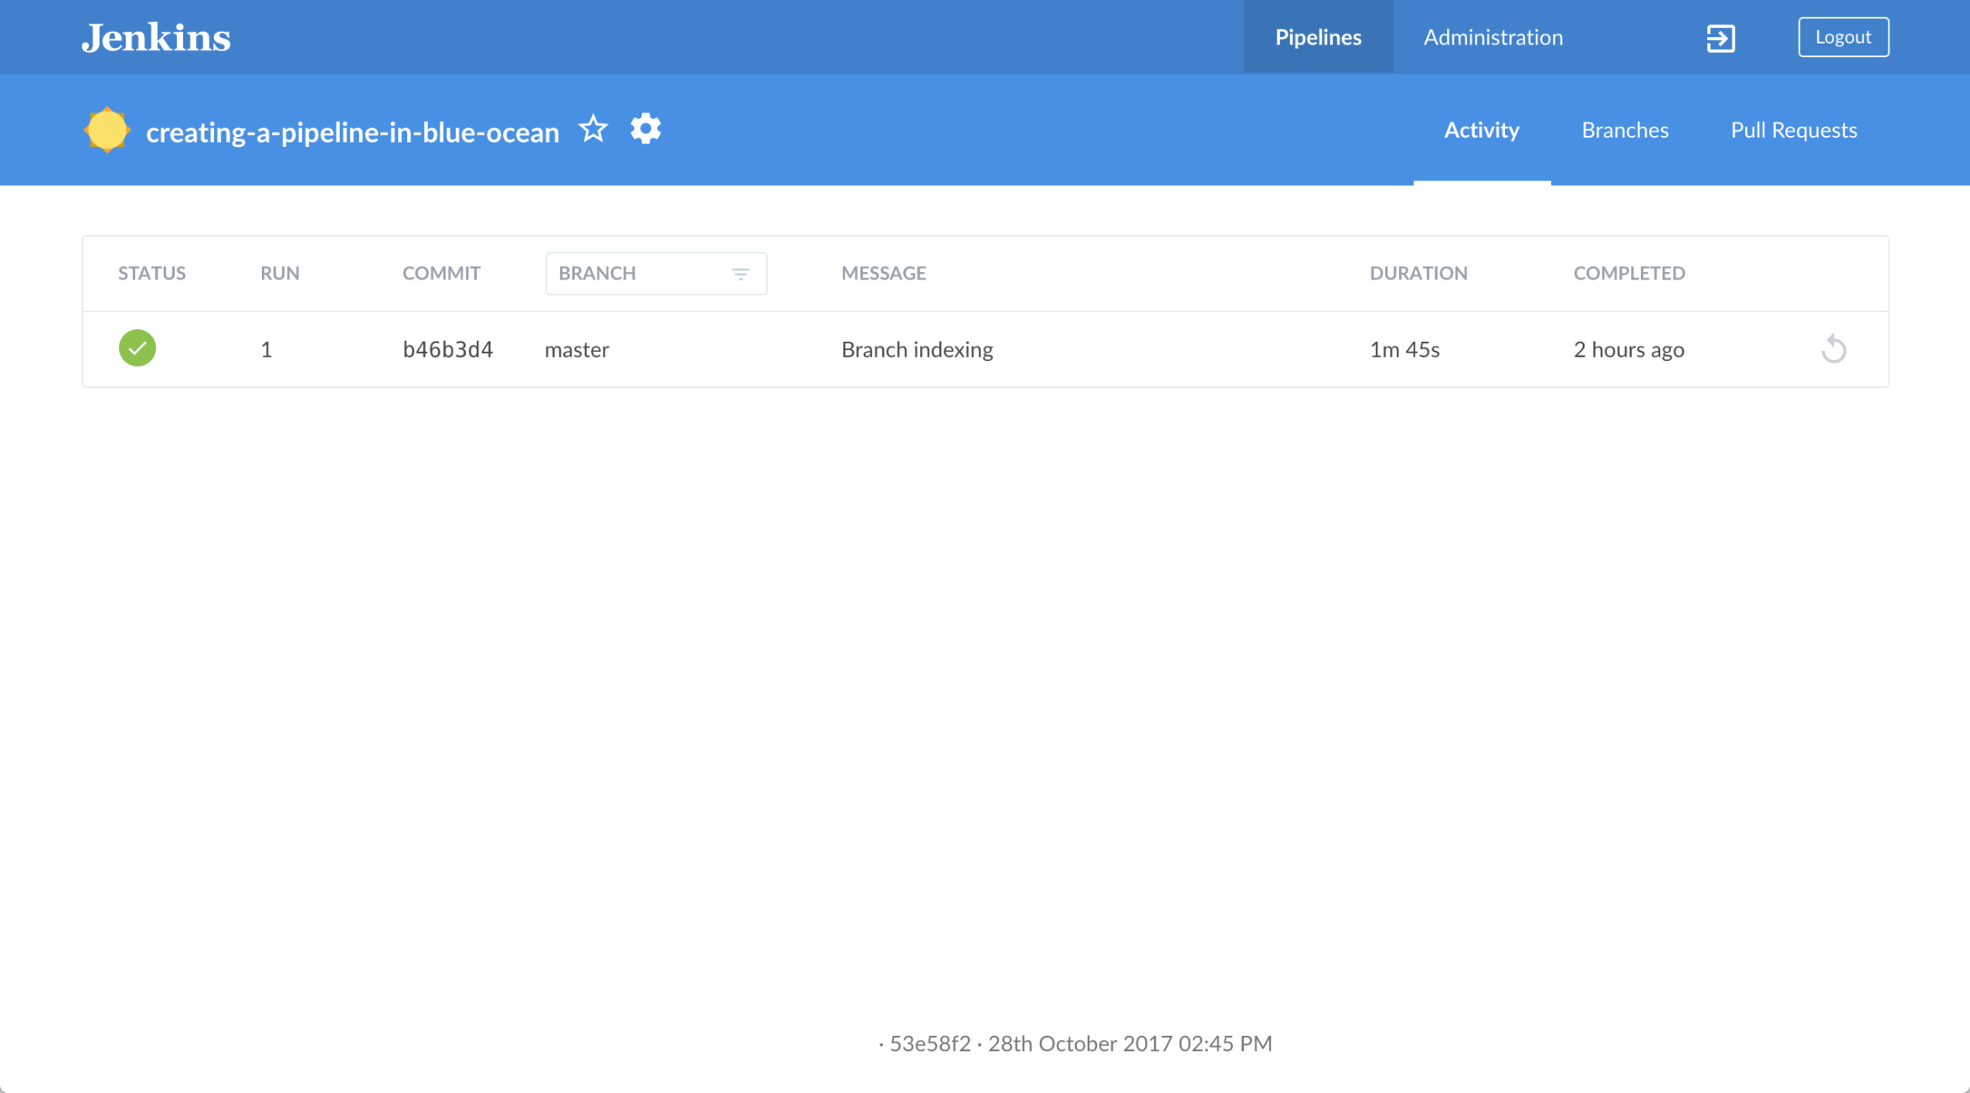  
**Note:** Before continuing on, you can check that Jenkins has created a Jenkinsfile for you at the root of your forked GitHub repository (in the repository’s sole master branch).

### Add a test stage to your Pipeline

1. From the main Blue Ocean interface, click **Branches** at the top-right to access your respository’s branches page, where you can access the master branch.

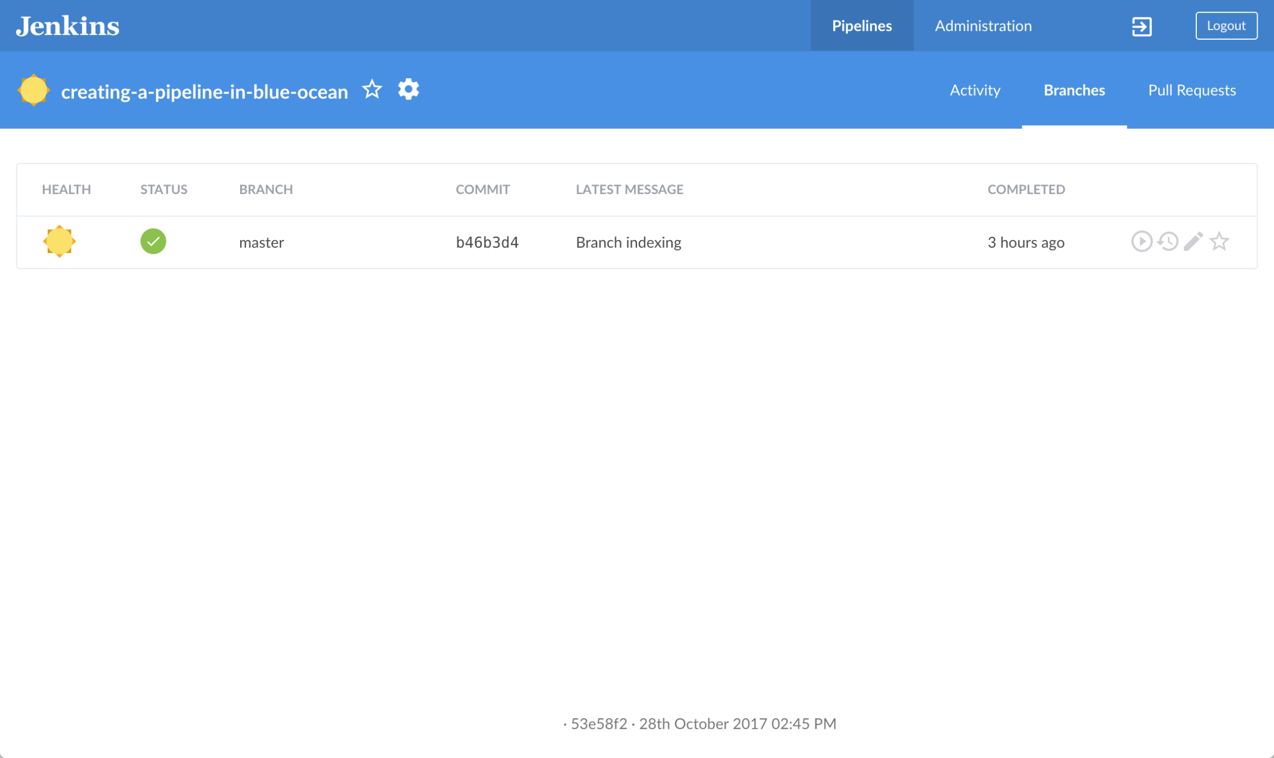

1. Click the master branch’s "Edit Pipeline" icon  to open the Pipeline editor for this branch.
2. In the main Pipeline editor, click the **+** icon to the right of the **Build** stage you created above to open the new stage panel on the right.

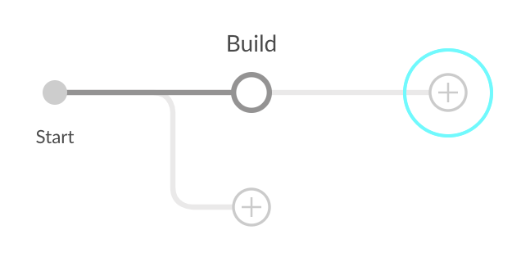

1. In this panel, type Test in the **Name your stage** field and then click the **Add Step** button below to open the **Choose step type** panel.
2. In this panel, click **Shell Script** near the top of the list.
3. In the resulting **Test / Shell Script** panel, specify ./jenkins/scripts/test.sh and then click the top-left back arrow icon to return to the Pipeline stage editor.
4. At the lower-right of the panel, click **Settings** to reveal this section of the panel.
5. Click the **+** icon at the right of the **Environment** heading (for which you’ll configure an environment directive).
6. In the **Name** and **Value** fields that appear, specify CI and true, respectively.

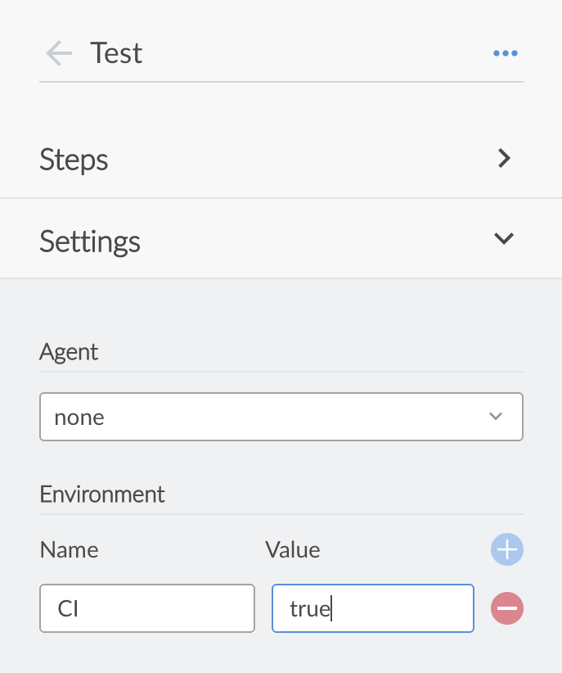  
**Note:** For an explanation of this directive and its step, refer to annotations **1** and **3** of the Declarative Pipeline in the “Add a test stage…​” section of the Build a Node.js and React app tutorial.

1. ( Optional ) Click the top-left back arrow icon  to return to the main Pipeline editor.
2. Click the **Save** button at the top right to begin saving your Pipeline with with its new "Test" stage.
3. In the **Save Pipeline** dialog box, specify the commit message in the **Description** field (e.g. Add 'Test' stage).
4. Leaving all other options as is, click **Save & run** and Jenkins proceeds to build your amended Pipeline.
5. When the main Blue Ocean interface appears, click the top row to see Jenkins build your Pipeline project.  
   **Note:** You’ll notice from this run that Jenkins no longer needs to download the Node Docker image. Instead, Jenkins only needs to run a new container from the Node image downloaded previously. Therefore, running your Pipeline this subsequent time should be much faster.  
   If your amended Pipeline ran successfully, here’s what the Blue Ocean interface should look like. Notice the additional "Test" stage. You can click on the previous "Build" stage circle to access the output from that stage.

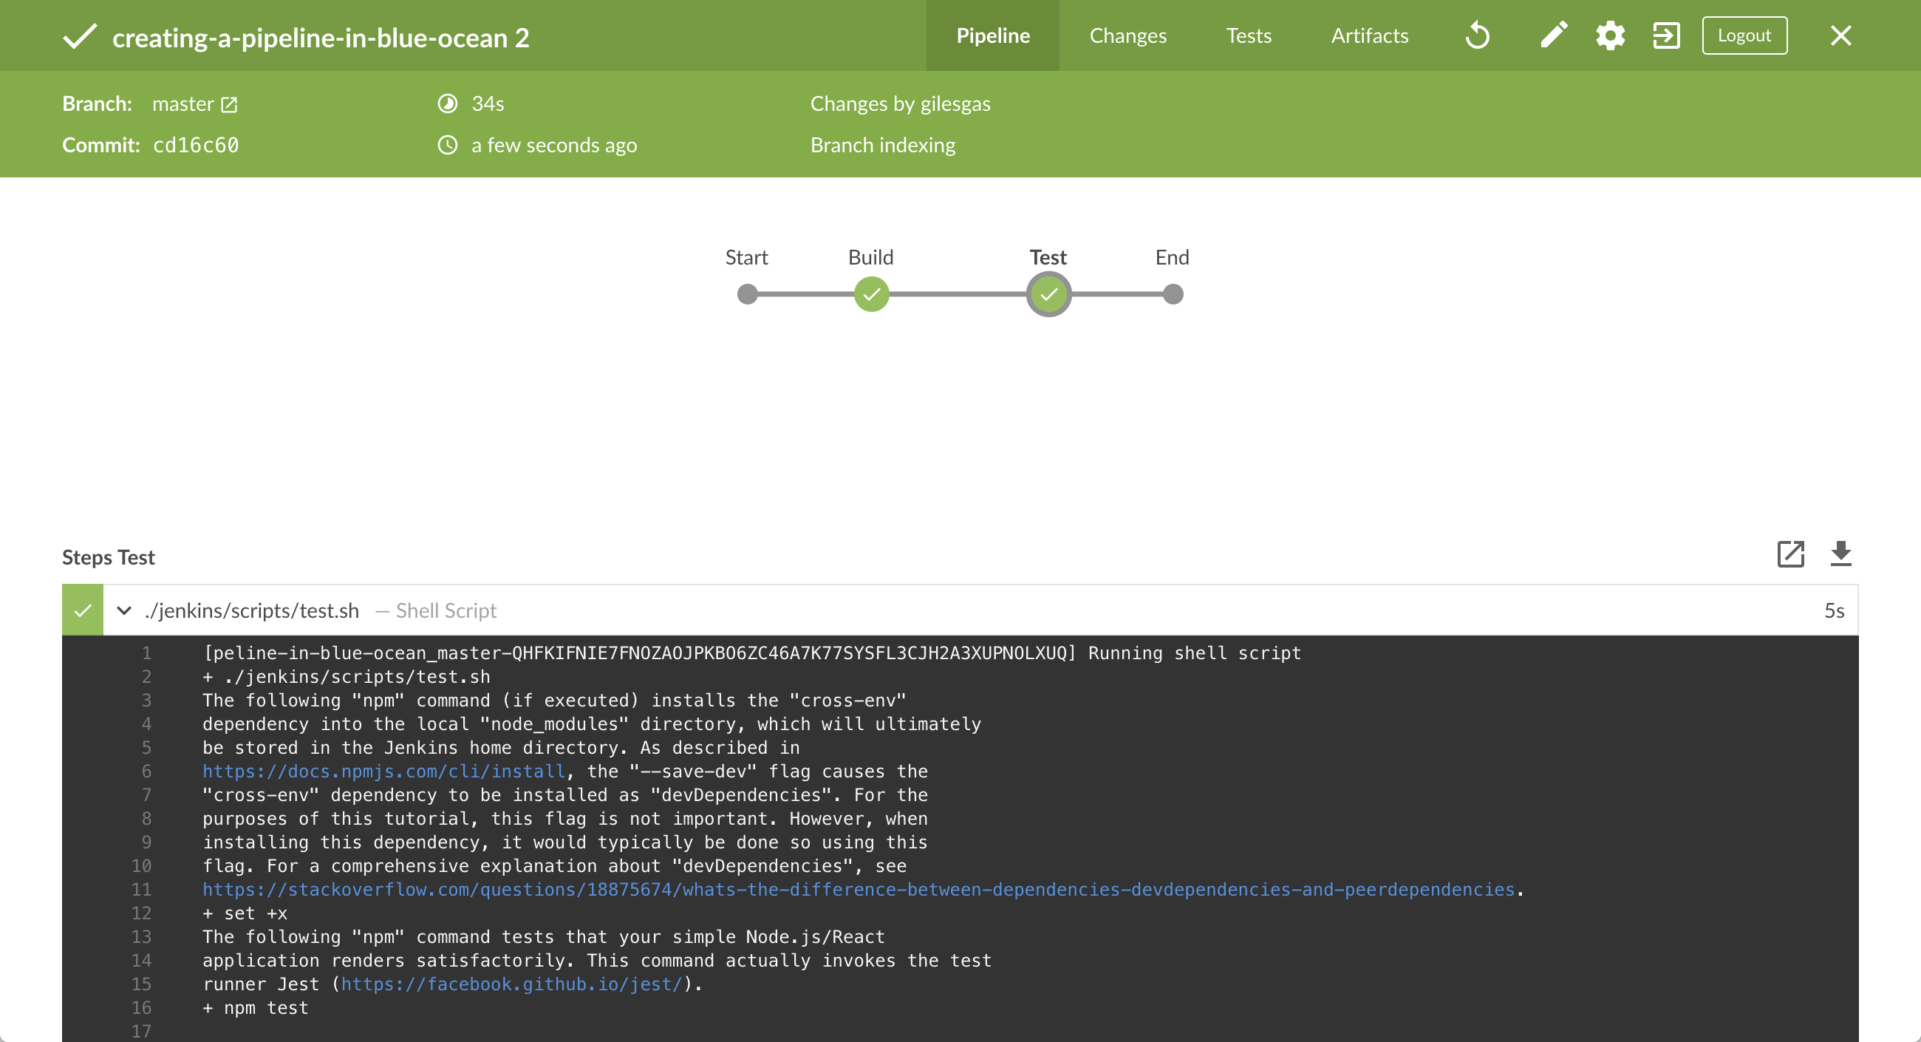

1. Click the **X** at the top-right to return to the main Blue Ocean interface.

### Add a final deliver stage to your Pipeline

1. From the main Blue Ocean interface, click **Branches** at the top-right to access your respository’s master branch.
2. Click the master branch’s "Edit Pipeline" icon  to open the Pipeline editor for this branch.
3. In the main Pipeline editor, click the **+** icon to the right of the **Test** stage you created above to open the new stage panel.

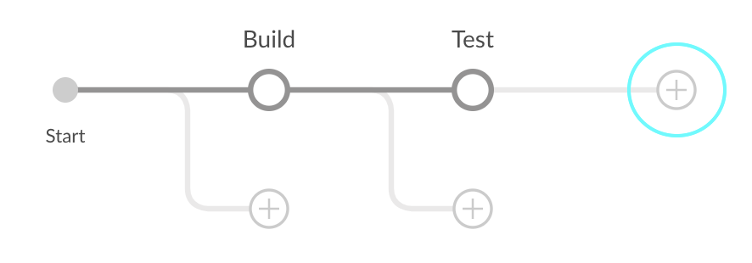

1. In this panel, type Deliver in the **Name your stage** field and then click the **Add Step** button below to open the **Choose step type** panel.
2. In this panel, click **Shell Script** near the top of the list.
3. In the resulting **Deliver / Shell Script** panel, specify ./jenkins/scripts/deliver.sh and then click the top-left back arrow icon  to return to the Pipeline stage editor.

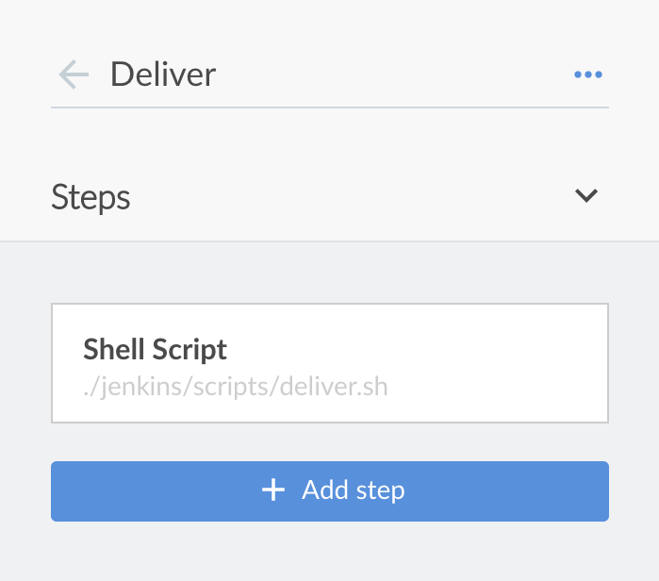  
**Note:** For an explanation of this step, refer to the deliver.sh file itself located in the jenkins/scripts of your forked repository on GitHub.

1. Click the **Add Step** button again.
2. In the **Choose step type** panel, type input into the **Find steps by name** field.

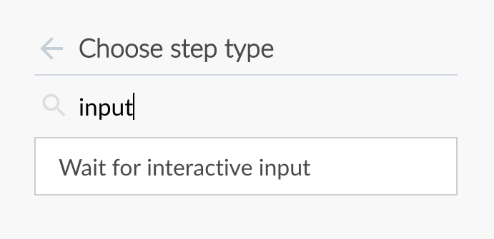

1. Click the filtered **Wait for interactive input** step type.
2. In the resulting **Deliver / Wait for interactive input** panel, specify Finished using the web site? (Click "Proceed" to continue) in the **Message** field and then click the top-left back arrow icon  to return to the Pipeline stage editor.

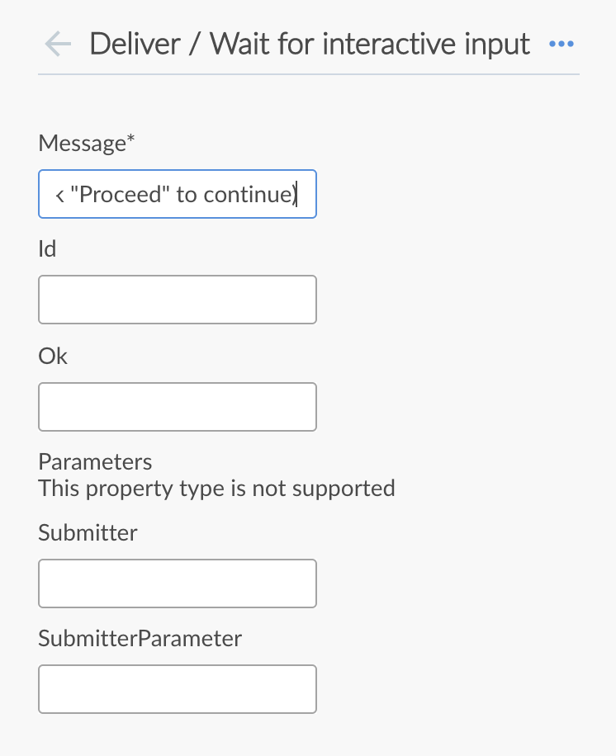  
**Note:** For an explanation of this step, refer to annotation **4** of the Declarative Pipeline in the “Add a final deliver stage…​” section of the Build a Node.js and React app tutorial.

1. Click the **Add Step** button (last time).
2. Click **Shell Script** near the top of the list.
3. In the resulting **Deliver / Shell Script** panel, specify ./jenkins/scripts/kill.sh.  
   **Note:** For an explanation of this step, refer to the kill.sh file itself located in the jenkins/scripts of your forked repository on GitHub.
4. ( Optional ) Click the top-left back arrow icon  to return to the main Pipeline editor.
5. Click the **Save** button at the top right to begin saving your Pipeline with with its new "Deliver" stage.
6. In the **Save Pipeline** dialog box, specify the commit message in the **Description** field (e.g. Add 'Deliver' stage).
7. Leaving all other options as is, click **Save & run** and Jenkins proceeds to build your amended Pipeline.
8. When the main Blue Ocean interface appears, click the top row to see Jenkins build your Pipeline project.  
   If your amended Pipeline ran successfully, here’s what the Blue Ocean interface should look like. Notice the additional "Deliver" stage. Click on the previous "Test" and "Build" stage circles to access the outputs from those stages.

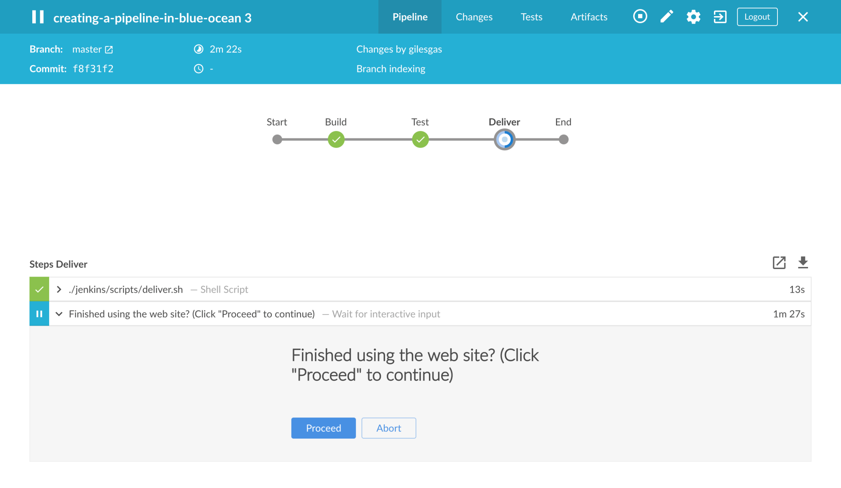

1. Ensure you are viewing the "Deliver" stage (click it if necessary), then click the green **./jenkins/scripts/deliver.sh** step to expand its content and scroll down until you see the http://localhost:3000 link.

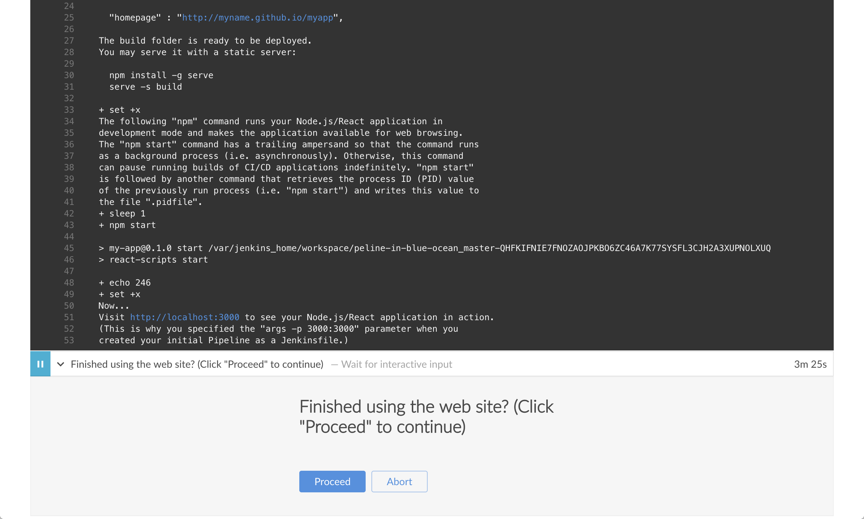

1. Click the http://localhost:3000 link to view your Node.js and React application running (in development mode) in a new web browser tab. You should see a page/site with the title **Welcome to React** on it.
2. When you are finished viewing the page/site, click the **Proceed** button to complete the Pipeline’s execution.

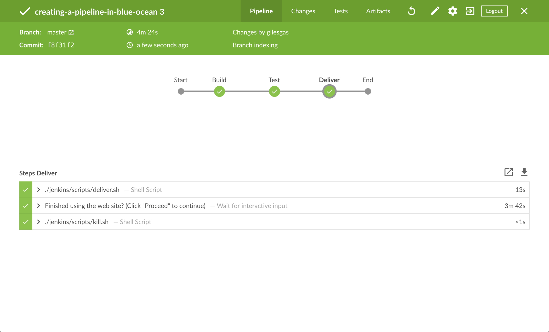

1. Click the **X** at the top-right to return to the main Blue Ocean interface, which lists your previous Pipeline runs in reverse chronological order.

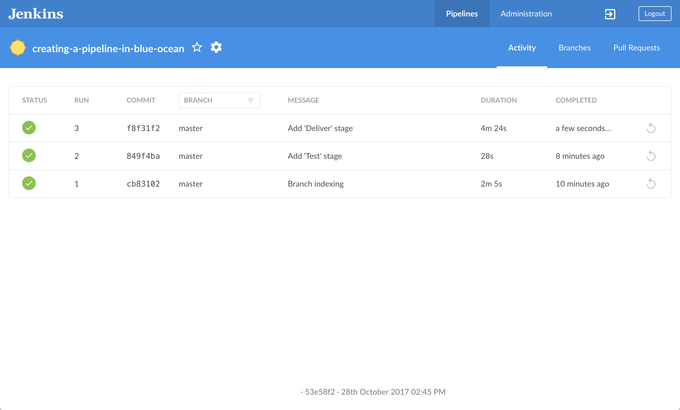

### Follow up (optional)

If you check the contents of the Jenkinsfile that Blue Ocean created at the root of your forked creating-a-pipeline-in-blue-ocean repository, notice the location of the environment directive. This directive’s location within the "Test" stage means that the environment variable CI (with its value of true) is only available within the scope of this "Test" stage.

You can set this directive in Blue Ocean so that its environment variable is available globally throughout Pipeline (as is the case in the Build a Node.js and React app with npm tutorial). To do this:

1. From the main Blue Ocean interface, click **Branches** at the top-right to access your respository’s master branch.
2. Click the master branch’s "Edit Pipeline" icon  to open the Pipeline editor for this branch.
3. In the main Pipeline editor, click the **Test** stage you created above to begin editing it.
4. In the stage panel on the right, click **Settings** to reveal this section of the panel.
5. Click the minus (**-**) icon at the right of the CI environment directive (you created earlier) to delete it.
6. Click the top-left back arrow icon  to return to the main Pipeline editor.
7. In the **Pipeline Settings** panel, click the **+** icon at the right of the **Environment** heading (for which you’ll configure a globalenvironment directive).
8. In the **Name** and **Value** fields that appear, specify CI and true, respectively.
9. Click the **Save** button at the top right to begin saving your Pipeline with with its relocated environment directive.
10. In the **Save Pipeline** dialog box, specify the commit message in the **Description** field (e.g. Make environment directive global).
11. Leaving all other options as is, click **Save & run** and Jenkins proceeds to build your amended Pipeline.
12. When the main Blue Ocean interface appears, click the top row to see Jenkins build your Pipeline project.  
    You should see the same build process you saw when you completed adding the final deliver stage (above). However, when you inspect the Jenkinsfile again, you’ll notice that the environment directive is now a sibling of the agent section.

# Build a multibranch Pipeline project

Before starting this tutorial, it is recommended that you run through at least one of the initial set of Introductory tutorials from the Tutorials overview page first to familiarize yourself with CI/CD concepts (relevant to a technology stack you’re most familiar with), how these concepts are implemented in Jenkins and the fundamentals of Jenkins Pipelines.

In this tutorial, you’ll use the same application that the Build a Node.js and React app with npm tutorial is based on. Therefore, you’ll be building and testing the same application but this time, its delivery will be different depending on the Git branch that Jenkins builds from. That is, the branch being built determines which delivery stage of your Pipeline is executed.

**Duration:** This tutorial takes 30-50 minutes to complete (assuming you’ve already met the Prerequisites below). The exact duration will depend on the speed of your machine and whether or not you’ve already run Jenkins in Docker from another tutorial.

You can stop this tutorial at any point in time and continue from where you left off.

If you’ve already run though another tutorial, you can skip the Prerequisitesand Run Jenkins in Docker sections below and proceed on to forking the sample repository. (Just ensure you have Git installed locally.) If you need to restart Jenkins, simply follow the restart instructions in Stopping and restarting Jenkins and then proceed on.

### Prerequisites

For this tutorial, you will require:

* A macOS, Linux or Windows machine with:
  + 256 MB of RAM, although more than 512MB is recommended.
  + 10 GB of drive space for Jenkins and your Docker images and containers.
* The following software installed:
  + Docker - Read more about installing Docker in the Installing Docker section of the Installing Jenkins page.  
    **Note:** If you use Linux, this tutorial assumes that you are not running Docker commands as the root user, but instead with a single user account that also has access to the other tools used throughout this tutorial.
  + Git and optionally GitHub Desktop.

### Run Jenkins in Docker

In this tutorial, you’ll be running Jenkins as a Docker container from the jenkinsci/blueocean Docker image.

To run Jenkins in Docker, follow the relevant instructions below for either macOS and Linux or Windows.

You can read more about Docker container and image concepts in the Docker and Downloading and running Jenkins in Dockersections of the Installing Jenkins page.

#### On macOS and Linux

1. Open up a terminal window.
2. Run the jenkinsci/blueocean image as a container in Docker using the following docker run command (bearing in mind that this command automatically downloads the image if this hasn’t been done):
3. docker run \
4. --rm \
5. -u root \
6. -p 8080:8080 \
7. -v jenkins-data:/var/jenkins_home \
8. -v /var/run/docker.sock:/var/run/docker.sock \
9. -v "$HOME":/home \

jenkinsci/blueocean

|  |  |
| --- | --- |
|  | Maps the /var/jenkins_home directory in the container to the Docker volume with the name jenkins-data. If this volume does not exist, then this docker run command will automatically create the volume for you. |
|  | Maps the $HOME directory on the host (i.e. your local) machine (usually the /Users/<your-username> directory) to the /home directory in the container. |

**Note:** If copying and pasting the command snippet above doesn’t work, try copying and pasting this annotation-free version here:

docker run \

--rm \

-u root \

-p 8080:8080 \

-v jenkins-data:/var/jenkins_home \

-v /var/run/docker.sock:/var/run/docker.sock \

-v "$HOME":/home \

jenkinsci/blueocean

1. Proceed to the Setup wizard.

#### On Windows

1. Open up a command prompt window.
2. Run the jenkinsci/blueocean image as a container in Docker using the following docker run command (bearing in mind that this command automatically downloads the image if this hasn’t been done):
3. docker run ^
4. --rm ^
5. -u root ^
6. -p 8080:8080 ^
7. -v jenkins-data:/var/jenkins_home ^
8. -v /var/run/docker.sock:/var/run/docker.sock ^
9. -v "%HOMEPATH%":/home ^

jenkinsci/blueocean

For an explanation of these options, refer to the macOS and Linux instructions above.

1. Proceed to the Setup wizard.

#### Accessing the Jenkins/Blue Ocean Docker container

If you have some experience with Docker and you wish or need to access the Jenkins/Blue Ocean Docker container through a terminal/command prompt using the docker exec command, you can add an option like --name jenkins-tutorials (with the docker run above), which would give the Jenkins/Blue Ocean Docker container the name "jenkins-tutorials".

This means you could access the Jenkins/Blue Ocean container (through a separate terminal/command prompt window) with a docker exec command like:

docker exec -it jenkins-tutorials bash

#### Setup wizard

Before you can access Jenkins, there are a few quick "one-off" steps you’ll need to perform.

##### **Unlocking Jenkins**

When you first access a new Jenkins instance, you are asked to unlock it using an automatically-generated password.

1. After the 2 sets of asterisks appear in the terminal/command prompt window, browse to http://localhost:8080 and wait until the **Unlock Jenkins** page appears.



1. From your terminal/command prompt window again, copy the automatically-generated alphanumeric password (between the 2 sets of asterisks).



1. On the **Unlock Jenkins** page, paste this password into the **Administrator password** field and click **Continue**.

##### **Customizing Jenkins with plugins**

After unlocking Jenkins, the **Customize Jenkins** page appears.

On this page, click **Install suggested plugins**.

The setup wizard shows the progression of Jenkins being configured and the suggested plugins being installed. This process may take a few minutes.

##### **Creating the first administrator user**

Finally, Jenkins asks you to create your first administrator user.

1. When the **Create First Admin User** page appears, specify your details in the respective fields and click **Save and Finish**.
2. When the **Jenkins is ready** page appears, click **Start using Jenkins**.  
   **Notes:**
   * This page may indicate **Jenkins is almost ready!** instead and if so, click **Restart**.
   * If the page doesn’t automatically refresh after a minute, use your web browser to refresh the page manually.
3. If required, log in to Jenkins with the credentials of the user you just created and you’re ready to start using Jenkins!

#### Stopping and restarting Jenkins

Throughout the remainder of this tutorial, you can stop the Jenkins/Blue Ocean Docker container by typing Ctrl-C in the terminal/command prompt window from which you ran the docker run ... command above.

To restart the Jenkins/Blue Ocean Docker container:

1. Run the same docker run ... command you ran for macOS, Linux or Windows above.  
   **Note:** This process also updates the jenkinsci/blueocean Docker image, if an updated one is available.
2. Browse to http://localhost:8080.
3. Wait until the log in page appears and log in.

### Fork and clone the sample repository on GitHub

Obtain the simple "Welcome to React" Node.js and React application from GitHub, by forking the sample repository of the application’s source code into your own GitHub account and then cloning this fork locally.

1. Ensure you are signed in to your GitHub account. If you don’t yet have a GitHub account, sign up for a free one on the GitHub website.
2. Fork the building-a-multibranch-pipeline-project on GitHub into your local GitHub account. If you need help with this process, refer to the Fork A Repo documentation on the GitHub website for more information.
3. Clone your forked building-a-multibranch-pipeline-project repository (on GitHub) locally to your machine. To begin this process, do either of the following (where <your-username> is the name of your user account on your operating system):
   * If you have the GitHub Desktop app installed on your machine:
     1. In GitHub, click the green **Clone or download** button on your forked repository, then **Open in Desktop**.
     2. In GitHub Desktop, before clicking **Clone** on the **Clone a Repository** dialog box, ensure **Local Path** for:
        + macOS is /Users/<your-username>/Documents/GitHub/building-a-multibranch-pipeline-project
        + Linux is /home/<your-username>/GitHub/building-a-multibranch-pipeline-project
        + Windows is C:\Users\<your-username>\Documents\GitHub\building-a-multibranch-pipeline-project
   * Otherwise:
     1. Open up a terminal/command line prompt and cd to the appropriate directory on:
        + macOS - /Users/<your-username>/Documents/GitHub/
        + Linux - /home/<your-username>/GitHub/
        + Windows - C:\Users\<your-username>\Documents\GitHub\ (although use a Git bash command line window as opposed to the usual Microsoft command prompt)
     2. Run the following command to continue/complete cloning your forked repo:  
        git clone https://github.com/YOUR-GITHUB-ACCOUNT-NAME/building-a-multibranch-pipeline-project  
        where YOUR-GITHUB-ACCOUNT-NAME is the name of your GitHub account.

### Create development and production branches in your repository

Before creating your Pipeline project in Jenkins, create "development" and "production" branches of your locally cloned Git repository. You’ll be creating a single Jenkinsfile (initially in the master branch, which you’ll pull into the other branches) whose stages will be selectively executed based on the branch that Jenkins is building from.

Within the building-a-multibranch-pipeline-project directory (i.e. your local clone of the sample repository):

1. Run the following commands to create these branches (from the contents of the master branch):
   * git branch development  
     and
   * git branch production
2. Check that these branches now exist by running the command git branch, which should give you:
3. development
4. * master

production

1. If the asterisk (indicating the current branch) does not appear next to master, run the command git checkout master to ensure that master is the current branch.

### Create your Pipeline project in Blue Ocean

Whenever you create any Pipeline project in Blue Ocean, Jenkins actually creates this as a multibranch Pipeline project behind the scenes. This becomes apparent if you were to access Jenkins’s classic interface after creating a Pipeline project in Blue Ocean; you’ll see that Jenkins will have created your project as a "Multibranch Pipeline" project.

1. Go back to Jenkins and ensure you have accessed the Blue Ocean interface. To do this, make sure you:
   * have browsed to http://localhost:8080/blue and are logged in  
     or
   * have browsed to http://localhost:8080/, are logged in and have clicked **Open Blue Ocean** on the left.
2. In the **Welcome to Jenkins** box at the center of the Blue Ocean interface, click **Create a new Pipeline** to begin the Pipeline creation wizard.  
   **Note:** If you don’t see this box, click **New Pipeline** at the top right.
3. In **Where do you store your code?**, click **Git** (not **GitHub**).
4. In the **Repository URL** field (within **Connect to a Git repository**), specify the directory path of your locally cloned repositoryabove, which is from your user account/home directory on your host machine, mapped to the /home directory of the Jenkins container - i.e.
   * For macOS - /home/Documents/GitHub/building-a-multibranch-pipeline-project
   * For Linux - /home/GitHub/building-a-multibranch-pipeline-project
   * For Windows - /home/Documents/GitHub/building-a-multibranch-pipeline-project
5. Click **Save** to save your new Pipeline project.  
   Blue Ocean detects the presence of the Jenkinsfile "Pipeline stub" in each branch and proceeds to run each Pipeline against its respective branch, whose build results are shown on the **Activity** page of the main Blue Ocean interface.

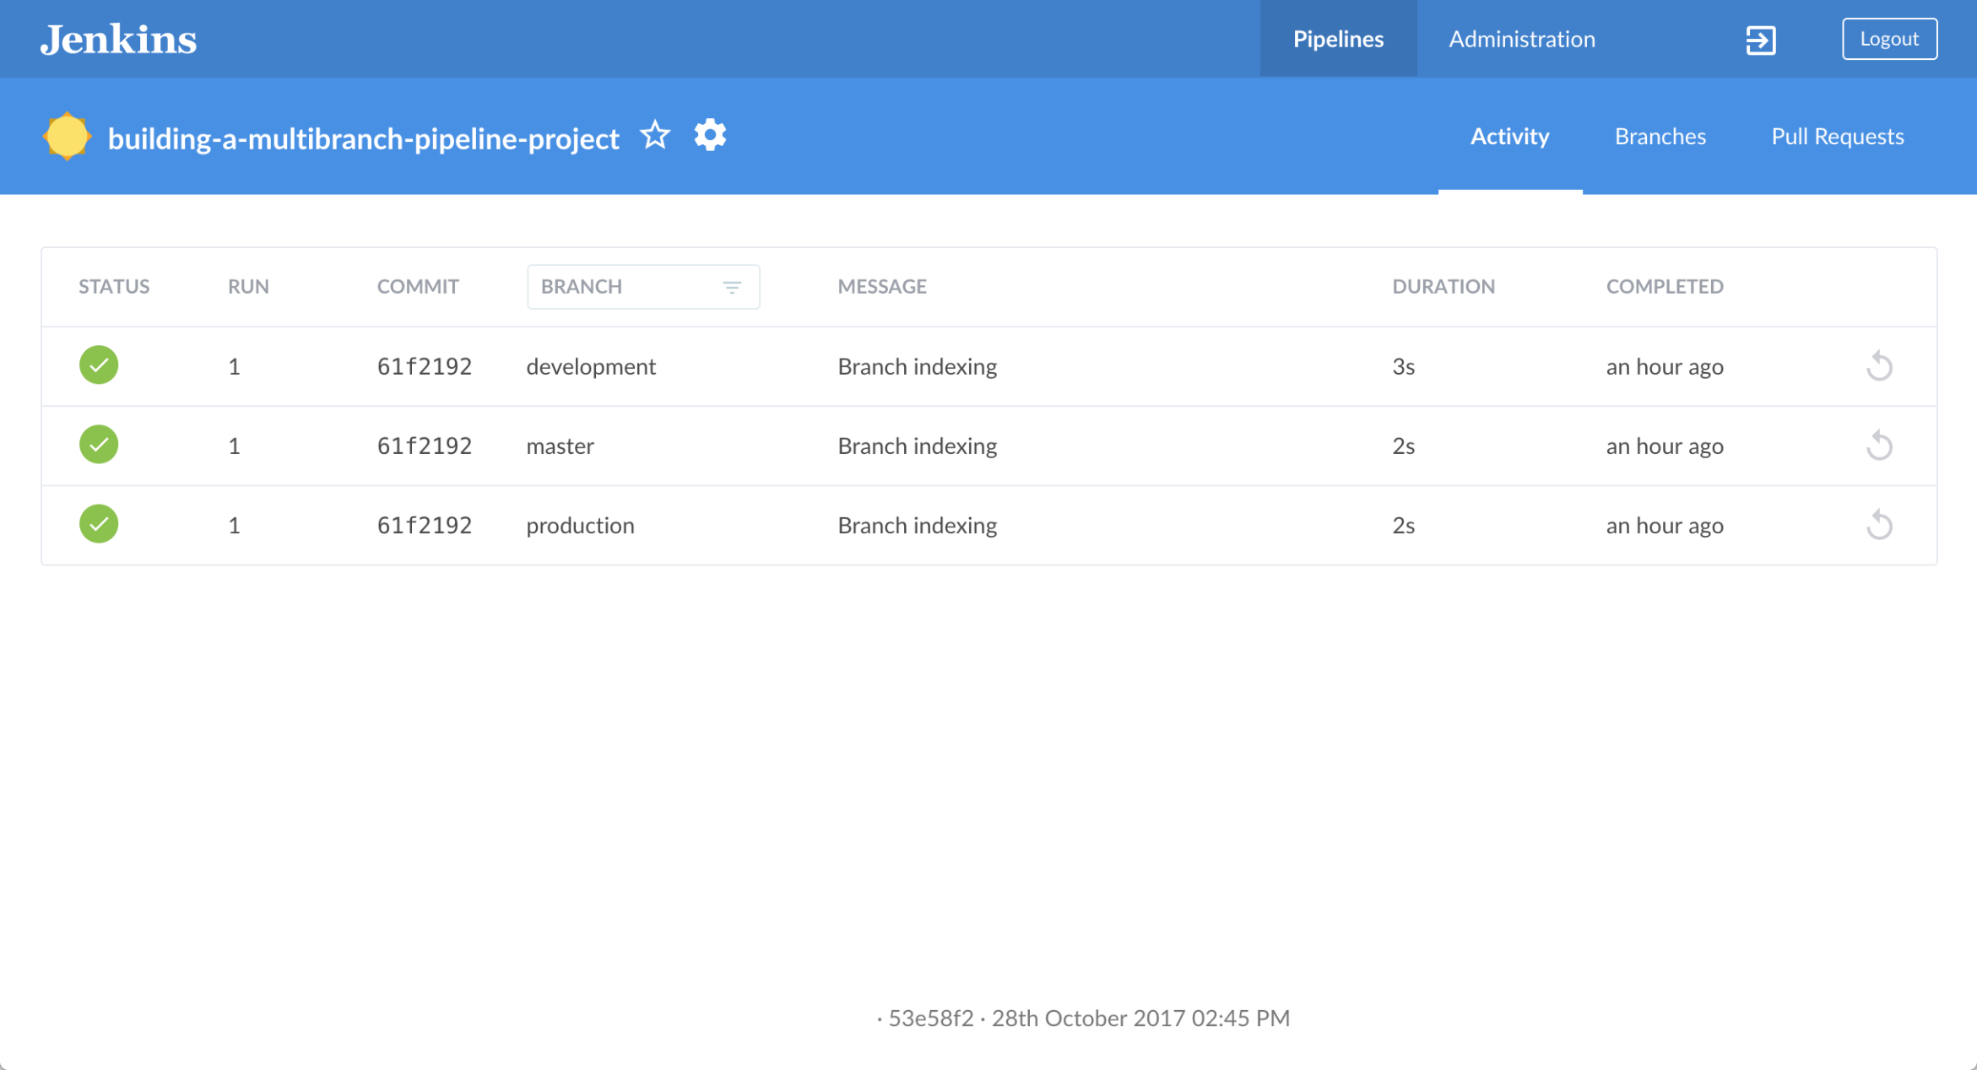

|  |  |
| --- | --- |
|  | The Pipeline stub consists of the basic requirements for a valid Pipeline - i.e. an agent and a stages section, as well as a stage directive.  The reason why the building-a-multibranch-pipeline-project repository includes a Jenkinsfile Pipeline stub is that its presence in a branch makes Blue Ocean detect that there’s something to build (i.e. the Jenkinsfile) immediately after creating the Pipeline project in Blue Ocean, which in turn makes these branches accessible through the Blue Ocean interface.  If you created a Pipeline project in Blue Ocean but didn’t have a Jenkinsfile in one or more of your repository’s branches, then to access the branches in Blue Ocean after subsequently pulling in/adding a Jenkinsfile to these branches, either:   * Use the **Scan Multibranch Pipeline Now** feature in the Multibranch Pipeline project (accessible through Jenkins’s classic interface), or * Implement webhooks into your Git repository. |

### Create your initial Pipeline as a Jenkinsfile with build and test stages

You’re now ready to create the Pipeline that will automate building your Node.js and React application in Jenkins. Your Pipeline will be created as a Jenkinsfile, which will be committed to the master branch of your locally cloned Git repository (building-a-multibranch-pipeline-project).

First, create an initial Pipeline to download a Node Docker image and run it as a Docker container that will build your simple Node.js and React application. Also add a "Build" stage to the Pipeline to begin orchestrating this whole process and a "Test" stage to check that the application renders satisfactorily.

1. Using your favorite text editor or IDE, open the existing Jenkinsfile at the root of your local building-a-multibranch-pipeline-project Git repository and clear its contents.  
   **Note:** Be sure you are performing this step on the master branch of your repository.
2. Copy the following Declarative Pipeline code and paste it into your empty Jenkinsfile:
3. pipeline {
4. agent {
5. docker {
6. image 'node:6-alpine'
7. args '-p 3000:3000 -p 5000:5000'
8. }
9. }
10. environment {
11. CI = 'true'
12. }
13. stages {
14. stage('Build') {
15. steps {
16. sh 'npm install'
17. }
18. }
19. stage('Test') {
20. steps {
21. sh './jenkins/scripts/test.sh'
22. }
23. }
24. }

}

|  |  |
| --- | --- |
|  | This args parameter makes the Node container (temporarily) accessible through ports 3000 and 5000. The significance of this is explained in the jenkins/scripts/deliver-for-deployment.sh and jenkins/scripts/deploy-for-production.sh files of your cloned repository, and are covered in subsequent sections of this tutorial. |

**Note:** For an explanation of the other components of this Jenkinsfile, refer to the annotations of the Declarative Pipeline in the “Create your initial Pipeline…​” and “Add a test stage…​” sections of the Build a Node.js and React app with npm tutorial.

1. Save your edited Jenkinsfile and commit it to your local building-a-multibranch-pipeline-project Git repository. E.g. Within the building-a-multibranch-pipeline-project directory, run the commands:  
   git stage .  
   then  
   git commit -m "Add initial Jenkinsfile with 'Test' stage"
2. Go back to Jenkins again, log in again if necessary and ensure you’ve accessed Jenkins’s Blue Ocean interface.
3. Click **Branches** at the top right to access the list of your Pipeline project’s branches.

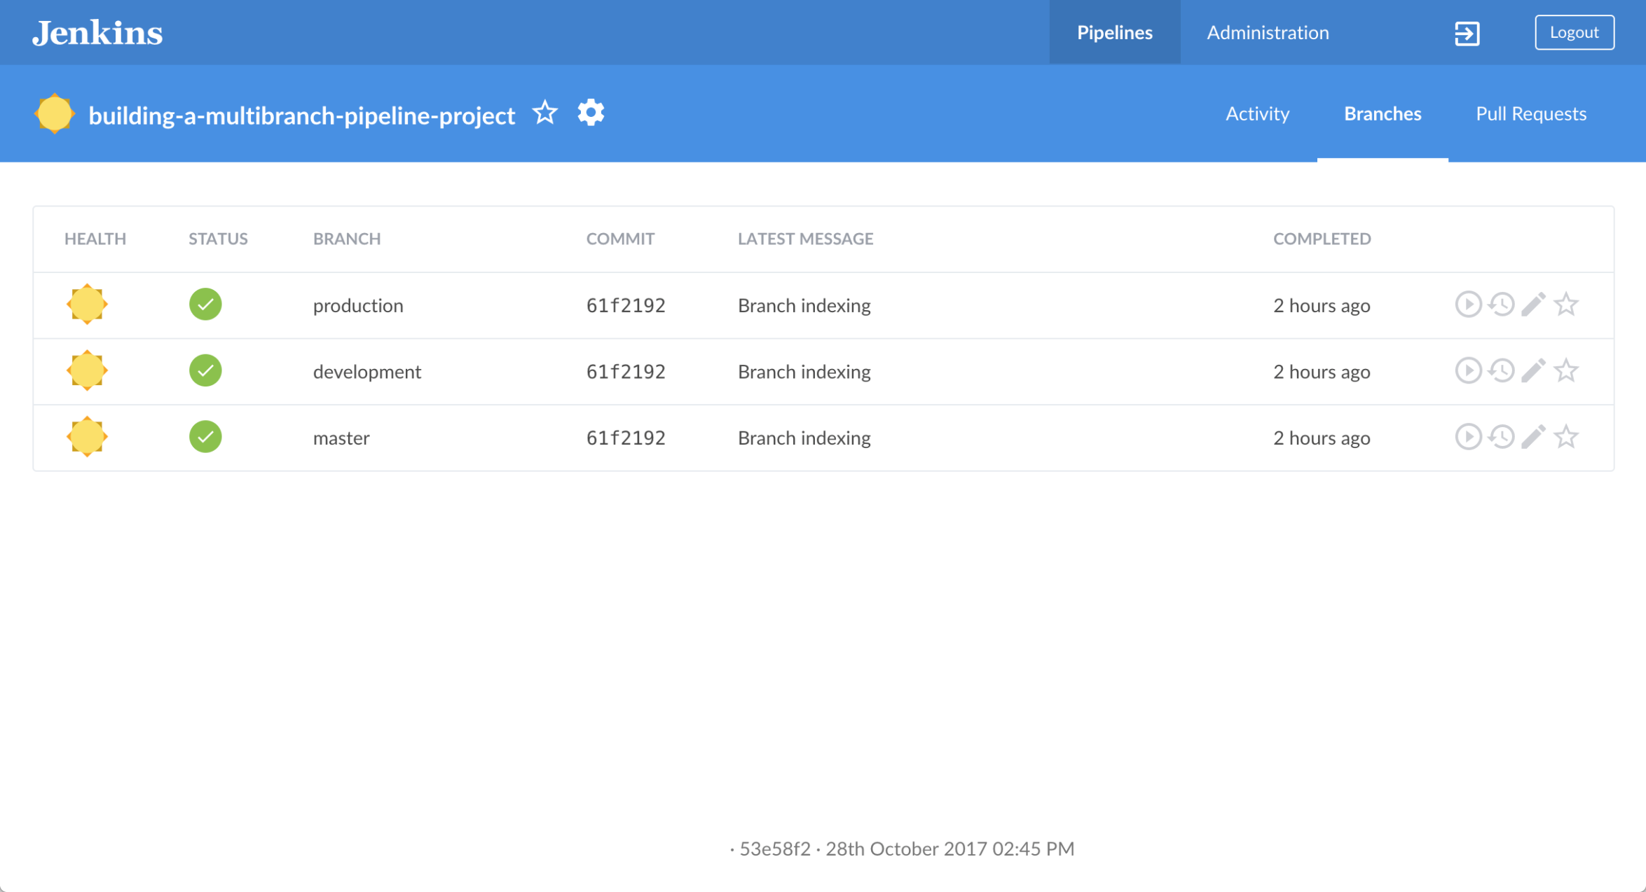

1. Click the run icon  of the master branch of your Pipeline project, then quickly click the **OPEN** link that appears briefly at the lower-right to see Jenkins building the master branch with the amended Jenkinsfile. If you weren’t able to click the **OPEN** link, click the top row on the Blue Ocean **Activity** page to access this feature.  
   Within a few minutes, the Blue Ocean interface turns green if Jenkins built your Node.js and React application successfully from your master branch.

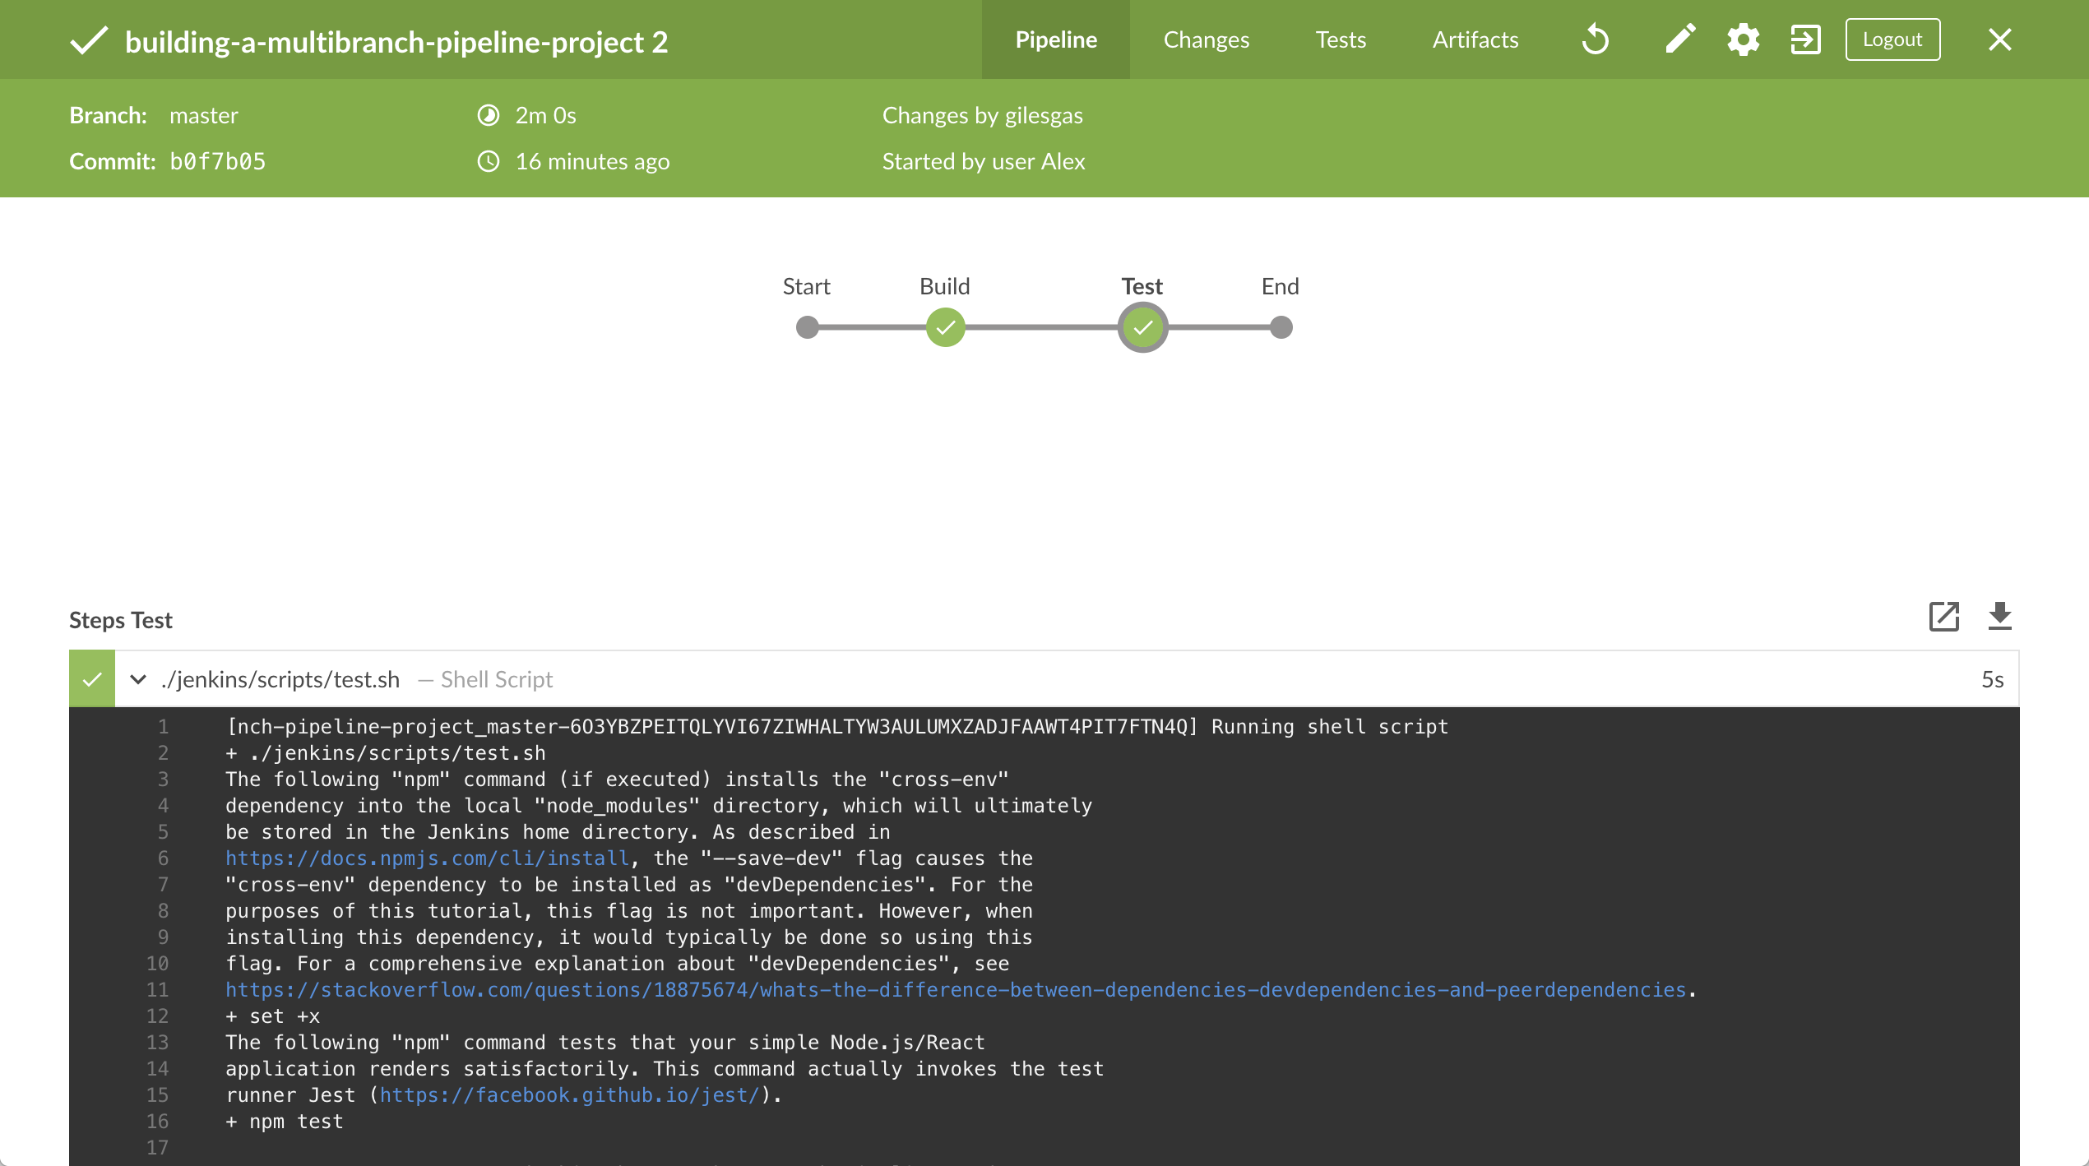

1. Click the **X** at the top-right to return to the **Activity** page of the Blue Ocean interface.

### Add deliver and deploy stages to your Pipeline

Next, add "Deliver for development" and "Deploy for production" stages to your Pipeline, which Jenkins will selectively execute based on the based on the branch that Jenkins is building from.

This takes the "Pipeline-as-Code" concept to a new level, in which a single Jenkinsfile describes your project’s entire build, test, delivery and deployment processes in Jenkins for each branch of your repository. Read more about Pipeline and what a Jenkinsfile is in the Pipeline and Using a Jenkinsfile sections of the User Handbook.

1. Go back to your text editor/IDE and ensure your Jenkinsfile is open.
2. Copy and paste the following Declarative Pipeline syntax immediately under the Test stage of your Jenkinsfile:
3. stage('Deliver for development') {
4. when {
5. branch 'development'
6. }
7. steps {
8. sh './jenkins/scripts/deliver-for-development.sh'
9. input message: 'Finished using the web site? (Click "Proceed" to continue)'
10. sh './jenkins/scripts/kill.sh'
11. }
12. }
13. stage('Deploy for production') {
14. when {
15. branch 'production'
16. }
17. steps {
18. sh './jenkins/scripts/deploy-for-production.sh'
19. input message: 'Finished using the web site? (Click "Proceed" to continue)'
20. sh './jenkins/scripts/kill.sh'
21. }

}

so that you end up with:

pipeline {

agent {

docker {

image 'node:6-alpine'

args '-p 3000:3000 -p 5000:5000'

}

}

environment {

CI = 'true'

}

stages {

stage('Build') {

steps {

sh 'npm install'

}

}

stage('Test') {

steps {

sh './jenkins/scripts/test.sh'

}

}

stage('Deliver for development') {

when {

branch 'development'

}

steps {

sh './jenkins/scripts/deliver-for-development.sh'

input message: 'Finished using the web site? (Click "Proceed" to continue)'

sh './jenkins/scripts/kill.sh'

}

}

stage('Deploy for production') {

when {

branch 'production'

}

steps {

sh './jenkins/scripts/deploy-for-production.sh'

input message: 'Finished using the web site? (Click "Proceed" to continue)'

sh './jenkins/scripts/kill.sh'

}

}

}

}

|  |  |
| --- | --- |
|  | These when directives (along with their branch conditions) determine whether or not the stages (containing these when directives) should be executed. If a branch condition’s value (i.e. pattern) matches the name of the branch that Jenkins is running the build from, then the stage that contains this when and branch construct will be executed. |

**Notes:**

* + For an explanation of the input message steps, refer to annotation **4** of the Declarative Pipeline at the “Add a final deliver stage…​” section of the Build a Node.js and React app tutorial.
  + For an explanation of the deliver-for-development.sh, deploy-for-production.sh and kill.sh script steps, refer to the contents of these files located in the jenkins/scripts directory from the root of the building-a-multibranch-pipeline-project respository.

1. Save your edited Jenkinsfile and commit it to your local building-a-multibranch-pipeline-project Git repository. E.g. Within the building-a-multibranch-pipeline-project directory, run the commands:  
   git stage .  
   then  
   git commit -m "Add 'Deliver...' and 'Deploy...' stages"
2. Go back to Jenkins again, log in again if necessary and ensure you’ve accessed Jenkins’s Blue Ocean interface.
3. Click **Branches** at the top right to access the list of your Pipeline project’s branches.
4. Click the run icon  of the master branch of your Pipeline project, then quickly click the **OPEN** link that appears briefly at the lower-right to see Jenkins building the master branch with the amended Jenkinsfile. If you weren’t able to click the **OPEN** link, click the top row on the Blue Ocean **Activity** page to access this feature.  
   Notice how Jenkins skips the last two stages you added, since the branch you are running the build from (master) does not meet the when directives' branch conditions in these stages.

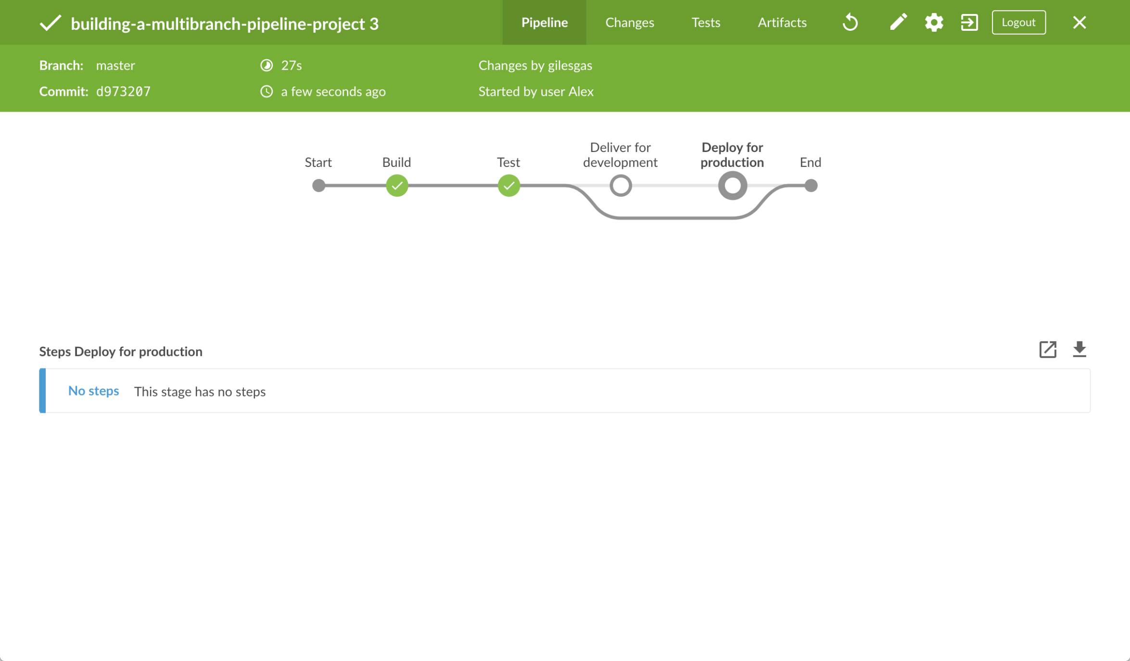

1. Click the **X** at the top-right to return to the **Activity** page of the Blue Ocean interface.

### Pull your updated Jenkinsfile into the other repository branches

Now that you have a completed Jenkinsfile to build your application in Jenkins, you can pull this file from the master branch of your local repository into its development and production branches.

Within your local repository’s building-a-multibranch-pipeline-project directory:

1. Run the following commands to pull changes from master to development:
   * git checkout development  
     and
   * git pull . master
2. Also run the following commands to pull changes from master to production:
   * git checkout production  
     and
   * git pull . master

Your development and production branches should now have all your Jenkinsfile updates you made on the masterbranch.

### Run your Pipeline on the development branch

1. Go back to Jenkins again, log in again if necessary and ensure you’ve accessed Jenkins’s Blue Ocean interface.
2. Click **Branches** at the top right to access the list of your Pipeline project’s branches.
3. Click the run icon  of the development branch of your Pipeline project, then quickly click the **OPEN** link that appears briefly at the lower-right to see Jenkins building the development branch with the amended Jenkinsfile. If you weren’t able to click the **OPEN** link, click the top row on the Blue Ocean **Activity** page to access this feature.
4. Within a few minutes and when the build pauses, ensure you are viewing the **Deliver for development** stage (click it if necessary), then click the top green **Shell Script** step to expand its contents and scroll down until you see the http://localhost:3000 link.

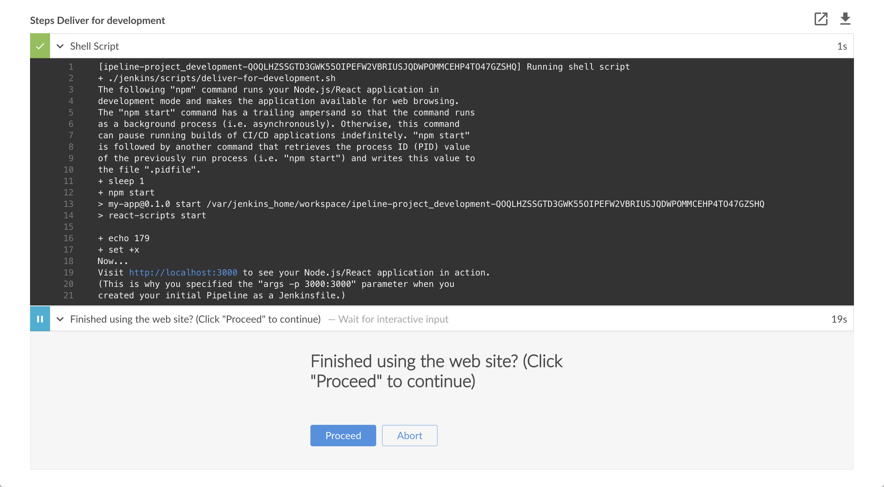  
**Note:** Since you are building the application on a different branch, the npm install step will require a few minutes for npmto download the many dependencies required to run your Node.js and React application (stored in a local node_modulesdirectory within the Jenkins home directory). These dependencies are downloaded again because this Jenkins build would be the first time you are running your Pipeline project on the development branch and each branch has its own workspace directory (containing its own node_modules directory) within the Jenkins home directory.

1. Click the http://localhost:3000 link to view your Node.js and React application running in development mode (with the npm start command) in a new web browser tab. You should see a page/site with the title **Welcome to React** on it.
2. When you are finished viewing the page/site, click the **Proceed** button in Blue Ocean to complete the Pipeline’s execution.  
   The Blue Ocean interface turns green if Jenkins built your Node.js and React application successfully from your developmentbranch. Notice how the **Deliver for development** stage was executed but the **Deploy for production** stage was not.

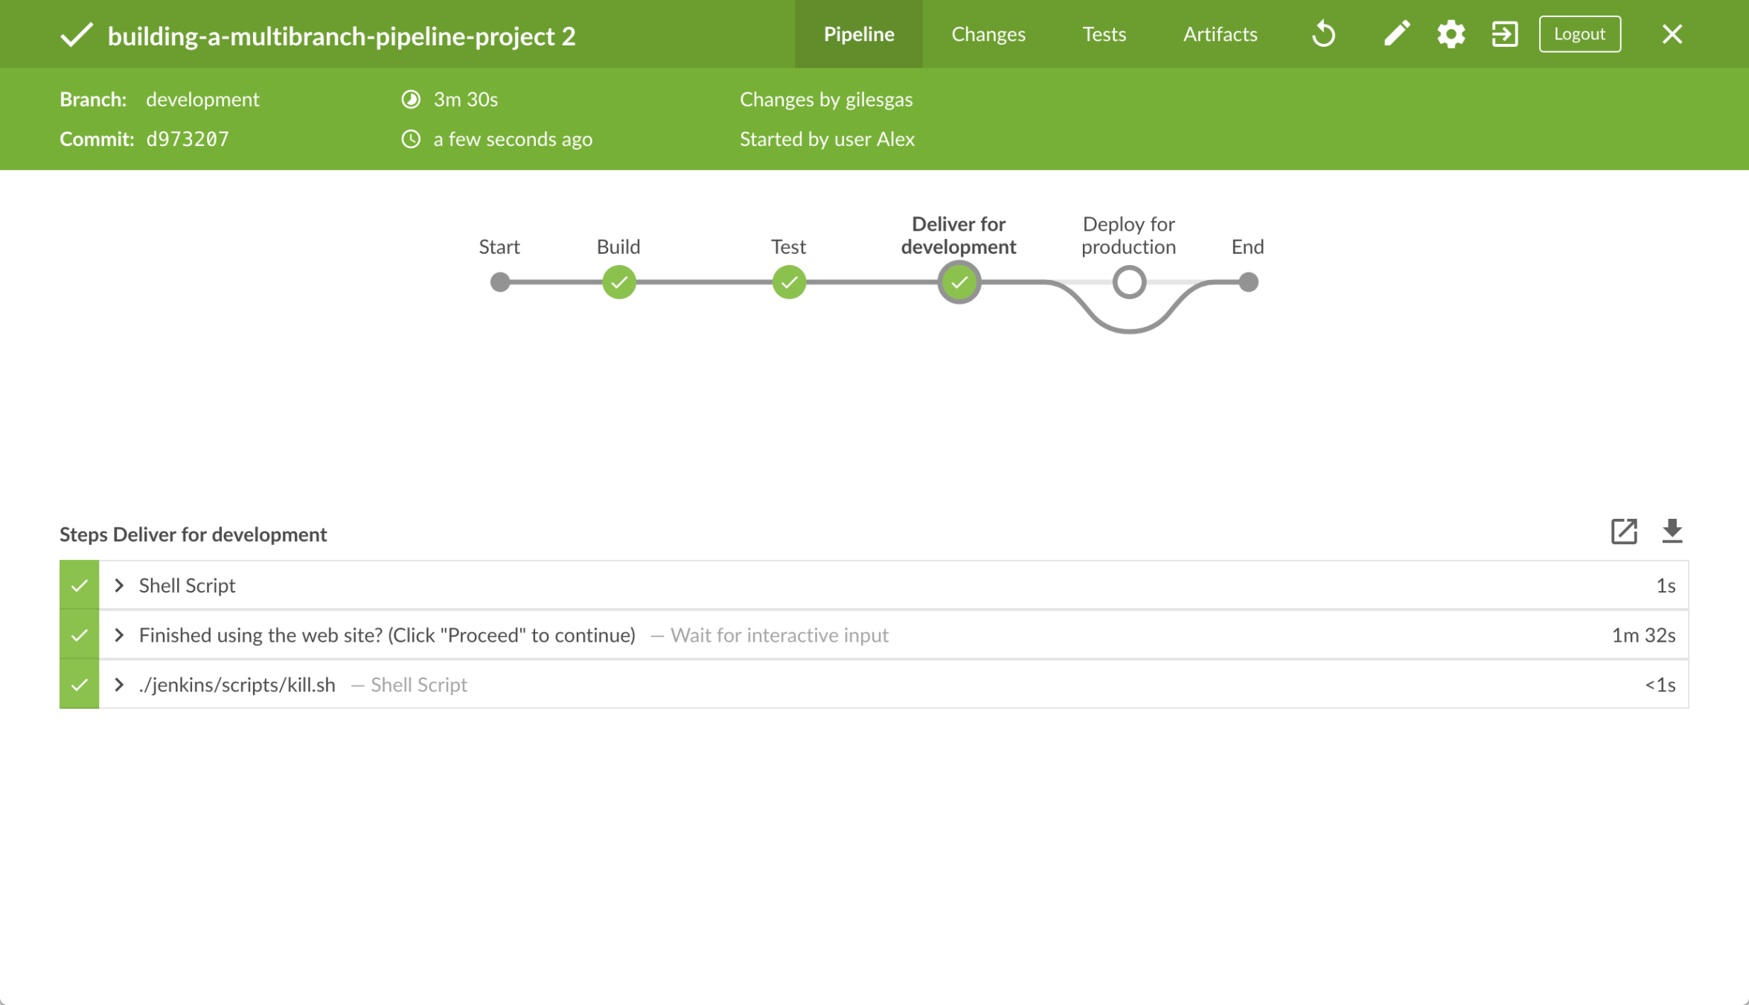

1. Click the **X** at the top-right to return to the **Activity** page of the Blue Ocean interface.

### Run your Pipeline on the production branch

1. Click **Branches** at the top right to access the list of your Pipeline project’s branches.
2. Click the run icon  of the production branch of your Pipeline project, then quickly click the **OPEN** link that appears briefly at the lower-right to see Jenkins building the production branch with the amended Jenkinsfile. If you weren’t able to click the **OPEN** link, click the top row on the Blue Ocean **Activity** page to access this feature.
3. Within a few minutes and when the build pauses, ensure you are viewing the **Deploy for production** stage (click it if necessary), then click the top green **Shell Script** step to expand its contents and scroll down until you see the http://localhost:5000 link.

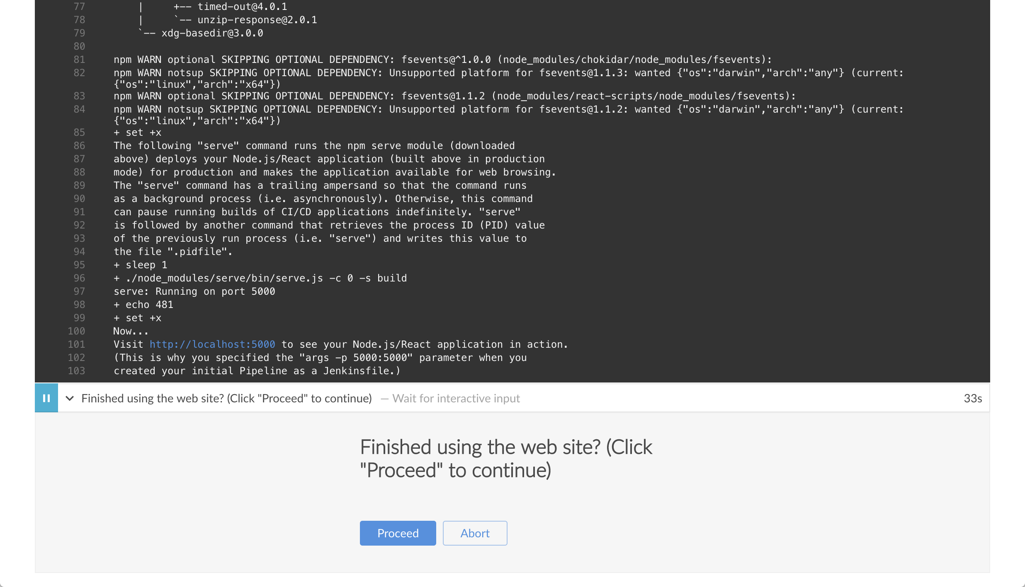

1. Click the http://localhost:5000 link to view your Node.js and React application in a new web browser tab. This will be running in production mode from a production build of your source code (generated using the npm run build command). Again, you should see a page/site with the title **Welcome to React** on it. However, this time, the application’s contents are served by the npm serve module and are also likely to continue running in the background in your browser.
2. When you are finished viewing the page/site, click the **Proceed** button in Blue Ocean to complete the Pipeline’s execution.  
   The Blue Ocean interface turns green if Jenkins built your Node.js and React application successfully from your productionbranch. Notice how the **Deploy for production** stage was executed but the **Deliver for development** stage was skipped.

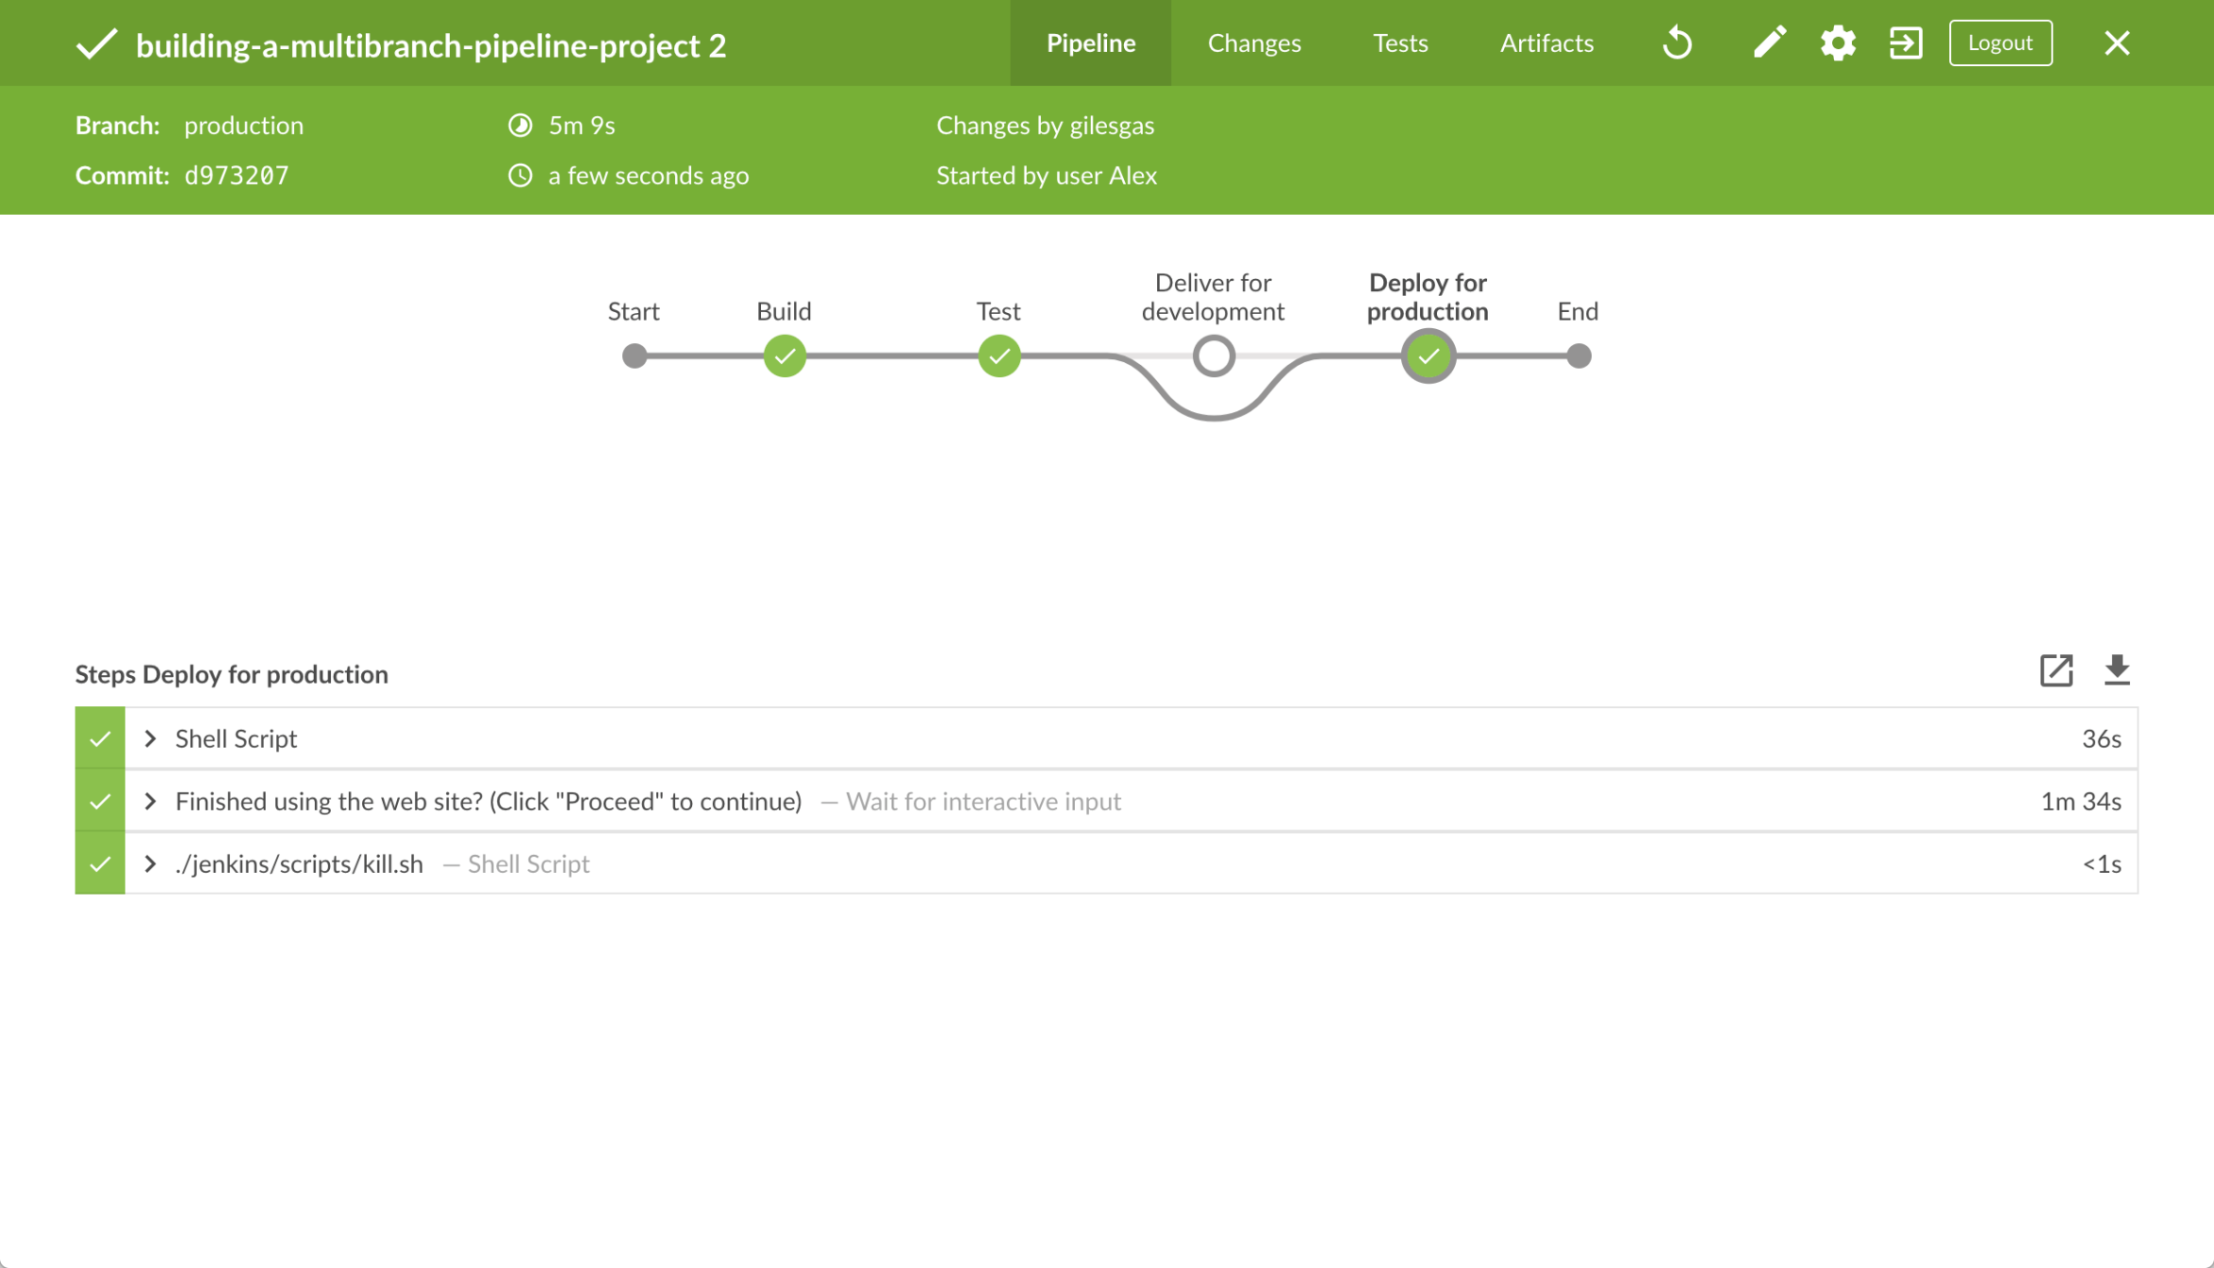

1. Click the **X** at the top-right to return to the **Activity** page of the Blue Ocean interface.  
   **Note:** Since your browser is likely to continue running the application’s content served by the npm serve module, your browser will still show the content you viewed at http://localhost:5000 long after Jenkins has killed off the serveprocess. Read more about how to clear the application and its content from your browser below.

### Follow up (optional)

This section takes you through a similated development workflow using Jenkins, whereby changes made to your application (i.e. the App.js source file) can be examined from the development branch before they are deployed to production (from the productionbranch) via the master branch.

1. Within your local repository’s building-a-multibranch-pipeline-project directory, run the command git checkout development to change to the development branch.
2. Go back to your text editor/IDE and open the App.js file in the src directory of your local building-a-multibranch-pipeline-project Git repository.
3. Copy and paste the following HTML syntax immediately under the To get started... line of your App.js file:
4. **<br/>**

This is a new line I added.

so that you end up with:

**import** React, { Component } from 'react';

**import** logo from './logo.svg';

**import** './App.css';

**class** App **extends** Component {

render() {

**return** (

**<div** className="App"**>**

**<header** className="App-header"**>**

**<img** src={logo} className="App-logo" alt="logo" **/>**

**<h1** className="App-title"**>**Welcome to React**</h1>**

**</header>**

**<p** className="App-intro"**>**

To get started, edit **<code>**src/App.js**</code>** and save to reload.

**<br/>**

This is a new line I added.

**</p>**

**</div>**

);

}

}

**export** **default** App;

1. Save the edited App.js file and commit it to your local building-a-multibranch-pipeline-project Git repository. E.g. Within the building-a-multibranch-pipeline-project directory, run the commands:  
   git stage .  
   then  
   git commit -m "Update 'App.js'"
2. Back in Blue Ocean, run your Pipeline on the development branch (as you did above) and check the results through http://localhost:3000 to see your new line added.
3. Assuming you’re happy with the change, then within your local repository’s building-a-multibranch-pipeline-projectdirectory, run the following set of commands to pull your change into the production branch (via the master branch):
   * git checkout master  
     and
   * git pull . development  
     then
   * git checkout production  
     and
   * git pull . master
4. Back in Blue Ocean, run your Pipeline on the production branch this time (as you did above) and check the results through http://localhost:5000 to see your new line added.  
   **Notes:**
   * Since your browser is likely to cache the contents of the npm serve module, you may need to refresh your browser page to see your change.
   * In a real software development environment with small to large teams of people, pulling changes between branches is more likely to be conducted using pull requests on a cloud- or web-hosted Git service (such as GitHub or BitBucket).

### Clearing the app from your browser

Your browser is likely to continue running your application’s content served by the npm serve module, which means that your browser will still show the content you viewed at http://localhost:5000 long after Jenkins has killed off the serve process. To clear the application and its content from your browser:

#### On Chrome

1. Enter the following into your browser’s URL field:  
   chrome://serviceworker-internals/
2. Locate the "ServiceWorker" entry for http://localhost:5000
3. Click its **Unregister** button.

#### On Firefox

1. Enter the following into your browser’s URL field:  
   about:serviceworkers
2. Locate the "Registered Service Worker" entry for http://localhost:5000
3. Click its **Unregister** button